ASSEMBLY:

22 Feb |  | No assembly
1 Mar |  | No assembly
DATES TO REMEMBER:
25 | Feb | Canberra Raiders Cyber
 |  | Safety
01 Mar |  | 5pm Billy Tea Bush
 |  | Dance
11 | Mar | Canberra Day - public
 |  | holiday
13 Mar |  | K-Yr2 Questacon
 |  | incursion
15 Mar |  | Yr3-6 Questacon
 |  | incursion
19 | Mar | Yr3-6 Author visit -
 |  | Katrina Nannestad
20 | Mar | Christian Education

NOTES:

- Yr3-6 Language Perfect

What’s On

21 February 2019

Week 3, Term 1
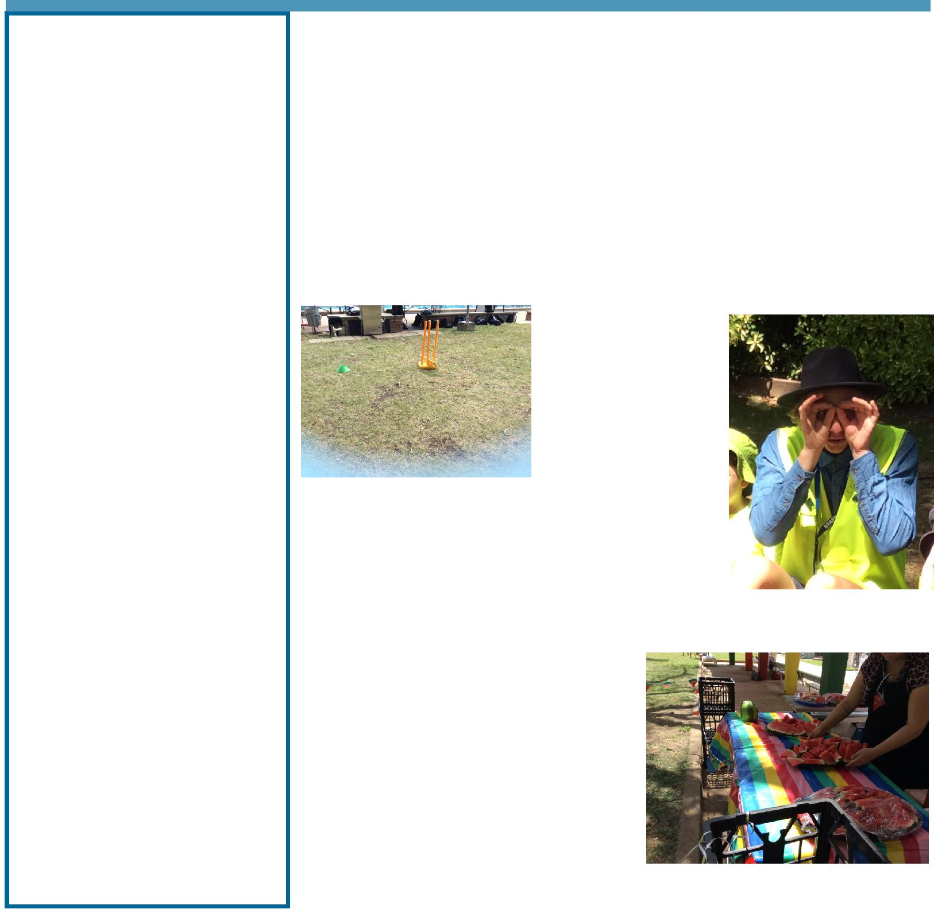

EXECUTIVE TEACHER’S MESSAGE

Week Three

Students have had a great start to the year and are settling into class routines and learning structures. Palmy, our Positive Behaviours for Learning (PBL) mascot has been widely spoken about in classrooms with students using the language of Safe, Respectful and Learners in the playground. It is great to see our staff and students building the common language to help our school deliver the PBL approach.

Swimming Carnival

Yesterday we had our annual swimming carnival at Dickson Pool. Students from K-6 attended the carnival with
competitive swimmers participating in the races. Junior and senior school students competed in structured rotations under the supervision of teachers. Thank you to all the

parent volunteers who assisted with time keeping, rotations or just turning up and cheering on the day. A

special thanks to our wonderful P&C for donating, cutting and distributing over 100kg of watermelon to Palmerston students on the day. The weather was fantastic, and the annual teacher race was won by Mr Shaw.

P&C BOARD NEWS P&C: 18 March 2019

All P&C activities, meeting agendas and minutes are available from the school website at – Parent Corner

School Board:

Together, we learn from each other

What’s On

Tennis Clinics

When walking around the school today I saw students from year 1 to 6 participate in our weekly tennis clinics. Palmerston District Primary School received a funding grant through the Sporting Schools Program. All students will receive a weekly session for 4 weeks delivered by accredited coaches from Tennis Canberra. Thanks to Mr Susko for organising such a fun event.

Student Leadership

On Friday last week at morning lines we announced the 2019 sporting house captains and vice captains. The excitement was everywhere. These students prepared speeches and presented them to their respective houses. House groups voted on their year 6 captains and year 5 vice captains. Our 2019 student leaders are:

Murrumbidgee captains: | Poppy | Toby
Murrumbidgee vice captains: | Charley | Max
Gudgenby captains: | Amarlie | Aidan
Gudgenby vice captains: | Kay | James
Snowy captains: | Sianna
Snowy vice captains: | Jessica | Melvin
Cotter captains: | Ashleigh | Zac
Cotter vice captains: | Safina | Dylan

We congratulate all these people and know they will fulfil their leadership positions admirably this year.

Bush Dance

Next Friday 1 March students (K-6) will have the opportunity to participate in The Billy Tea Bush Band workshops. During the workshops, students will learn the activities that are part of the community dance. That evening Palmerston District Primary School will be holding a community dancing evening and the P&C will be providing a sausage sizzle. All students and families are welcome to attend.

Time: 5.00pm-7.00pm

Where: PDPS Hall

Cost: Gold coin donation

Sausage Sizzle: $2

Have a great week,

Matt Gowen

EXTREME WEATHER

At this time of year gum trees (Eucalyptus species) are prone to drop limbs without warning as a result of the consistently higher temperatures, prevailing winds and low rainfall patterns. Schools have been requested to ask students, staff and visitors to avoid congregating, walking or parking vehicles under native trees particularly larger specimens until conditions improve. You will find many schools and surrounding areas have gum trees in Canberra. As a school, we will work with our students around gum tree safety.

Together, we learn from each other

What’s On

UPCOMING EVENTS

Yr1-6 Tennis Clinics

Date: Weeks 2-5

Location: PDPS, blacktop

Run by Tennis Canberra, funded by Sporting School’s grant

Canberra Raiders Cyber Safety

Date: Monday 25 February 2019

Location: PDPS, hall

The National Rugby League is excited to launch its new Cyber Safety resource designed to support students as they en-

gage in the cyber world. This face to face presentation will cover key elements designed to highlight safe practices when

online and in the cyber world. Our NRL Game Development Officers will guide the students through discussion with an

engaging and real-world relevant presentation.

Key topics covered in the presentation include:

- Sharing your information online

- Cyber Bullying

- Avoid getting scammed online

Covering formats such as gaming, YouTube, and online interaction the presentation will leave students with a better knowledge and range of tactics to ensure their safety online.

By using Rugby League as a vehicle for the cyber safety, presenters will be able to utilise their enthusiasm for sport and competition to encourage interaction and participation. The presentation is designed in line with the Australian curricu-lum to promote health, safety and wellbeing as part of Health and physical Education learning area.

Billy Bush Tea Dance

Date: 5-7pm Friday 1 March 2019

Location: PDPS, hall

Questacon incursion

Date: K-Yr2 , Wednesday 13 March 2019

Yr3-6 Friday 15 March 2019

Location: PDPS
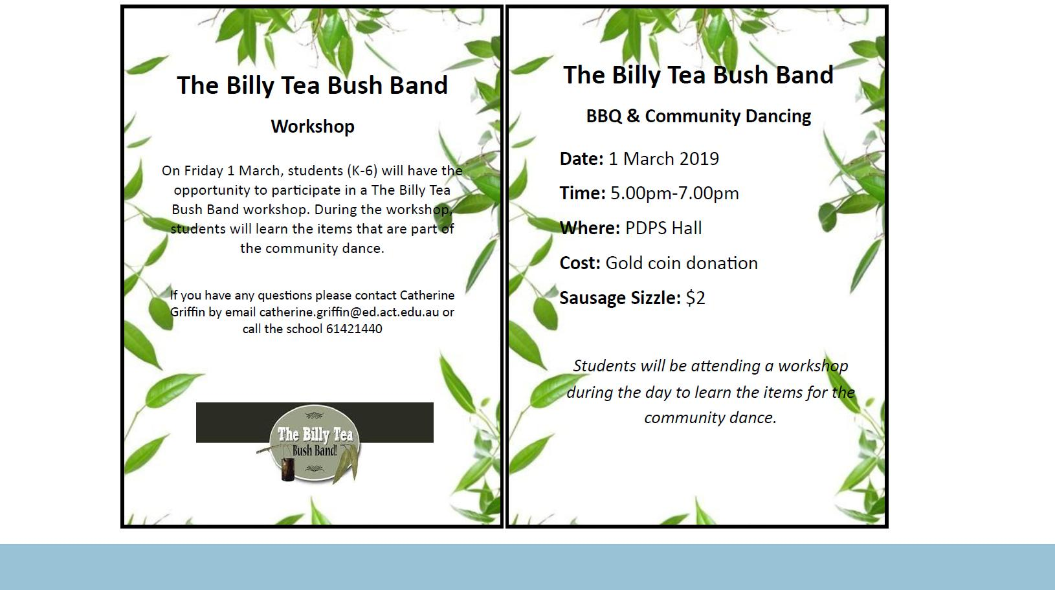

Together, we learn from each other

What’s On

SCHOOL BOARD NOMINATIONS 2019

School Board elections will be held in early 2019

Membership of the School Board is a wonderful opportunity for parents to participate in the ongoing management of the school and to contribute to the determination of the school’s future directions. There are two (2) vacancies for parent representatives on the Palmerston District Primary School Board for the period 1 April 2019 to 31 March 2021. Election of the parent representative will be undertaken in the first few weeks of the 2019 school year. Nomination period:

Opens – 11:00am on Thursday 14 February 2019

Closes – 11:00am on Thursday 28 February 2019

Voting period (if election is required):

Opens – 11:00am on Tuesday 12 February 2019

Closes – 11:00am on Tuesday 19 March 2019

The positions for election will be:

Two (2) - Parent Representative Position. Elected positions run for a two (2) year term.

The successful candidates will be announced by Monday, 25 March 2019.

If you are interested in being a member of the Palmerston District Primary School Board for 2019-2021 and would like more information about the roles and responsibilities of School Board members, please contact the Principal, Melissa Travers on 6142 1440. A copy of the School Board Manual is also available for perusal at the front office. Nomination forms will be available from the school front office. If you would like to have a form before that date, please contact the school front office on 6142 1440.

CANTEEN UPDATE 2019

As mentioned last year, PDPS would like to thank Y’s Bites for providing the school with the Thursday canteen service over the past two years. We would also like to thank the P&C for supporting this initiative and assisting with the sorting and delivery of the lunches each Thursday.

Unfortunately, the food service will not be provided in 2019 due to the conclusion of grant funding with the YMCA, they are no longer able to provide the school the current service. We are currently looking into an alternate lunch option with more information available in early 2019.

ART SUPPLIES

If you have any unwanted wool, fabric or ribbon the school would love them for art projects. Please drop them off at the front office.

Together, we learn from each other

What’s On

P&C NEWS

Together, we learn from each other

What’s On

It is easy to order. The Book Club LOOP platform for parents allows you to pay by credit card. Your child’s order is submitted directly to school safe and sound and the books will be delivered to class approximately 2 weeks after the deadline closes. You can place your child’s order at scholastic.com.au/LOOP or using the LOOP app, which can be downloaded from the App Store or Google Play.

Or

If you wish to order and pay with cash, then complete the order form on the back

of the brochure and place into an envelope with the correct money and then place

into the ‘Boomerang’ Box located in the front office foyer by the order deadline.

Each order helps earn free books and teaching materials for our school, how-ever there is never any obligation to order.

My name is Edwina and I am a volunteer at the school, I look after the Scholastic Book Club.

Issue 1 of the Book Club Catalogues have been distributed with some spares available on top of the ‘Boomerang Box’ located in the front office foyer..

All Orders are due by this Friday 22 Feb (Week 3).

If you have any questions regarding Book Club, then please don’t hesitate to contact me via the front office.

Edwina

Book Club Coordinator

NAPLAN Online will occur in our school between 14 and 24 May 2019.

NAPLAN Online is a more engaging assessment that adjusts questions to each student’s achieve-ment level. It also delivers more precise results to schools and parents more quickly.

NAPLAN provides valuable information to schools and parents about literacy and numeracy achieve-ment. It supports school improvement processes by enabling teachers to monitor student progress over time and to identify areas of strength and development.

All eligible students are encouraged and supported to participate in NAPLAN testing. Visit www.nap.edu.au to see interactive versions of the test and for more information.

Together, we learn from each other

What’s On

Safety & Law Enforcement around schools
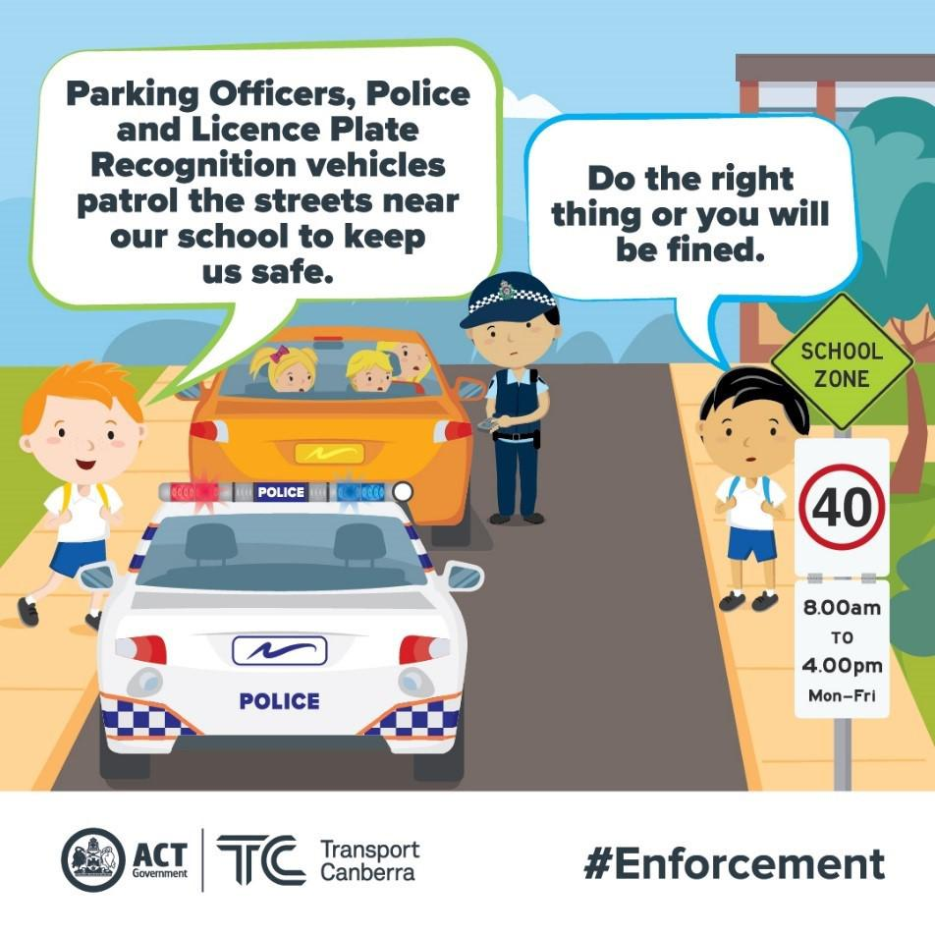

Parking Operations use a Licence Plate Recognition vehicle (or electronic chalking), which regularly patrols school environments to increase safety for children. Motorists that commit an offence will receive their infringement notice in the mail (rather than on their windscreen) 5-7 days after the offence.

While the school can become congested during the peak times, illegal parking should be avoided at all times as it creates an unsafe environment for children and local residents. Parents are welcome to park on side streets around the school, but please remember to park legally. Infringements for parking on nature strips,
footpaths, verges, street corners and near children’s

crossings start from $114.

More information is available on the Transport Canberra website to promote safe behaviours around schools. Please help to make our school community safe.

Safe parking behaviours
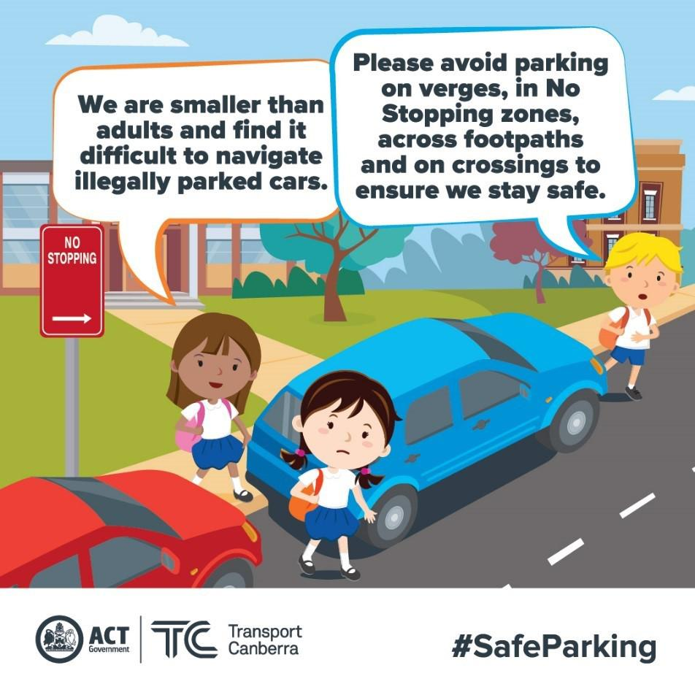

Unsafe driving and parking behaviours increase the potential road safety risk for children around schools. Road safety is a shared responsibility, it is important the road rules are followed near our school to ensure the entire school community feels safe.

Please remember children are more at risk than adults around schools because they are smaller and less visible to drivers. They are also less predictable and less experienced, which makes them more likely to make errors of judgement.

Failing to follow simple road rules like parking on the verge, in no stopping zones, in bus stops, near children’s crossings, on footpaths or across

driveways increases the risk to children around schools. Please do the right thing to create a safe environment around our school.

Together, we learn from each other

What’s On

HIRER’S NEWS

Together, we learn from each other

