Palmerston DPS acknowledges the Ngunnawal people, the traditional owners and custodians of this land we learn upon.

Term 3 , Issue 1 2 August 2019

PALMERSTON POST

PRINCIPALS MESSAGE

Term 3 is smoothly rolling on as we draw into the end of week 2. I am mak-ing more connections now, with a term now under my belt.

Congratulations to our assembly hosts - 2MO and 2AF last Friday. It never ceas-es to amaze me, how confidently our presenters lead the assembly – a great job indeed with the important messages of reduce, reuse , recycle. It is always really lovely to celebrate the achieve-ments of our junior students making new connections in their learning – congratulations to all award recipients.

Term 3 is a term that holds some really significant events: Book Week will be upon us soon, and we really look for-ward to our dress up day – a day to cele-brate the connections we have with books and our favourite character. This year, we are moving away from giving two prizes per class, as I believe the joy of the day is what should be celebrated and I would find it dreadfully difficult to choose just two children – I hope you agree with me that the day can be colos-sal irrespective of the perceived quality of costumes. Let’s all just have fun.

Science Week is another designated fo-cus week, where Ms Campbell and class teachers will focus on the importance and connections Science has in our world – different activities will be un-dertaken in each class, with the MOON being a prominent focus.

To top off the end of term – Learning Journeys will be scheduled in during Week 9, a time for parents and carers to come and visit the learning space of your child/ren and witness the connec-tions and gains made across the year so far. I am looking forward to our class-rooms bursting with family members, acknowledging and celebrating their learning. After that happening in the morning, we can lunge into our Walka-

thon – this is a major fundraiser for us I understand.

The connections forging between our Yr 5/6 students and all younger stu-dents within the Peer Support program on Friday afternoons is just sensational. All teachers are marvelling in the man-ner in which our seniors are embarking with confidence, humour and empathy towards our younger students. Excellent role models – we are very proud of you.

Today, we will be sending home a note to be filled out for every child, clarifying your permissions to use photos in our newsletters and FB page. As we plan to boost our visual showcase and share the wonderful things that happen across our school, we ask for your input/ permission to occasionally use relevant photos. Of course, we respect your wish-es to privacy if you select no. We would greatly appreciate a swift response and return to Kirsty in the Front Office so we can update our records.

With all of these community connec-tions this term – I look forward to see-ing you and learning more about you and your families. I welcome feedback, suggestions or questions to my email address kate.smith@ed.act.edu.au any-time.

Until next time- stay curious!

Kate Smith

DATES TO REMEMEBR

Please see page 9

Principal:

Kate Smith

Deputy Principals:

Marijana Pasalic Helen Cox

Executive Teachers:

Felicity McNiece

Kylie Moller

Haeley Simms

Kristina Collins

Business Manager:

Sonya Campbell Office Manager:

Kirsty Brown

Board Chair:

Lisa Fior

P & C President:

Lisa Fior

Helen Cox

Marijana Pasalic

DEPUTY PRINCIPAL MESSAGE

As Leader of Achievement and Potential, my role is to lead the school in re-search-based best practice in order to reach and teach all learners.

To do this, a high priority will be given to the school-wide collection, analysis and use of student data. Test data in English, Mathematics and Science will be key elements. Data will be used to identify gaps in student learning, to monitor improvement over time and to monitor growth across the years of school.

We will also develop a coherent, sequenced plan for curriculum delivery, that is aligned with the three dimensions of the Australian Curriculum and which ensures consistent teaching and learning expectations in skills and knowledge for all grade levels. A high priority in this curriculum planning will be the progressive development of students’ deep understandings of con-cepts, principles and big ideas within learning areas, as well as promoting the intellectual, physical, social, emotional, moral, spiritual and aesthetic development and wellbeing of students.

Differentiation is a priority of the school and it will be a feature of every teacher’s practice. Differentiated teaching will be actively promoted as a strategy for ensuring that every student is engaged and learning successful-ly. Some students will require significant adjustments to their learning pro-grams if they are to be optimally engaged and challenged.

I recognise that highly effective teaching is the key to improving student learning throughout the school. I am SO excited to have joined the Palmer-ston District Primary School team. I look forward to working with the won-derful Palmerston staff to maximise student learning and to ensure that every student is effectively challenged and engaged with their learning!

DEPUTY PRINCIPAL MESSAGE

At Palmerston District Primary School we are working together to create a safe and respectful environment to engage, learn and achieve our best every day. To be safe at our school we all need to keep our hands and feet to our-selves, follow teacher instruction and move sensibly around the school. To be respectful we take responsibility for our actions, use our manners and friendly voices and put our rubbish in the bin. Finally, to be a learner we should always strive to be in the right place at the right time and not be afraid to try new things. Students will be acknowledged for the positive be-haviours they display with a token and a point towards their house

group. We are looking forward to reviewing and refining the PBL framework at our school and will be continuing to seek community involvement. Watch this space!

LIBRARY NEWS

Each year, schools and public libraries across Australia spend a week cele-brating books, and Australian authors and illustrators. Teachers and librari-ans conduct activities relating to a theme to highlight the importance of reading. This year we will be celebrating Book Week from 17-23 August

(Week 5). Students K-6 (and Teachers!) will have the opportunity on

Wednesday of that week to join in our Costume Parade by dressing as a favourite book character. Pre-schoolers will be dressing up and parading for the school on Tuesday and Thursday. During the week we will be read-ing some wonderful Australian Literature and undertaking activities that celebrate our love of reading and all things books! If you are looking for quality Australian literature for your children the CBCA list of notables

each year is a wonderful place to start. https://www.cbca.org.au/notables-

2019

Author Visit

Notes have gone home for our visit from Michael Salmon on Wednesday

13th August (Week 4). Michael is a prolific and entertaining Australian au-thor and creative illustrator and we are very much looking forward to his

visit. Please3 remember to return your permission notes and payment as 3 soon as possible.

All P&C activities, meeting agendas and minutes are available from the school website at – Parent Corner

4

P & C/BOARD NEWS

The P&C are fundraising with the Entertainment Book. The Entertain-ment™ Book is a local restaurant and activity guide which provides hun-dreds of up to 50% off and 2-for-1 offers from the finest restaurants, cafes, attractions, activities, retailers and hotel accommodation. The Membership entitles buyers to exclusive offers that are virtually re-striction-free, and is valid through to 1 June 2020!

The Entertainment™ Digital Membership (app) puts all of the value of the Entertainment ™ Book into the customer's smartphone. With 'near me' technology and the ability to show and save using a phone, this is perfect for the person on-the-go, with no card or voucher to present.

You can purchase a book through the front office or download the app via this link

https://www.entertainmentbook.com.au/orderbooks/2487s6

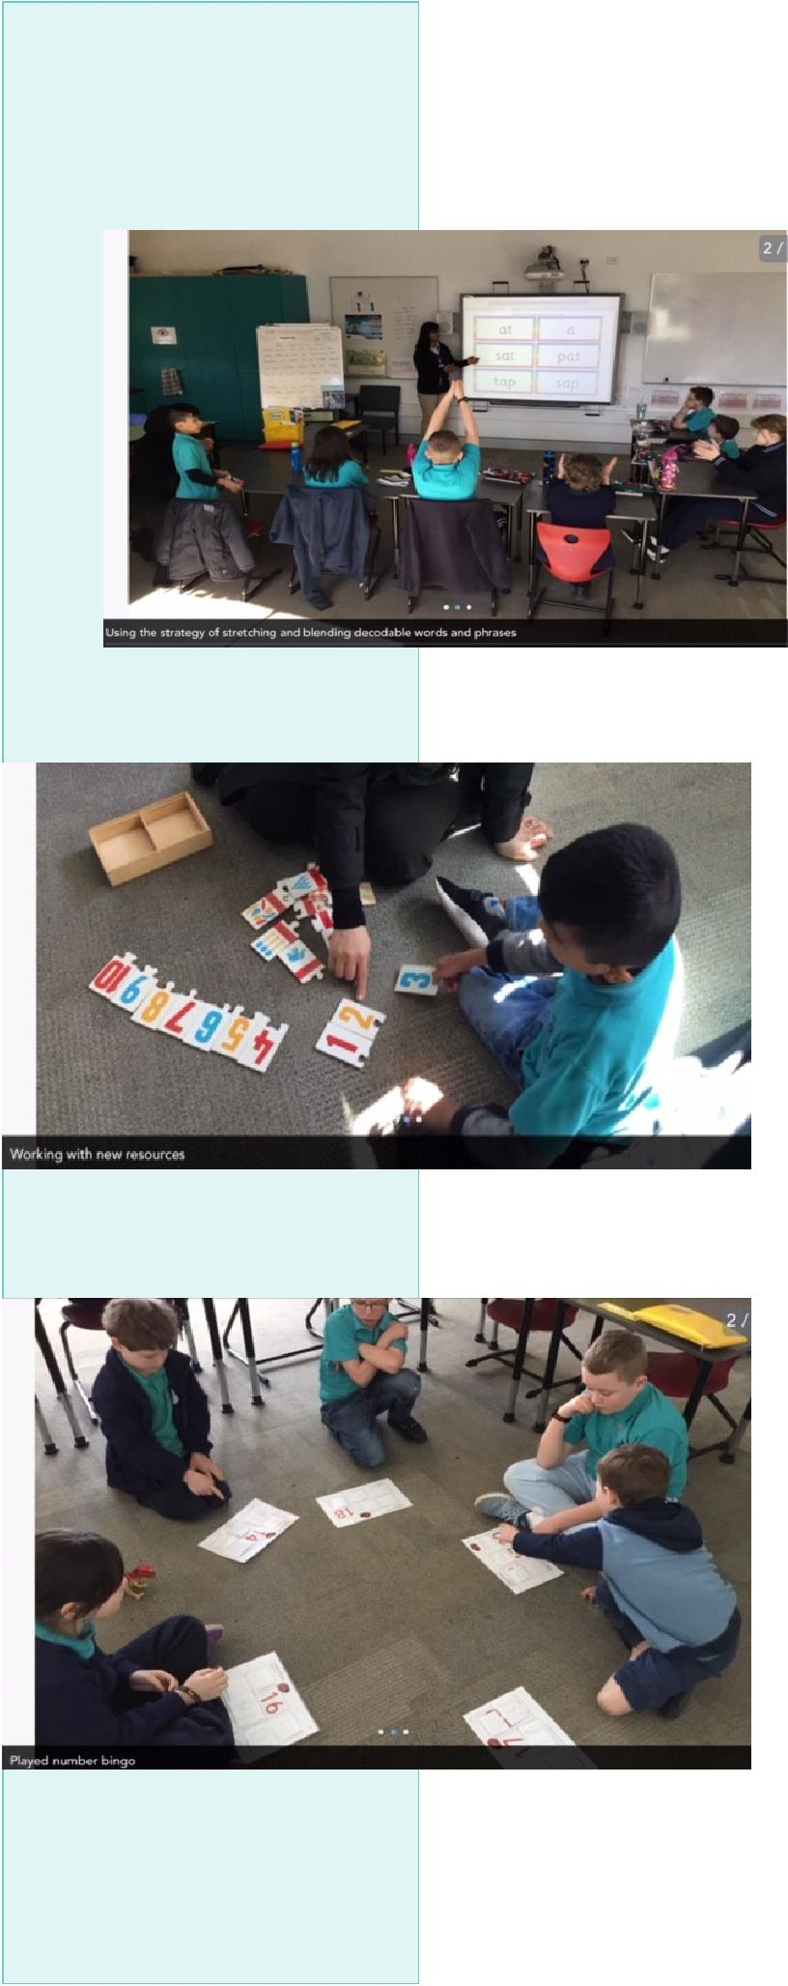
CLASSROOM CELEBRATIONS

LSU
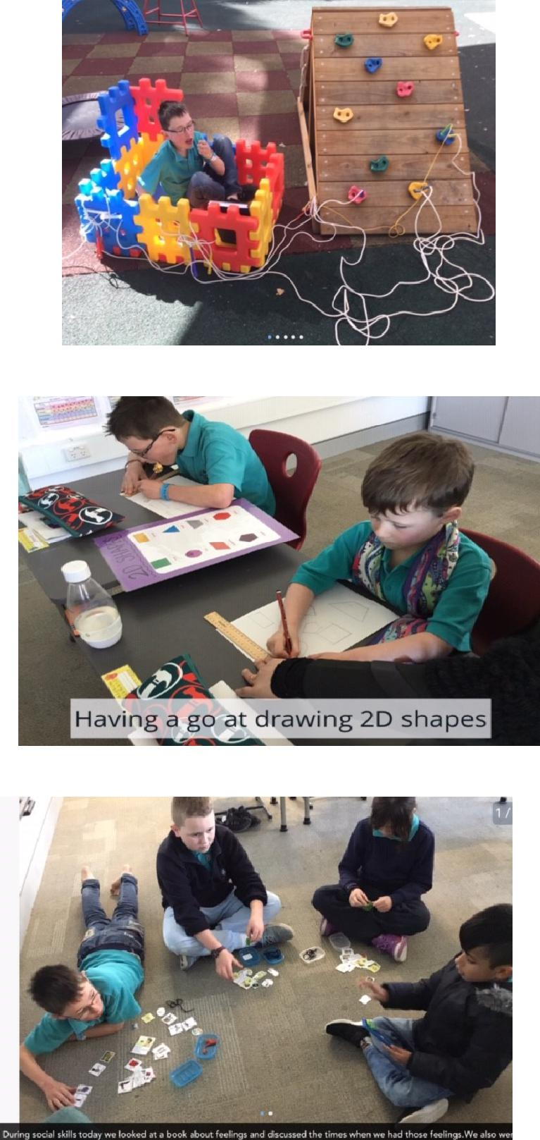

5

PALMERSTON PRIDE

Congratulations to the following students who received a PRIDE Award at assembly.

PARTICIPATION – becoming involved, “having a go” and cooper-ating with others

Amber— KFD | Stanley—KMC | Violet—KMC
Jedd— KGM | Geoge—KGM | Jacqueline—2AF
Rohan—2AF | Chase— 1KW | Ainslie— 2DK
Aynalem— 2DK | Jasmine—2DK | Leila—2DK
Tatam— 2SH | Phone—2SH | Christian—2SH
Victoria—2SH | Emma— 1HD | Madison—2MO
Ralph—KKA | Gurfateh—KKA | Emma—1AS

RESPECT – having respect for self, others and their property

An—KFD | Eric— KGS | Amirali—KGM
Ayush—2Af | Violet—2AF | Matea—1DE
Lachlan—2DK | Grace—KKA | Biar—1AS

INTEGRITY – being honest, fair, responsible and loyal

Jason—1DE

DETERMINATION - being persistent and resilient

Yashvir - KFD Hannah—KGS Sera—KMC

Thomas—2AF Anne—2AF Jasmine—2DK

Elliott—2SH Choden—1HD Jaxon—2MO

Julian—2MO

EMPATHY - understanding and supporting others regardless of our differences

Meer—KGM

6

DEFENCE NEWS

***POSTINGS***

As posting orders arrive please keep me updated with your families plans for relocation or absences e.g. deployment or courses so, I can best support your child/ren at school. Please contact kristy.retzlaff@ed.act.edu.au or Ph: 6142 1440.

Thank-you,

Kristy Retzlaff

Defence School Mentor

DCO KidSMART Program

Commences Thursday 8th August, 3:30 – 5:00pm Defence Community Organisation Ground Floor, 8 Thesiger Crt, Deakin

Details: This event is only for the children of Australian Defence Force members.

The KidSMART program is designed to help primary school aged children manage issues arising from parent deployment and absence from home. It helps children to learn how to manage change, stay connected with friends, meet new people, and coping strategies when they are feeling stressed or anxious and handling different situations.

DCO is offering a four-week program for children aged from 7-10, running on consecutive Thursdays during August for one and a half hours each week (8,15,22,29 August).

Children will be provided with afternoon tea upon arrival. Parents do not need to stay for the ses-sions, but if you would like to remain close by the Mint Café is located across from DCO and is open until 5pm, also Deakin shops are nearby.

When registering, ensure your contact details are accurate. You will receive a booking confirmation via email, and you will be contacted to provide further registration details before the start of the pro-gram.

Please head to the Defence Community Organisation Facebook Page for booking information or alter-natively contact Defence Family Helpline on 1800 624 608. I can also assist you with further infor-mation if you require assistance with bookings at kristy.retzlaff@ed.act.edu.au

7

DEFENCE NEWS CONTINUED

Defence Community Organisation – Coffee Connections

ADF Partners and families in Canberra are invited to join us at our regular coffee group. Come along to this child friendly café and re-lax and chat with other ADF families and meet the DCO Canberra team.

Location: Tulips Café, Beltana Rd Pialligo

Date: Tuesday 6th August 2019

Time: 10:00am – 11:30am
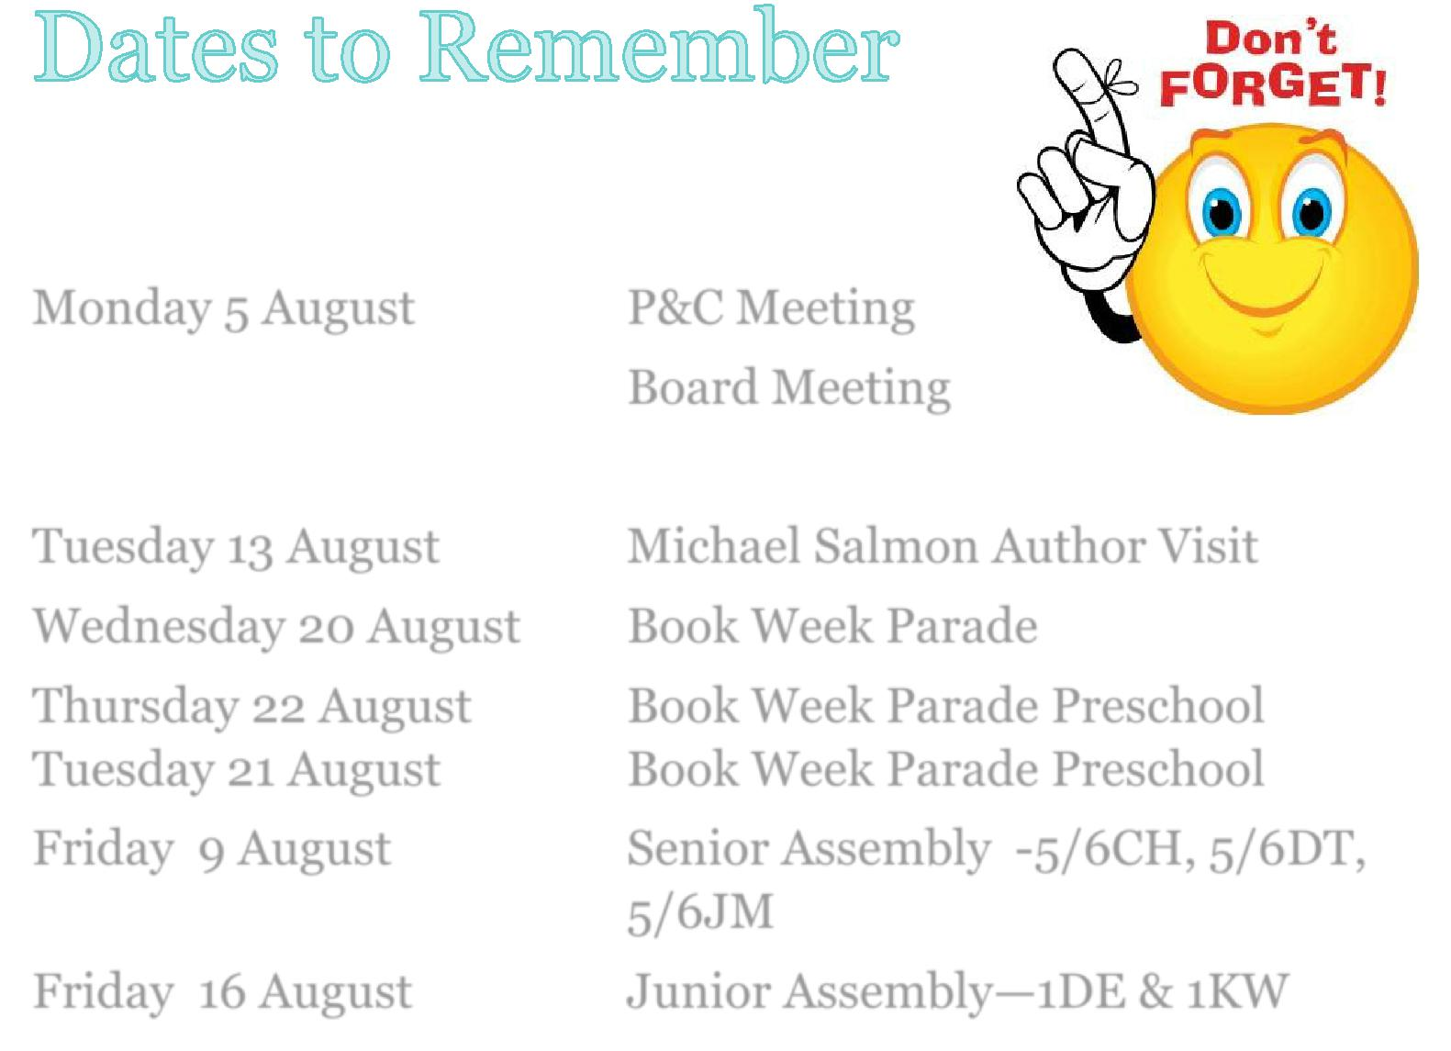

Monday 5 August P&C Meeting

Board Meeting

Tuesday 13 August Michael Salmon Author Visit

Wednesday 20 August Book Week Parade

Thursday 22 August Book Week Parade Preschool

Tuesday 21 August Book Week Parade Preschool

Friday 9 August Senior Assembly -5/6CH, 5/6DT,

5/6JM

Friday 16 August Junior Assembly—1DE & 1KW

8

COMMUNITY CONNECTIONS

Dear Families,

In pursuit of continuous improvement, we’re delighted to an-nounce we have increased our involvement with KindyNow and the KindyNow App. We will now be rolling out the KindyNow App at all of our Out of School Hours Care services. For those that use our long day care centres you would no doubt be famil-iar with the KindyNow App and the benefits it offers, which in-clude: Quickly & easily notifying the program of your child’s ab-sent days. Securing last minute, casual before & after school care bookings, right up to 4hrs before the program is scheduled to begin. Find available vacancies up to two weeks in advance. Families have 24/7 access to the KindyNow App and can perform these actions without having to call or email the Enrolments Team. You can get started today and download the App from the Apple Store at kindynow.com/ios and from the Google Play
Store at kindynow.com/app and begin to notify of absences or

book casual care from Monday 29 July 2019 If you have any questions, please contact the Enrolments Team on 1300 212 273 between 9am and 5pm Monday to Friday.

9

