Palmerston District Primary School acknowledges

the Ngunnawal People,

the traditional owners and custodians of this land.

Palmerston Post

PRINCIPALS MESSAGE

“Empower your dreams with deadlines”

This has been a very important part of my leadership philosophy for several years now and wanted to share with you as the background reason for me asking for your assistance with meeting deadlines. Teachers provide some amazing learning opportunities with excursions to enrich the class learning program, such as Questacon. There are also ‘incursions’ such as this week’s visit by author Michael Salmon – both lovely opportunities for students to experience something that stretches learning outside the classroom. We greatly value these learning opportunities, but we have noticed that deadlines for payment are not being met. Could you please help us be super efficient by adhering to deadlines on the permission note. That way, we have clear understanding of participation before the event. From now on, we are hoping you will help us, and understand any potential consequence if the deadline is missed and the child misses out.

Another deadline I urge as many families to help out is the 2nd September. Every year all ACT public schools undertake a School Satisfaction Survey. This is an excellent opportunity for every family to have their thoughts and feelings represented. I find this data exceptionally important in understanding how you feel about your school, what you enjoy, what you are thankful for, and areas that you deem need a focus for ways to improve. I am acutely keen to find out what every family feels about our school, and acknowledge our strengths, and importantly, let us know where we need to improve. The leadership team will eagerly await this data so that we can plan forwards for 2020 and beyond. Thank you, in advance for spending about 10 minutes to complete the survey.

Science Week has been a success this week. There have been so many rich learning experiences for our students integrating science with artwork, nutrition, geography,

maths, astronomy, literacy and technology.

Our Environmental Science teacher, Ms Campbell, even presented all staff with a special morning tea and brain break with a highly competitive Science Quiz. Mr Tilley came out on top with the most correct answers! I have experienced a truly vibrant vibe around celebrating Science this week --- well done to all students, I am sure you have heard around your dinner table at night, many stories about experiments and investigations undertaken this week.

In 2014, I was lucky enough to represent Australia at the International Educators NASA Space Camp experience for a few weeks in Huntsville , Alabama. During this intensive time, I undertook simulated experiences for astronautical training and it was such an authentic and unreal opportunity that not many folk get to experience, thus, my love for Science deepened. Science is one core component of STEM, and I am really pleased to announce that we have just purchased around 120 new Chromebook devices for our students. While this sounds like a lot of new technology, we desperately need more and for the first time in many years, we are seeking your input for Voluntary Contributions. I presented our case to the School Board a few weeks ago, and have their full support to try and gather some additional finances to purchase more devices that will bring us up to a healthier ration of students to devices. Please see the note coming home from our Board Chair.

Thanks for your support, as always, please feel free to
email me at kate.smith@ed.act.edu.au for any feedback,
I welcome building new connections with you and
hearing your point of
view.

Kate Smith

DATES TO REMEMBER

DEPUTY PRINCIPAL MESSAGE

Please see page 15

Principal:

Kate Smith

Deputy Principals:

Marijana Pasalic Helen Cox

Executive Teachers:

Felicity McNiece Kylie Moller Haeley Simms Kristina Collins

Business Manager:

Sonya Campbell

Office Manager:

Kirsty Brown

Board Chair:

Lisa Fior

P & C President:

Lisa Fior

The K-10 Australian Curriculum that we
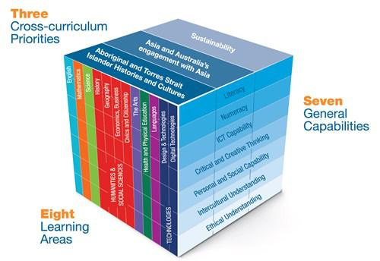
use at Palmerston District Primary School
has a three-dimensional design – eight
discipline-based Learning Areas, seven
General Capabilities as essential 21st cen-
tury skills and three contemporary Cross-
curriculum priorities.
The Learning Areas are:
- English
- Mathematics
- Science

- Humanities and Social Science (comprising History, Geography, Civ-ics and Citizenship and Business and Economics)

- The Arts (comprising Dance, Drama, Media Arts, Music and Visual Arts)
- Languages
- Health and Physical Education

- Technologies (comprising ICT and De-sign and Technology).

The General Capabilities define knowledge, skills, behaviours and disposi-tions that can be developed and applied across the curriculum to help students become successful learners, confident and creative individuals, and active and informed citizens. The
General Capabilities are:
- Literacy
- Numeracy

- Information and communication technology (ICT) capability

  - Critical and creative thinking
  - Ethical behaviour
  - Intercultural understanding
- Personal and social capability.

The Cross-curriculum Priorities are contemporary issues about which young Australians should learn. They are:

- Aboriginal and Torres Strait Islander histories and cultures

- Asia and Australia’s engagement with
Asia
- Sustainability.

As teachers, we are quite familiar with the Learning Areas, within the year levels that we teach, as these are what we report on each semester. We are not as familiar with the other two dimensions. Consequently, for the last four weeks we have been working hard with Central Office personnel to develop our knowledge and understand-ing of the General Capabilities. As a result, our units of work will incorporate these elements, where relevant, to further engage students.

Helen Cox
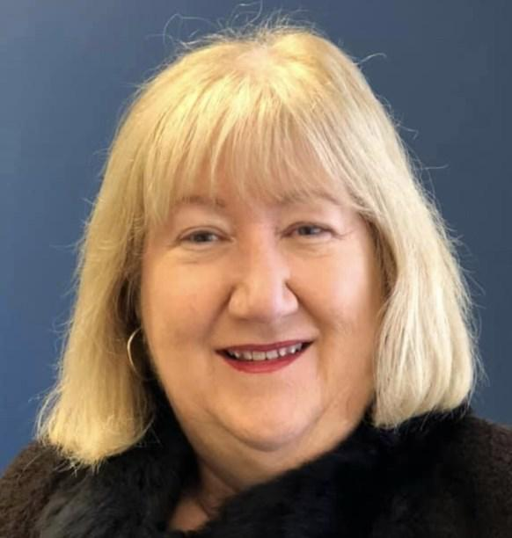

DEPUTY PRINCIPAL MESSAGE

Over the last four weeks I have spent quite a bit of time walking around the play-ground and through busy classes to meet with, and talk to, as many students as I can. I have received lots of warm smiles, friendly hellos and little people cheerfully saying, “welcome to our school!” It has certainly made my heart sing and I wanted to take this opportunity to thank all the staff, students and parents for such a warm welcome to this lovely school community.

Over the past few weeks I have also been very lucky to visit each class to share with them a book called The Dot. The Dot is a picture book written by Peter H. Reynolds that tells the story of a young girl named Vashti who thinks she can’t draw. Her teacher asks Vashti to begin by making a mark on paper and to “see where it takes her”. Feeling encouraged by her teacher Vashti discovers the creative spirit inside her and creates the most magnificent dots you have ever seen. At the end of the story Vashti then inspires a young boy to also try his best and see where it takes him.
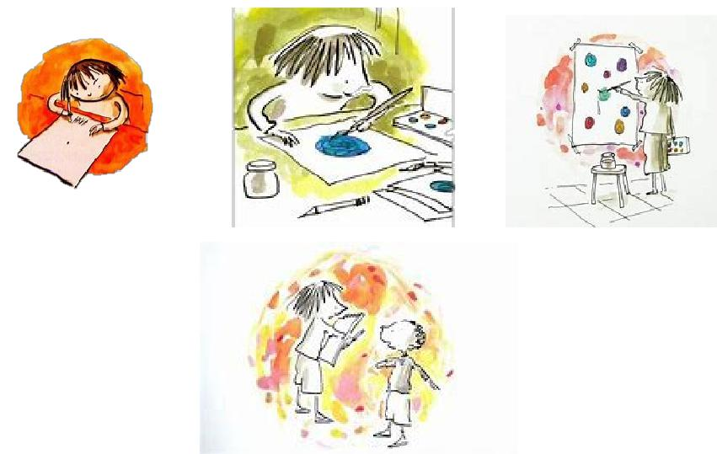

I love this beautiful story for so many reasons. I love that the teacher encouraged and believed in her student, which in turn provided Vashti with the belief in herself that she could be creative and achieve something great. I love that the teacher said such positive things to her student, and that their relationship was so strong. I loved that Vashti had such a strong growth mindset and didn’t give up even when the task seemed too difficult. Finally, quite possibly my favourite part, was when Vashti encouraged another student at the end of the story to do his best and to try. I would love to see these same things continue to be part of the positive school culture at Palmerston District Primary School. Let’s all try harder to be a little nicer, encourage each other and offer support when it is needed.

Please make sure you take time to see the lovely dot display in the office foyer celebrating the creativity of students and the diversity of our wonderful school community. Thank you to all the staff and students for contributing the display. I think it looks so amazing!
Marijana Pasilic

2019 School Satisfaction Survey

Over the next two weeks parents, students (in years 4-6) and teachers are being asked to participate in the 2019 School Satisfaction Survey. A letter and email have been sent home to families this week.

Although the survey is voluntary, we hope you will want to participate. It won’t take much of your time and will help us improve our school for your child and future students. A letter or email about the parent and carer survey have been sent out this week. The key ACT results from the 2018 School Satisfaction Surveys have been published on the Education Directorate website (www.education.act.gov.au) and a summary of our school results is provided in our 2018 School Board Report.

By doing this survey you will help us improve our school for your child and future students. The survey results will also be used in public interest

research projects and longitudinal studies aimed at improving the quality of services in the ACT. No personal information will be provided to any school or college. The survey will take about 5 to 10 minutes to complete and will be open until 2 September 2019.

The survey can be found here: https://acteducation.au1.qualtrics.com/jfe/form/ SV_6LosQ3xQfheARzn

Together WeTogether We Learn From Each Other

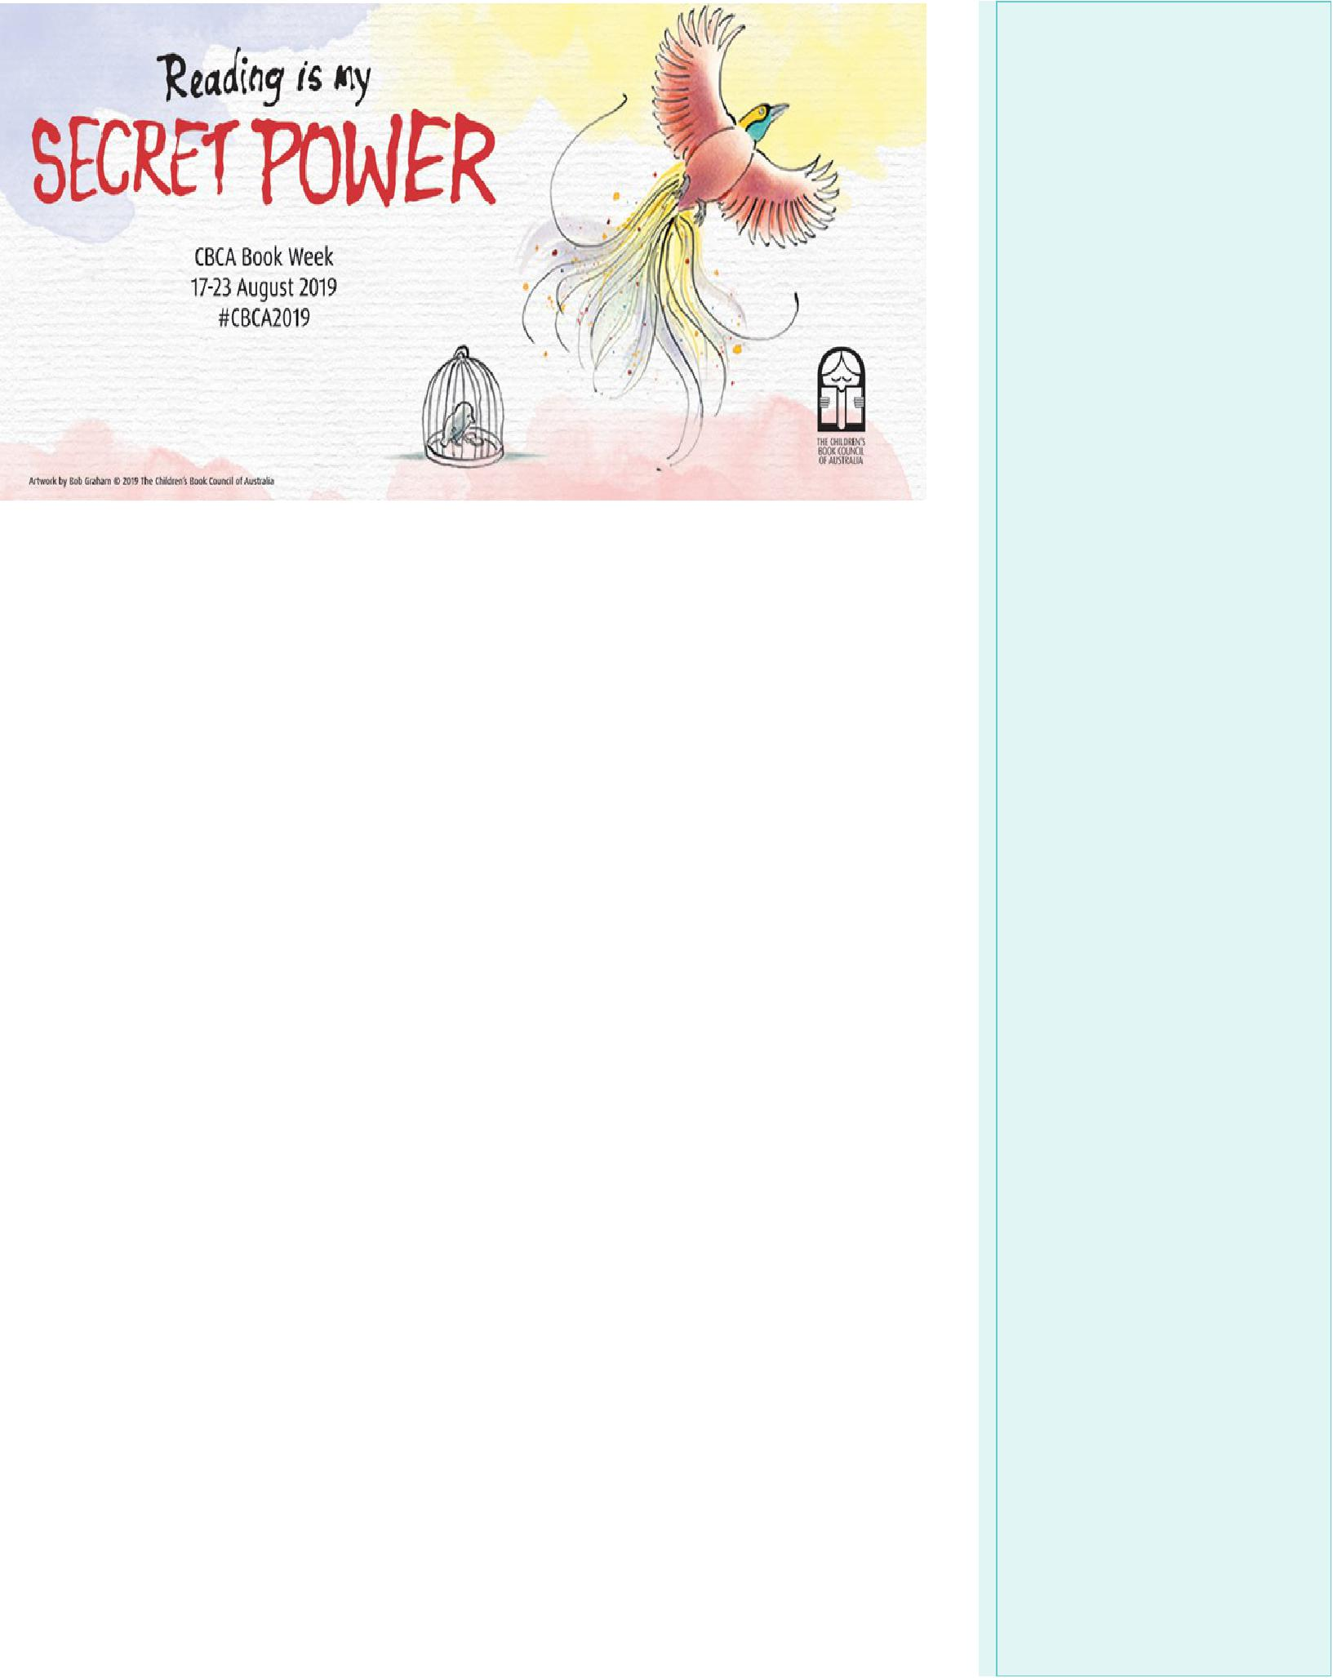

LIBRARY NEWS

This week students across the school were thrilled to hear our vis-iting author Michael Salmon discussing writing and illustrating. Mi-chael is a prolific author and entertaining presenter and students found him very entertaining. Maybe he has inspired some potential authors in our audience?

Don’t forget next week is Book Week!!!!!!
Students in Preschool will be dressing up and parading on Tuesday
and Thursday. Students K-6 are encouraged to come dressed as
their favourite book character on Wednesday. During the week we
will be reading some of the shortlisted books in each category and
undertaking art and literacy activities focussed on these quality
Australian texts. | 5

All P&C activities, meeting agendas and minutes are available from the school website at – Parent Corner

P & C/BOARD NEWS

The P&C are fundraising with the Entertainment book. The Entertainment™ Book is a local restaurant and activity guide which provides hundreds of up to 50% off and 2-for-1 offers from the finest restaurants, cafes, attractions, activities, retailers and hotel accommodation. The Membership entitles buy-ers to exclusive offers that are virtually restriction-free, and is valid through to 1 June 2020!

The Entertainment™ Digital Membership (app) puts all of the value of the Entertainment ™ Book into the customer's smartphone. With 'near me' technology and the ability to show and save using a phone, this is perfect for the person on-the-go, with no card or voucher to present.

You can purchase a book through the front office or download the app via this link

https://www.entertainmentbook.com.au/orderbooks/2487s6
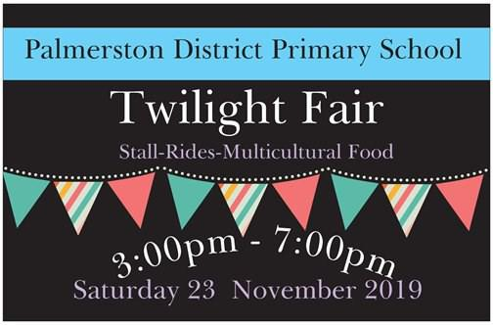

6

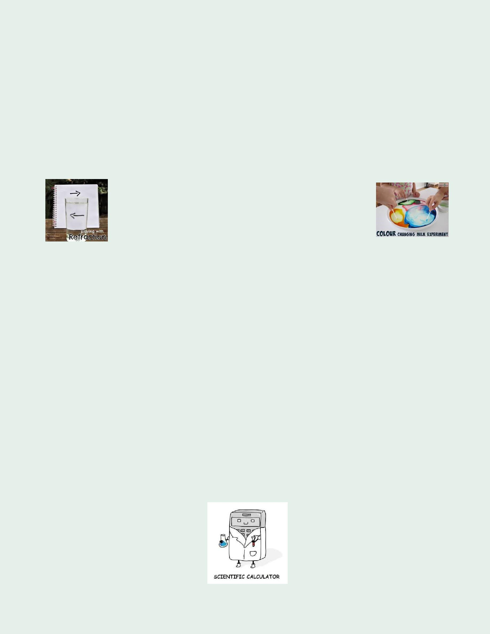
Palmerston District Primary
School Science Fair

September 18-20
2019

SCIENCE IS FUN!

Ask a Question…
What do you wonder about?

The Science Fair is an annual event for Palmerston District Primary students. The idea is for students to have a fun and safe experience conducting a science experiment or researching the answer to a Science question at home. Then showcase their results at the Science Fair Wednesday 18 September - Friday 20 September in the school library.

This year display boards will be a $2 payment for all students who want to participate in the Science Fair. Money will be place in the money spinner as students collect their Science boards next week Tuesday 20 August, Wednesday 21 August and Thursday 22 August afternoons between 3:00 – 3:15pm from the library.

On Friday 20 September students and their families are invited to come and see the projects as part of the learning journey. But you can come anytime between Wednesday 18 September - Friday 20 September.

People’s Choice Award for junior (K-2), middle (3-4) and senior (5-6) students.

Looking forward to seeing lots of entries this year.

Karon Campbell
karon.campbell@ed.act.edu.au

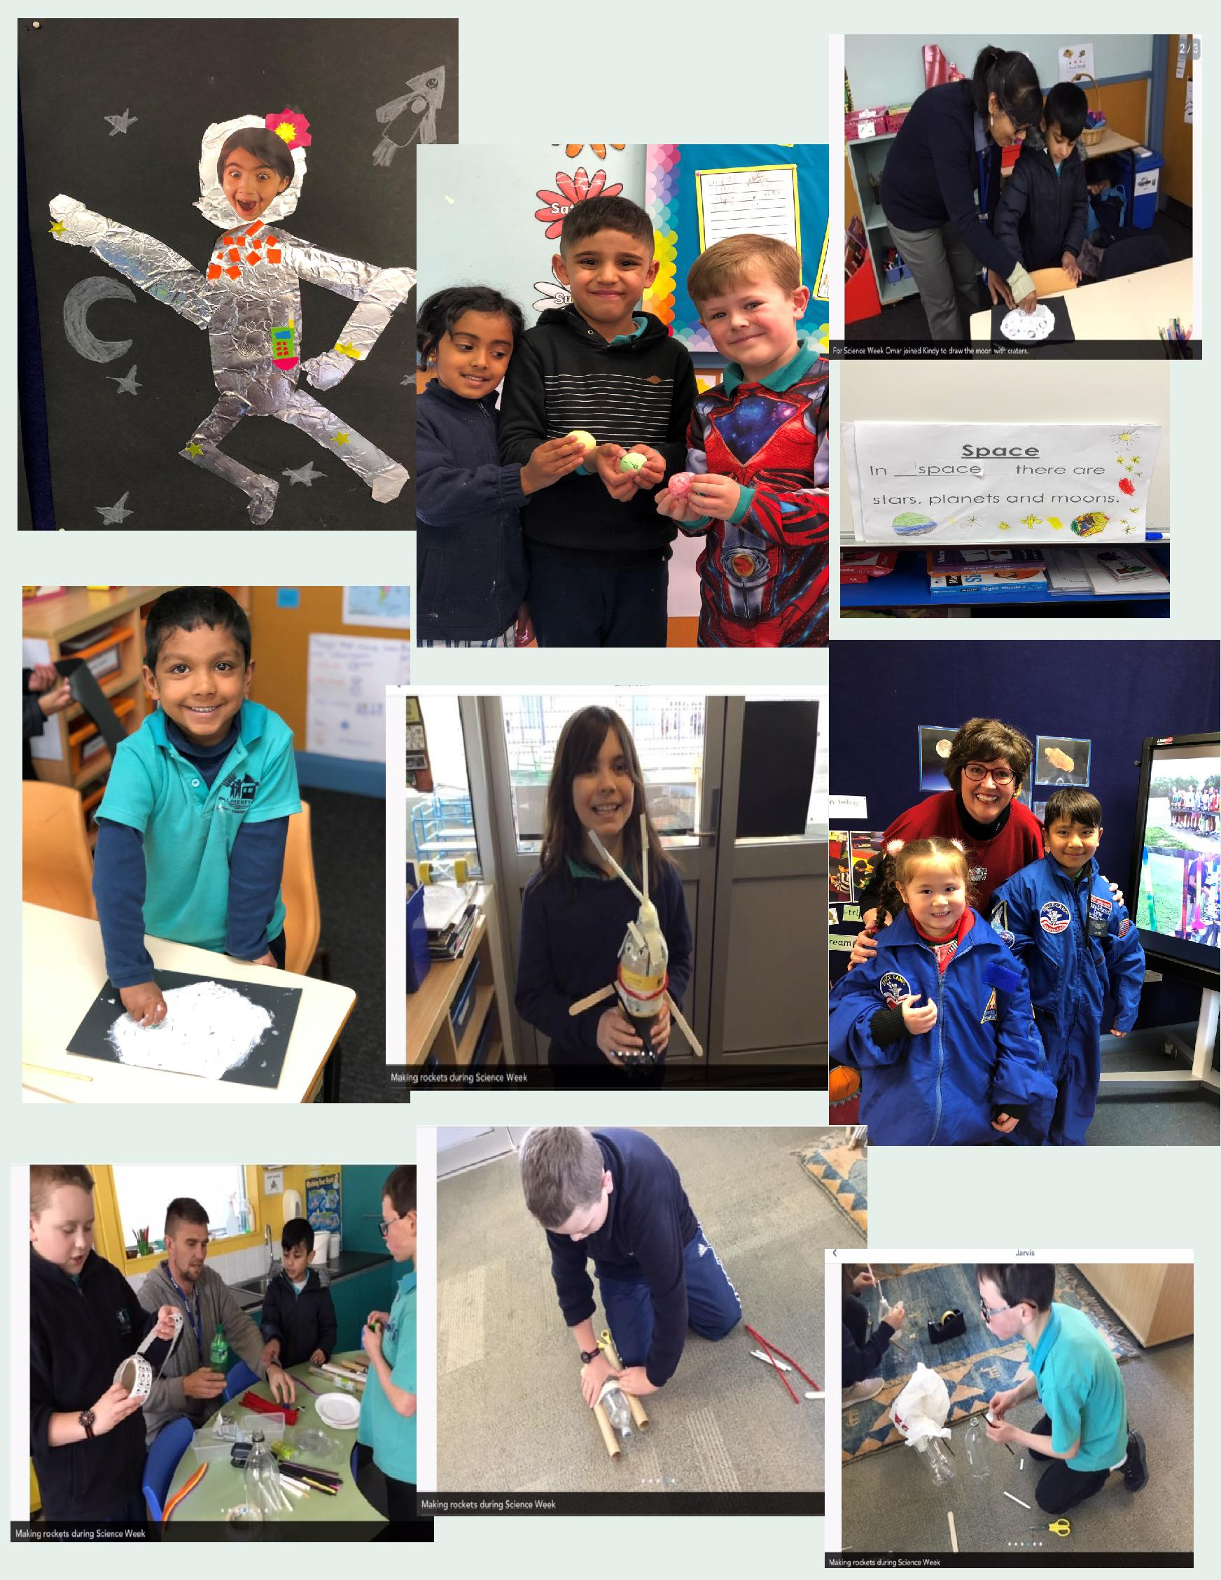
Science Week

CLASSROOM CELEBRATIONS
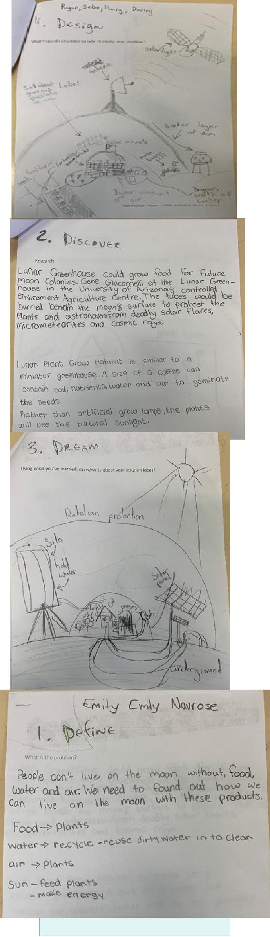

As part of National Science week Year 5/6 CH explored making the impossible possible by Investigating what would be required to establish a base on the moon. We explored the three elements needed for sur-vival; food, water and air and brainstormed and researched ideas of how these could exist on the moon. Students in teams designed and created models of moon bases with all the support systems to enable that base to survive.
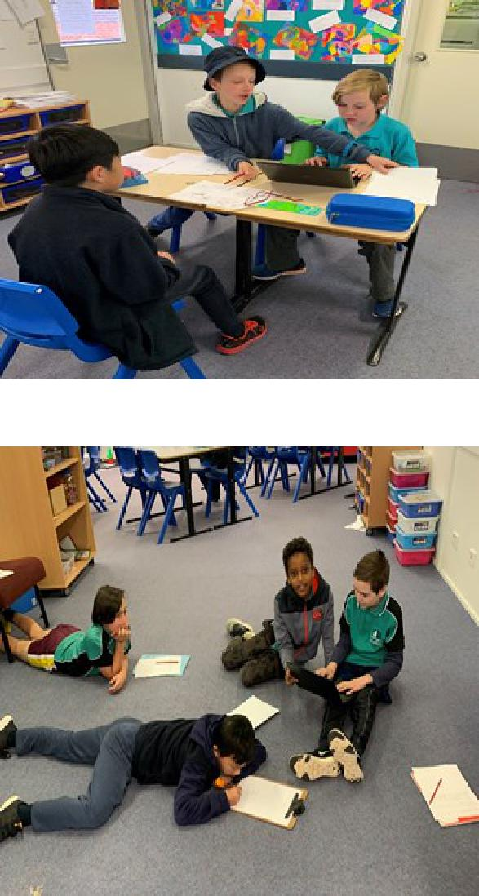

5/6CH

Science
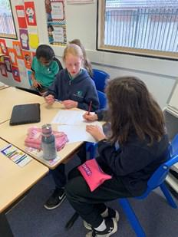

Week

9

SCIENCE WEEK
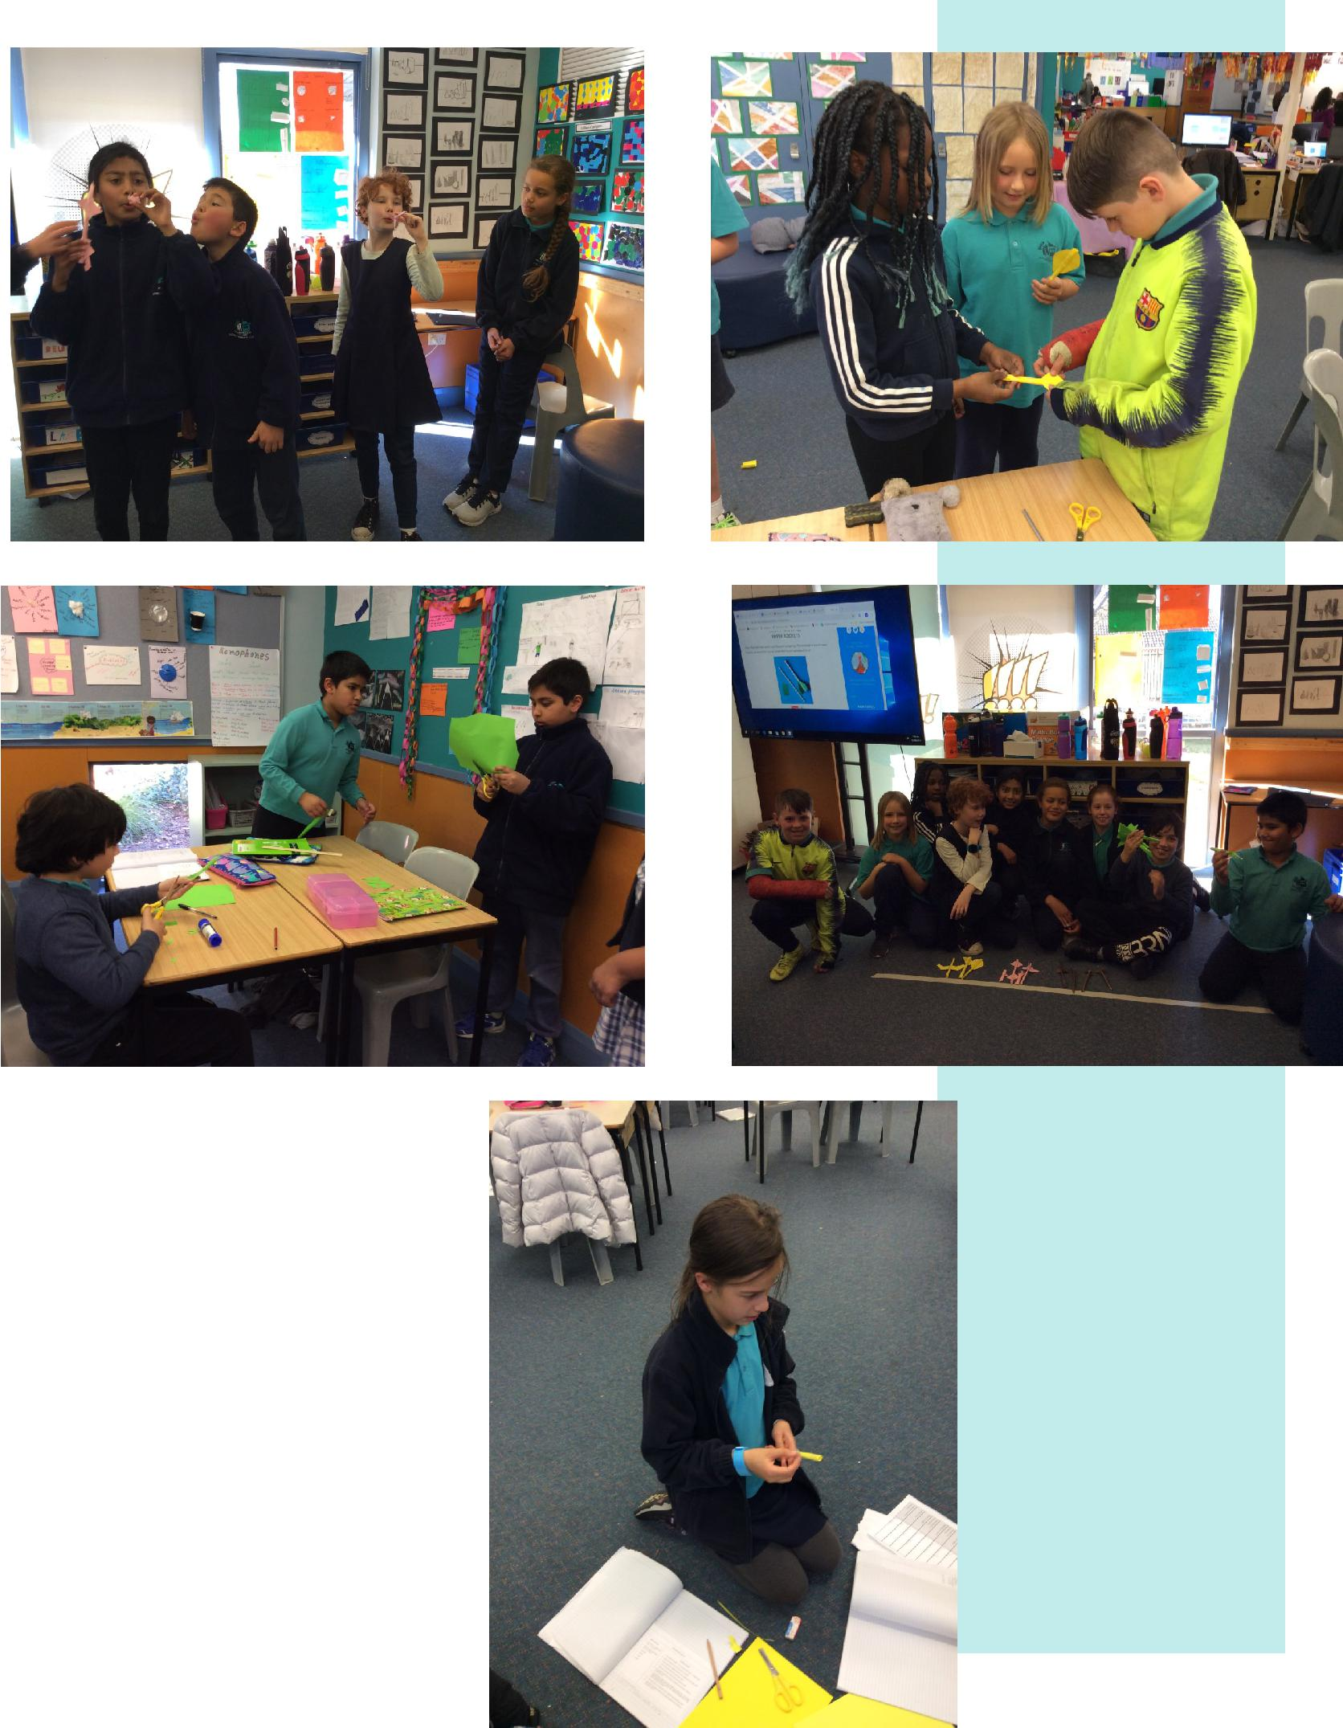

The science week challenge for Year 4 students was to make a rocket that can trav-el the furthest with one puff of air. They explored differ-ent variables such as length and width of the rocket, weight of the rocket, size, shape and number of fins on the wings and investigated what combination makes it go further.

Year

4

PALMERSTON PRIDE

Congratulations to the following students who received a PRIDE Award at assembly.

PARTICIPATION – becoming involved, “having a go” and cooper-ating with others

Jasmine - 2DK | Agam—3AJ | Aastha—KGM
Owen—KGM | Isabel— 2SH | Antoinette— 2DK
Stephanie— 2DK | Zandar - 2DK | Gunav—1HD
Oscar—1HD | Artie— KMC | Zayaan— 1DE
Rayan—1DE | Naeva— 2MO | Rohan—2AF
Matthew—KFD | Meryl— KGS | Delaney—KGS
Olu—KGS | Christian—KGS | Karina—KKA
Louis—KKA | Chanyai— 1KW | Lucia—1KW
Braxton— 1KW

RESPECT – having respect for self, others and their property

Amirali—KGM

Yan Shin—KGM

Zandar—2DK

Alyce— 1AS

Chloe—KFD

Cooper— kGS

INTEGRITY – being honest, fair, responsible and loyal Garv— 1DE Hamish—2AF

DETERMINATION - being persistent and resilient

Jasmine—2DK | Elliott—2SH | Jaliyah 4VS
Max— 2SH | Leila— 2DK | Aaliyah—1AS
Veer— KMC | Jazz— KMC | Imogen—2MO
Christina—2AF | Jasmine— 1KW | Viraj—KFD

EMPATHY - understanding and supporting others regardless of our differences

Aidan Marshall—KGM Isabel—2SH Stella—2AF

11

Environmental Science News

Students participating in the Environmental Science Program with Mrs Campbell have been cooking with fresh foods. Some of these foods have been sourced from the school kitchen garden - lettuce, silverbeet, parsley, garlic, mint and eggs from the happy chickens; and others from local gardens including limes, parsley and mint.

The recipes have been well received and students have enjoyed the fresh tastes leaving them asking for more. It has been a positive experience to see how responsibly the students participate in food preparation, cleaning up and appreciating freshly cooked foods with fresh ingredients.

Karon Campbell

Environmental Science Teacher

Silverbeet and Cheese Fritters

Ingredients

Oil for frying

Silverbeet – 1 bunch

Garlic – 1 clove

Brown onion -1

Spring onion – 1

Parsley – small bunch

Mint – small bunch

Lemon 1 – zest and juice

Plain flour – 1 cup

Cheese – 250 grams - grated

Eggs – 2

Salt and pepper to taste

Method

Step 1

Finely chop: silverbeet, garlic, brown onion, spring onion, parsley and mint and place into large bowl and mix

Step 2

Grate cheese, squeeze and zest lemon add to l arge bowl – mix

Step 3

Whisk eggs in small bowl and then add to large bowl mix thoroughly

Step 4

Add salt and pepper to taste

Step 5

Fry in oil until golden brown

Step 6

Serve with lemon wedge or sweet chilli sauce

Environmental Science News

San Choy Bau

Ingredients

Lettuce leaves

Vegetable oil – 1 tablespoon

Garlic – 2 cloves finely chopped

Ginger – 2cm piece grated

Parsley – small bunch – finely chopped

Celery leaves – finely chopped

Brown onion -1 finely chopped

Spring onion – 2 thinly sliced

Chicken mince- 300 grams

Soy sauce – 1 tablespoon

Hoisin sauce – 2 tablespoons

Lime -1 juiced

Water chestnuts- ¼ cup finely chopped

Celery – chopped finely

Carrots - grated

Rice Noodles- 1 square soaked in hot water

Coriander- ¼ cup fresh leaves- roughly chopped for topping

Mint – 1 small bunch – finely chopped – for topping

Optional: fresh red chilli finely chopped and /or sweet chilli sauce

– for topping

Method

Step 1

Wash lettuce leaves, pat dry and prepare leaves on a tray.

Step 2

Heat wok or frypan. Add oil and fry garlic, ginger, pars-ley, celery leaves, brown and spring onion. Add chicken mince and fry until mince changes colour.

Break up chicken mince into small pieces.

Step 3

Add soy sauce, hoisin sauce, lime juice, celery, carrot and water chestnuts and fry until all combined

Step 4

Stir noodles through the chicken mix. Break into small pieces

Step 5

Spoon chicken and noodle mix into lettuce leaves. Sprin-kle with coriander and mint leaves before serving. Add / fresh chilli or sweet chilli sauce - optional

DEFENCE NEWS

***POSTINGS***

As posting orders arrive please keep me updated with your families plans for relocation or absences e.g.
deployment or courses. So, I can best support your child/ren at school.

Please contact kristy.retzlaff@ed.act.edu.au or Ph: 6142 1440.

Thank-you,

Kristy Retzlaff

Defence School Mentor

Market Day Mufti Day Fundraiser

On Friday 30th of August, there will be whole school mufti casual clothes day to raise money to purchase supplies needed for the Year 5/6 Market Day later this term. The 5/6 students and teachers would appreciate if students could dress up in appropriate casual clothes and footwear and bring in a gold coin donation.

Your help is very much appreciated

The 5/6 Team

14

Book Club News

Unclaimed Book Club – I am still holding an order from last term. It was for 2 items. The order included the correct amount of cash $38 (but no name or contact details).

If you are missing 2 items then please contact the front office to collect.

Issue 5 of Book Club has now closed and all books should be distributed to classes shortly.

Thanks

Edwina

Dates to Remember

Tuesday 20 August Wednesday 21 August Thursday 22 August Friday 23 August Friday 23 August Monday 26 August Tuesday 27 August Thursday 29 August Friday 30 August Friday 30 August

Book Week Parade—

Preschool

Book Week Parade—

K—6 9.15am

Book Week Parade—Preschool

Buswash— Hungry Bears

Senior Assembly - 3/4DJ & 4MG

Buswash—Itchy Bears

Buswash—Noisy & Brave Bears

Buswash—Cranky & Sleepy Bears

Fathers Day Breakfast

Market Day Mufti Day Fundraiser

COMMUNITY CONNECTIONS

Together WeTogether We Learn From Each Other

