Palmerston Post

10 May 2018

Week 2, Term 2

Board Chair: Lisa Fior Board Members: Parent Reps: Jesse Dang and George Villaflor

Teacher Reps: Jessica Lago and Maxine Green

P&C President: Lisa Fior

Principal: Kate Flynn (acting) Deputy Principal: Haeley Simms (acting)

Executive Teachers: Kylie Moller, Jacqui Warden, Matt Gowen, Catherine Griffin (acting)

ASSEMBLY:
11 May | Mother’s Day Concert
18 May | Junior - 1HD & 1AE
25 May | Senior - Yr5
DATES TO REMEMBER:
11 May | P/S Mother’s Day -
 | Stay & Play
11 May | K-6 Mother’s Day
 | Concert & Stall
14-16 May | Yr5/6 Camp
16-17 May | NAPLAN
21-24 May | NAPLAN
25 May | Yr1 Canberra Theatre
 | Excursion
29 May | Yr1/2 Author Visit

NOTES HOME:

- Yr 1 - Canberra Theatre Excursion

- Yr 5/6 Camp Reminder

- Yr 5/6 Tournament of Minds

- Yr 1/2 Author Visit

- IEC walking excursion

P&C BOARD NEWS P&C: 7:30pm 14 May 2018

All P&C activities, meeting agendas and minutes are available from the School website at – Parent Corner

School Board: 7:30am 21 June 2018

* please note the change of dates

DEPUTY PRINCIPAL’S MESSAGE

Dear Parents and Carers,

Welcome to week 2. This week has started to become colder and I take this opportunity to remind students to dress warmly and make sure they label all of their jumpers and jackets.

Last week we held our annual ANZAC assembly. I would like to thank Kristy Retzlaff our Defence Transition Assistant for overseeing this important event. During the assembly the students, teachers and community reflected on the sacrifice of our service men and women throughout Australia’s history. The children sang beautifully. Thank you to Mr Shaw who has been working with classes practising the special song for this assembly.

This week at Palmerston the students have been excitedly preparing for the Mother’s Day concert/morning tea/stall on Friday. I hope all of the dads and significant others are cooking up a storm for our morning tea. We look forward to seeing lots of mothers and carers there. Just drop it into the canteen tomorrow. Students who have brought in a gift for our Mother’s Day Stall will be able to choose a gift tomorrow, they just need to remember to bring their $2 in. Thank you to Miss Griffin who has been working hard on all of our Mother’s Day preparations.

On Tuesday and Wednesday of this week we have had Chris Killey (our spelling expert) working with teachers and students to implement Palmerston’s whole school approach to spelling. Chris brings enthusiasm for spelling and when Chris teaches a spelling lesson all of the students in the class end up with big smiles on their faces.

Next week and in week four our year three and five students will commence NAPLAN. This is the first year that NAPLAN will be online with the exception of year 3 writing. Can I remind parents they can assist their children by ensuring they get a good night’s sleep and a

Together, we learn from each other

Palmerston Post Page 2

healthy breakfast, before each assessment. In this weeks newsletter I have included a timetable of what dates these asessements will be on. It is important for parents to remember that NAPLAN provides information about your child for a specific point in time, it does not provide all of the information about your child’s literacy and numeracy. Keeping this in mind, students should try and see NAPLAN as a learning experience to gain experience in test conditions. Please contact me if you have any questions about this.

Our year 5/6 students will be going on their camp on Monday. A reminder to make sure you are here nice and early for the bus. Please see your child’s teacher or Mr Gowen if you have any questions. Attached to the newsletter this week are Palmerston Traffic management guidelines. This includes a guide to where it is legal and illegal to park in the surrounding streets of Palmerston. I would like to thank parents/carers for driving carefully in our carpark and looking out for our students on the three crossings. There has been a noticeable improvement in the flow of traffic. Our additional car park should be completed in the next two weeks. Once completed teachers will park here, which will free up spaces in the main carpark.

Have a great week,

Haeley Simms

YEAR 3/4 NEWS

Basketball Clinics

In Term 1 students participated in basketball clinics facilitated by ACT Basketball. During these clinics students practiced passing, catching, ball dribbling and shooting baskets. These skills were taught in the first three clinics and in the final session they played a game of basketball to showcase their skills.

Birrigai Day Camp

During week 9 term 1, students travelled to Tidbinbilla Nature Reserve to attend Birrigai day camp. Throughout the day students engaged in various activities such as giant swing, crate climbing, team trek and obstacle courses. The activities required students to work together, problem solve and communicate positively to complete the activities. Students were enthusiastically engaged all day and talked excitedly on the way home about their camp!
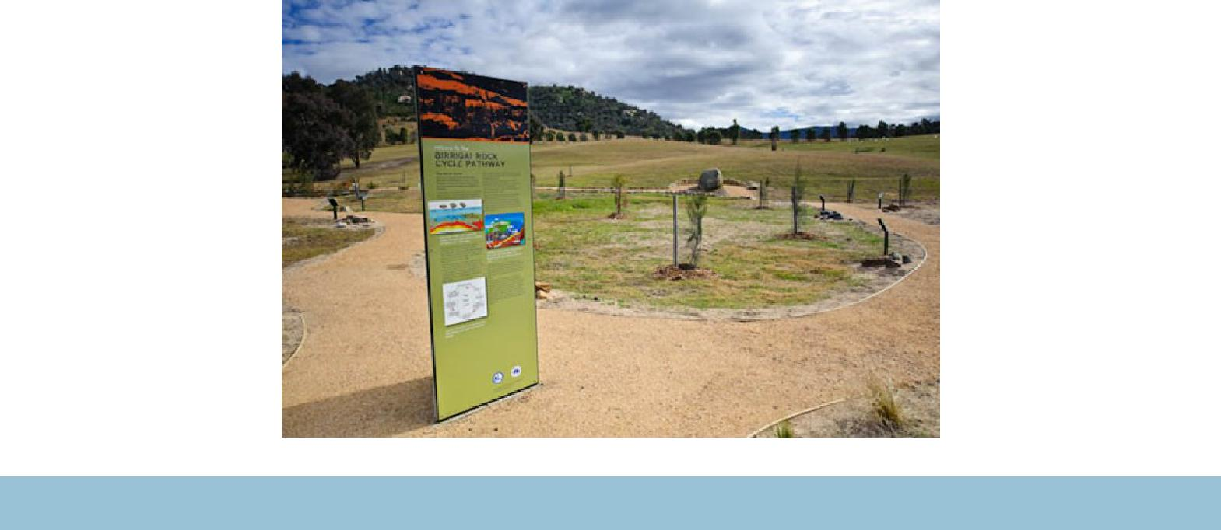

Together, we learn from each other

Palmerston Post Page 3

UPCOMING EVENTS

Mother’s Day Celebrations

Date: Friday 11 May - Cranky, Hungry & Sleepy, K-6

Location: Palmerston District Primary School

Year 5/6 Camp

Date: 14 - 16 May 2018

Location: Borambola, NSW

National Walk to School Day

Date: Friday 18 May 2018

Year 1 Canberra Theatre Excursion ‘Yo Diddle Diddle’

Date: Friday 25 May 2018

Location: Canberra Theatre

Year 1/2 Author Visit - Dr Cameron Stelzer

Date: Tuesday 29 May 2018

Location: Palmerston District Primary School

North/Gungahlin Cross Country

Date: Wednesday 30 May 2018

Location: Palmerston District Primary School

CULTURAL INTERGIRY AT PALMERSTON

WHAT IS CULTURAL INTEGRITY?

Cultural Integrity describes the environment a school creates to support Aboriginal and Torres Strait Islander students, and to welcome and engage their families and communities. Every school’s story and community is unique, so Cultural Integrity will mean something different to each school.
The whole school community will benefit from greater levels of Cultural Integrity, with Aboriginal and Torres Strait Islander perspectives embedded throughout teaching and learning, and into the physical school environment.

GREATER CULTURAL INTEGRITY HELPS EVERYONE

By building Cultural Integrity in all schools, the ACT is growing richer, more engaging learning environments for all Aboriginal and Torres Strait Islander students, and for the whole school community.

WHAT’S NEW?

This year Palmerston District Primary School has established a Cultural Integrity Working Party. The aim of this is to create an environment of high expectations for our students and our school by identifying and achieving priorities for building Cultural Integrity. The working party meets each Wednesday afternoon at 4:30pm. We would love for interested members of our community to join this working party to guide our direction with Aboriginal and Torres Strait Islander understandings and engagement. If you would like to be part of the working party, or contribute to our knowledge by consultation, please contact Kate Flynn or Karon Campbell on 6142 1440 (or drop by the front office).

Together, we learn from each other

Palmerston Post Page 4

PRESCHOOL 2019 INFORMATION SESSION

An information session will be held for parents of preschool children entering preschool in 2019. The session will be held at 5pm in the Library at Palmerston District Primary School on Wednesday 30 May 2018. After the session you will be welcome to walk through the preschool classrooms to see the learning spaces.

Children must turn four years old by 30 April 2019 to be eligible for enrolment into preschool for the 2019 school year.

To register your interest for the session please call 6142 1440.

Come and tour the preschool facilities of the school and speak with current staff. Tours will be conducted during May on Mondays and Fridays at 9:30 to 10:00am. Book a tour of the preschool by calling the school on 6142 1440.

VOLUNTEERS WANTED

If you can spare some time, the library staff would love your assistance. Please drop in the library anytime on Thursdays.

Thank you,

Noreen Pidgeon & Eleni Velanis

NAPLAN

During week 3 & 4 our students in year 3 & 5 will be completing NAPLAN. Please find below the schedule for completing the tests.

If you have any questions please contact Haeley Simms via the front office.

Monday 14 May |  |  | Tuesday 15 May | Wednesday 16 May | Thursday 17 May
 |  |  | Year 3 Writing | Year 3 Reading | Year 5 Writing
 |  |  |  | Year 3 Language Conven- | Year 3 Numeracy
 |  |  |  | tions
Monday 21 May |  |  | Tuesday 22 May | Wednesday 23 May | Thursday 24 May
Year 5 Reading |  |  | Year 5 Numeracy | Catch up Assessment | Catch up Assessment
Year 5 Language Conventions
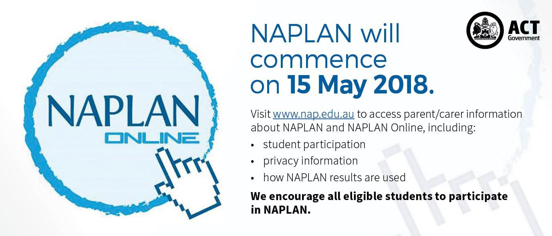

Together, we learn from each other

Palmerston Post Page 5

P&C NEWS

Book Club :

Everyone should have received their catalogues this week.

Issue 3 closes Friday 18 May (week 3).

Reminder: we accept cash/cheques by completing the form on the back page with all of the students details and placing in a sealed envelope/bag into the ‘Boomerang’ box located in the front office

foyer.

Otherwise, if you wish to order using a credit card then please

Visit www.scholastic.com.au/LOOP (or download the APP from the App store)

For a quick start, just click on ORDER in the top menu or REGISTER first to save your details for next time

- Select your school and your child’s class

- Add your child’s first name and last initial (so the school knows who the book is for)

- Enter the item number from the Book Club catalogue

- You can order for multiple children at once if they attend the same school

- All orders are linked directly to the school for submission to Scholastic. Books will still be delivered to your child’s classroom if you order by the close date

- There’s no need to return paper order forms or payment receipt details to your school!

Once the catalogues closes, it can then take up to 2 weeks to receive your order.

PBL@Palmerston

At Palmerston we are excited to continue our journey into Positive Behaviour for Learning (PBL). PBL is an evidence-based, school-wide approach that supports student behaviour to improve social and academic outcomes for all students. Our PBL team consists of teachers from all areas of our school, preschool to year 6. The PBL team will be working with the community this term to refine a framework outlining our school’s expectations for Safe, Respectful Learners, through the use of positive statements.

Together, we learn from each other

Palmerston Post Page 6
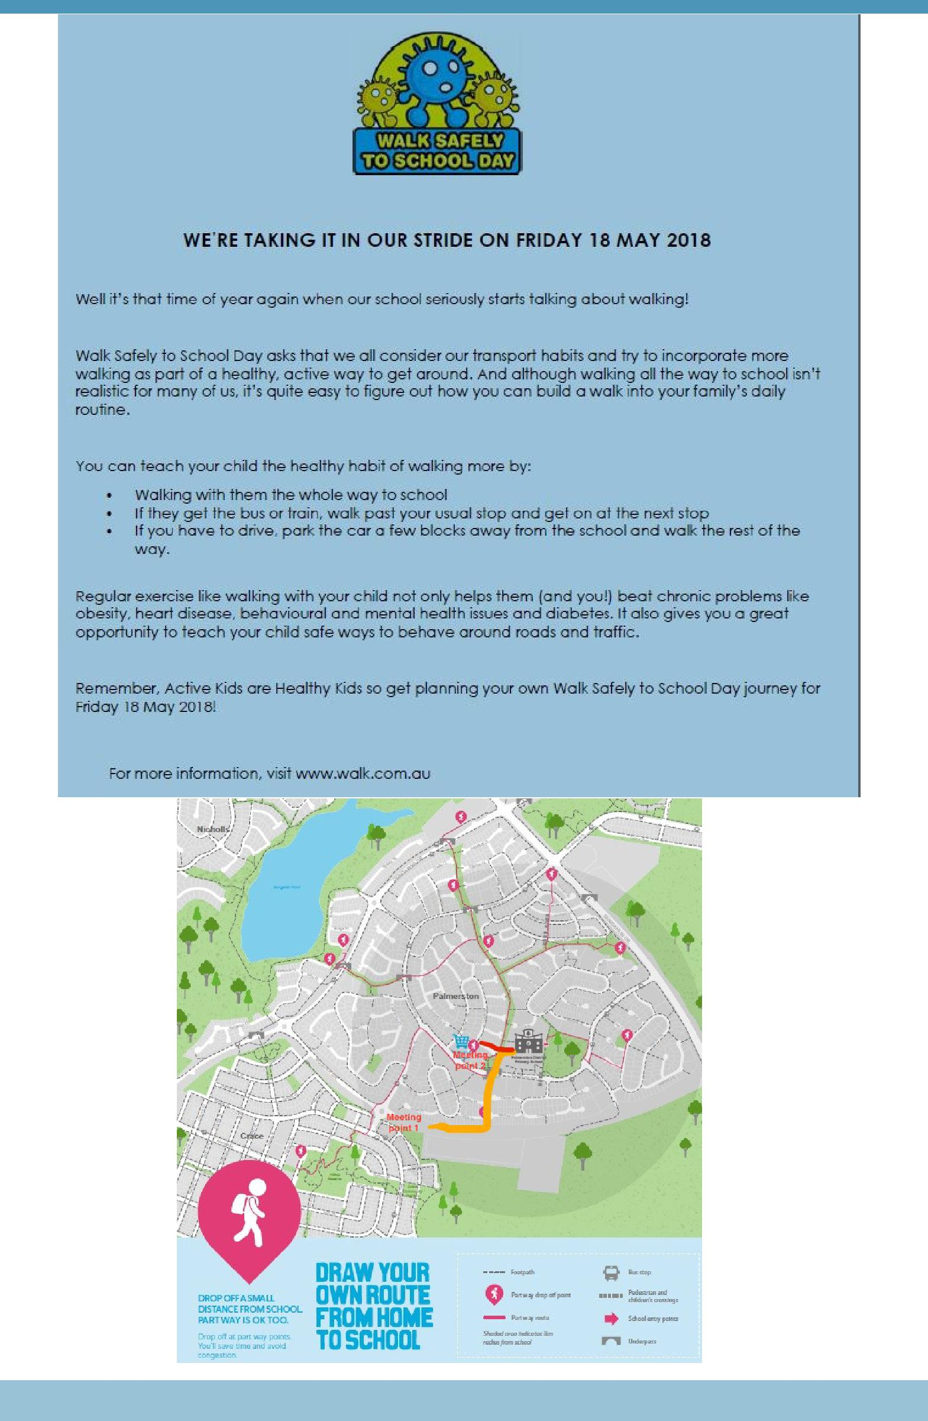

Together, we learn from each other

Palmerston Post Page 7

Year 7 School Open Days 2019
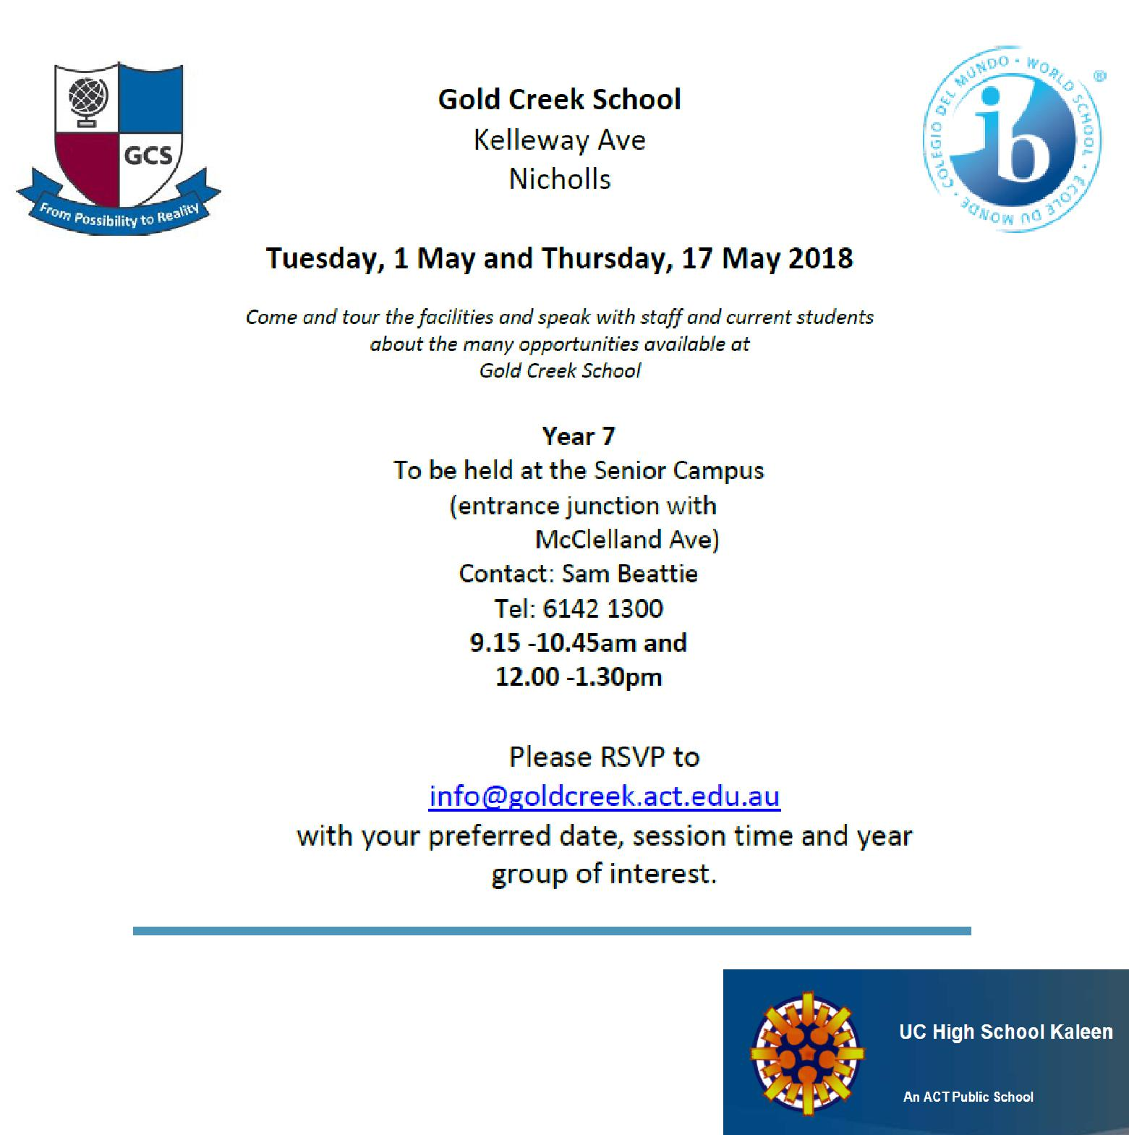

Kaleen High School

Tuesday 15 May 2018

6:00 – 8:00pm in the Library

On the evening of the 15 May from 6-8pm we will be opening

our school to the community for our annual Open Night. This is a fantastic evening for families to attend as they research which high school well best suit the needs of their child. The evening highlights the many wonderful opportunities on offer at UCHSK as well demonstrating exactly how we fulfil our mission of doing whatever it takes to ensure high levels of learning in every student.

Together, we learn from each other

Palmerston Post Page 8
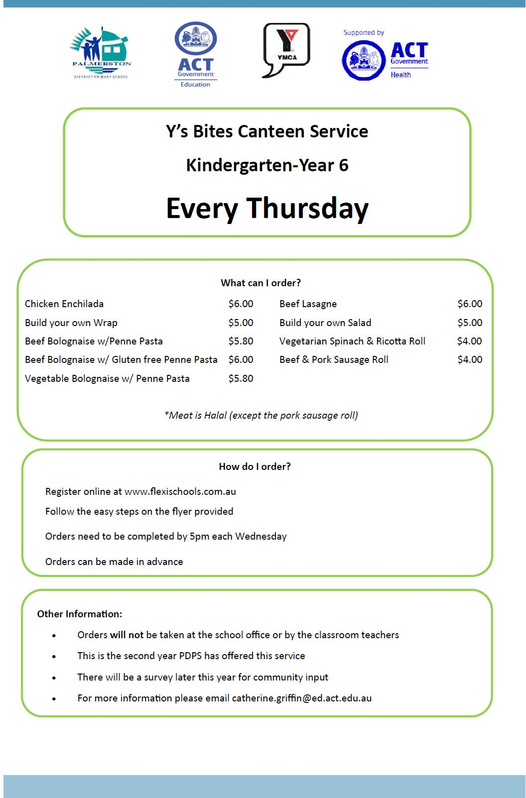

Together, we learn from each other

Palmerston Post Page 9

Together, we learn from each other

Palmerston Post Page 10

COMMUNITY NEWS

Together, we learn from each other

Palmerston Post Page 11
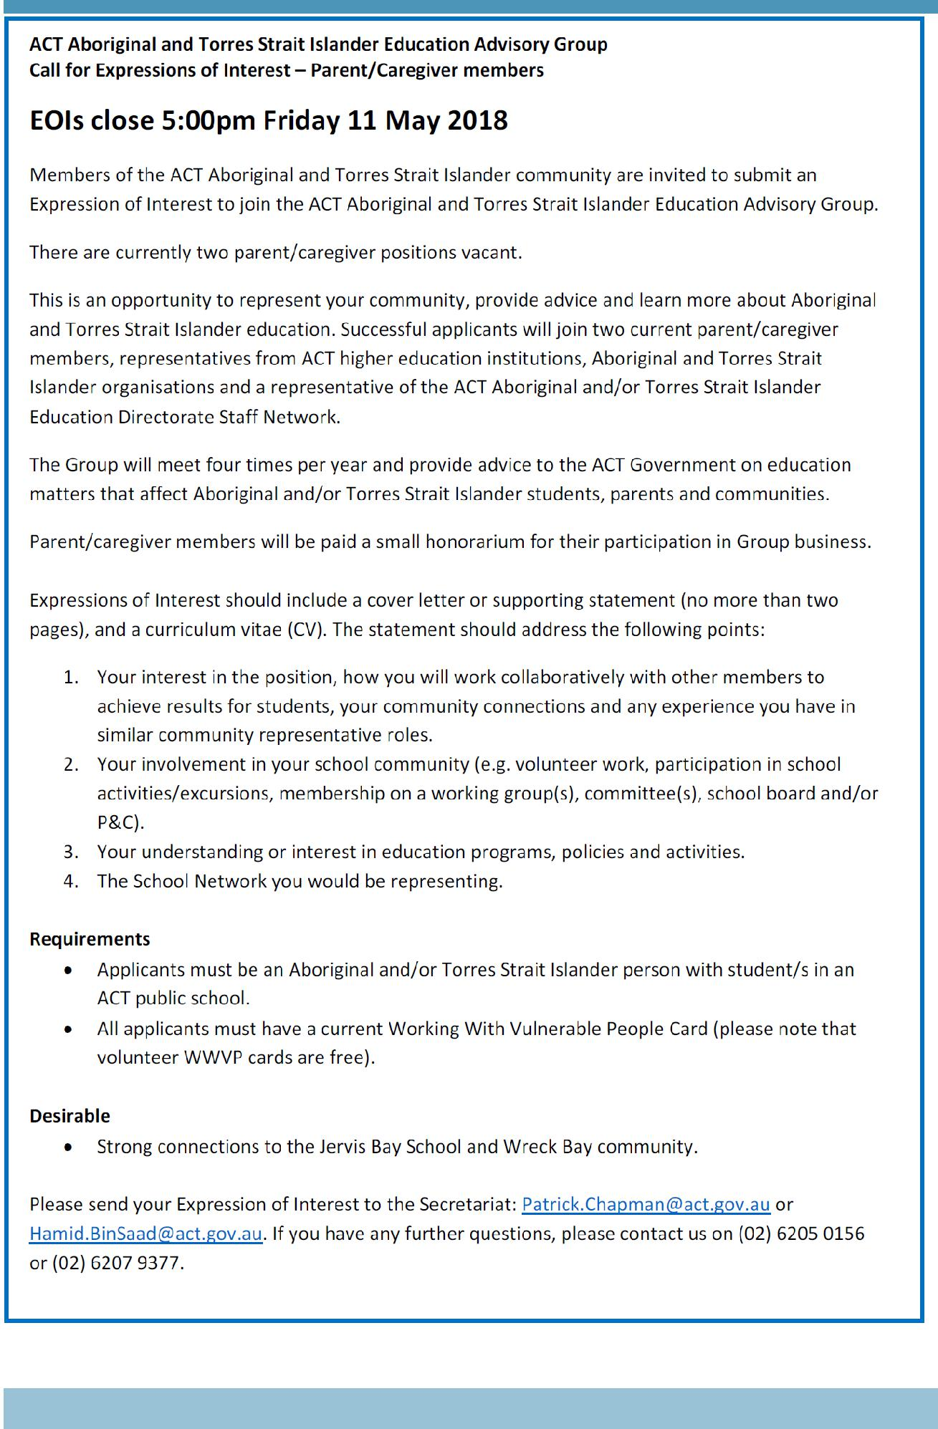

Together, we learn from each other

