What’s On

17 May 2018

Week 3, Term 2

ASSEMBLY:
18 May | Junior - 1HD & 1AE
25 May | Senior - Yr5
1 Jun | Junior—2EG & 2LM
DATES TO REMEMBER:
21-24 May | NAPLAN
25 May | Yr1 Canberra Theatre
 | Excursion
29 May | Yr1/2 Author Visit
29 May | ICAS - Science
30 May | North Gungahlin
 | Cross Country
30 May | 5pm 2019 P/S
 | Information Session

NOTES HOME:

- Seesaw information (youngest)

- Yr6 Woodwind Band Pair

- Positive Behaviours for Learning Session (youngest)

P&C BOARD NEWS P&C: 7:00pm 25 June 2018

All P&C activities, meeting agendas and minutes are available from the School website at – Parent Corner

School Board: 7:30am 21 June 2018

PRINCIPAL’S MESSAGE

Welcome to week 3. We are in the middle of what has proven to be an exciting and adventurous week for our 5/6 campers!

The children had an amazing time at Borambola this week. We were certainly in luck with the weather with the average temperature for the days being 18-19 degrees! Borambola is a wonderful place for the children and staff to come together and collaboratively participate in a variety of problem solving and outdoor challenges such as the low rope obstacle course, archery and abseiling. We had plenty of smiling faces when the bus arrived back at school yesterday. I would like to thank Matthew Gowen for facilitating this camp as well as our teaching staff for assisting to provide a great experience for our Palmerston children.

Positive Behaviour for Learning (PBL)

Included in today’s newsletter is an invitation to families to come and attend a parent session on PBL on Wednesday 13 June at 5pm in the library. PBL is a whole school approach that supports a positive school environment where students feel safe supported and included. The key to the success of this approach lies in input and ownership from the whole school community and during this time we will be explaining the Palmerston philosophy of PBL as well as gathering your thoughts and ideas. We hope you can join us at this time.

One of the things the PBL team is looking to involve our community in is the creation of a Palmerston PBL school mascot/logo to represent our students as Safe, Respectful Learners. Basically we would like to hear from you and the students around what type of mascot/logo you think could represent PBL at Palmerston. The team is in the middle of outlining the details around a mascot/logo competition and are very much looking forward to launching this in the next week or so.

Cultural Integrity update

The main item on the agenda for the Cultural Integrity working party at the moment is the organisation of Reconciliation Day activities. Reconciliation Day is an opportunity to learn about our shared

Together, we learn from each other

What’s On Page 2

histories, cultures and achievements and explore how we can contribute to achieving reconciliation in Australia. The National Reconciliation Week 2018 theme “Don’t make history a mystery” invites Australians to Learn, Share, and Grow – by exploring our past, learning more about Aboriginal and Torres Strait Islander histories and cultures, and developing a deeper understanding of our national story. This year at Palmerston we will be marking Reconciliation Day throughout week 5, with teams carrying out a range of activities such as games and looking at/hearing stories. Included in the newsletter is a flyer advertising activities that are occurring in Glebe Park on the Reconciliation Day holiday, Monday 28 May.

Mother’s Day

The celebration of Mother’s Day here last Friday was amazing! We were overwhelmed with the number of mothers/grandmothers/special people who turned up for our concert and morning tea. We thank everyone who could be in attendance on the day. After recess Miss Griffin successfully ran the Mother’s Day stall. Thanks to all who contributed to this stall- we had some wonderful gifts that the children loved selecting from. We hope that you all had a nice day last Sunday.

Kate Flynn

SCIENCE CLASS
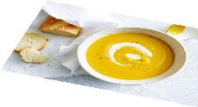

Classes that are participating in the Environmental Science Program have been cooking pumpkin soup. Soup really is a matter of taste and you can add in or leave out ingredients.

This is the recipe we used at school:

Pumpkin Soup

The pumpkin was prechopped and precooked with a

combination and microwaving and roasting the pumpkin

pieces.

Chop:

- Garlic

- Brown onion

- Spring onion

- Herbs (we had parsley, basil, tarragon, garlic chives, oregano, rosemary)

- Celery and celery leaves

Add chopped ingredients to a big pot and fry with olive oil, salt and pepper. Stir for a few minutes.

This brings out all the flavour.

Add the cooked pumpkin to the big pot and mix through.

Add stock (we used ‘chicken style’ vegetarian powdered stock) and water to the amount of soup you want.

Put the lid on the pot and boil. Blend the soup for a smoother consistency before serving. Pumpkin soup is extra yummy with sour cream stirred through and crusty bread (as pictured) – we just had the soup in a cup without the extras.

Together, we learn from each other

What’s On Page 3

UPCOMING EVENTS

National Walk to School Day

Date: Friday 18 May 2018

Year 1 Canberra Theatre Excursion ‘Yo Diddle Diddle’

Date: Friday 25 May 2018

Location: Canberra Theatre

Year 6 Woodwind Band Pair

Date: Thursday 24 May 2018

Location: Palmerston Primary School

Year 1/2 Author Visit - Dr Cameron Stelzer

Date: Tuesday 29 May 2018

Location: Palmerston District Primary School

North/Gungahlin Cross Country

Date: Wednesday 30 May 2018

Location: Palmerston District Primary School

2019 Preschool Information Session

Date: 5pm Wednesday 30 May 2018

Location: Palmerston District Primary School, library

STUDENT ACHIEVEMENTS

Ballet

Amelia - 6AJ competed in the NSW Cecchetti Medals at NIDA in Sydney. This is a very prestigious competition and attracts Cecchetti syllabus dancers from all over NSW and ACT. Amelia competed in the pre-junior section, which consisted of 75 competitors. Amelia placed in the top 10 and received an Honourable Mention.

Gymnastics

Isaac - 6AJ has been selected to represent ACT at the Australian Gymnastics Championships to be held in Melbourne in June.

Congratulations to both Amelia and Isaac!

Together, we learn from each other

What’s On Page 4

PRESCHOOL 2019 INFORMATION SESSION

An information session will be held for parents of preschool children entering preschool in 2019. The session will be held at 5pm in the Library at Palmerston District Primary School on Wednesday 30 May 2018. After the session you will be welcome to walk through the preschool classrooms to see the learning spaces.

Children must turn four years old by 30 April 2019 to be eligible for enrolment into preschool for the 2019 school year.

To register your interest for the session please call 6142 1440.

Come and tour the preschool facilities of the school and speak with current staff. Tours will be conducted during May on Mondays and Fridays at 9:30 to 10:00am. Book a tour of the preschool by calling the school on 6142 1440.

VOLUNTEERS WANTED

If you can spare some time, the library staff would love your assistance. Please drop in the library anytime on Thursdays.

Thank you,

Noreen Pidgeon & Eleni Velanis

NAPLAN

During week 3 & 4 our students in year 3 & 5 will be completing NAPLAN. Please find below the schedule for completing the tests.

If you have any questions please contact Haeley Simms via the front office.

Monday 14 May |  |  | Tuesday 15 May | Wednesday 16 May | Thursday 17 May
 |  |  | Year 3 Writing | Year 3 Reading | Year 5 Writing
 |  |  |  | Year 3 Language Conven- | Year 3 Numeracy
 |  |  |  | tions
Monday 21 May |  |  | Tuesday 22 May | Wednesday 23 May | Thursday 24 May
Year 5 Reading |  |  | Year 5 Numeracy | Catch up Assessment | Catch up Assessment
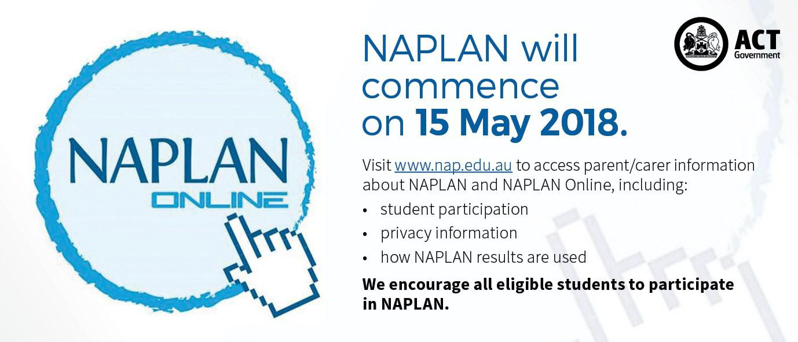

Together, we learn from each other

What’s On Page 5

PBL@Palmerston

At Palmerston we are excited to continue our journey into Positive Behaviour for Learning (PBL). PBL is an evidence-based, school-wide approach that supports student behaviour to improve social and academic outcomes for all students. Our PBL team consists of teachers from all areas of our school, preschool to year 6. The PBL team will be working with the community this term to refine a framework outlining our school’s expectations for Safe, Respectful Learners, through the use of positive statements.
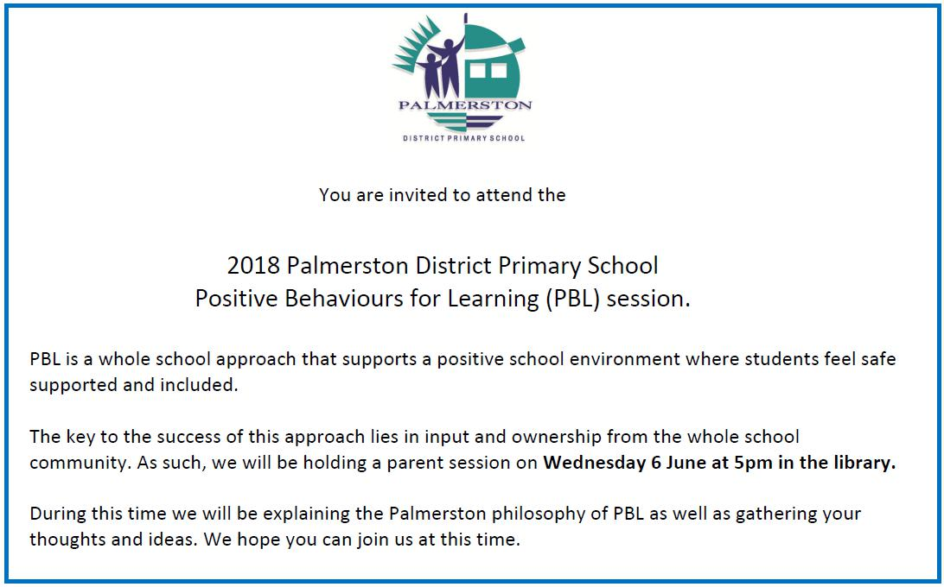

Together, we learn from each other

What’s On Page 6
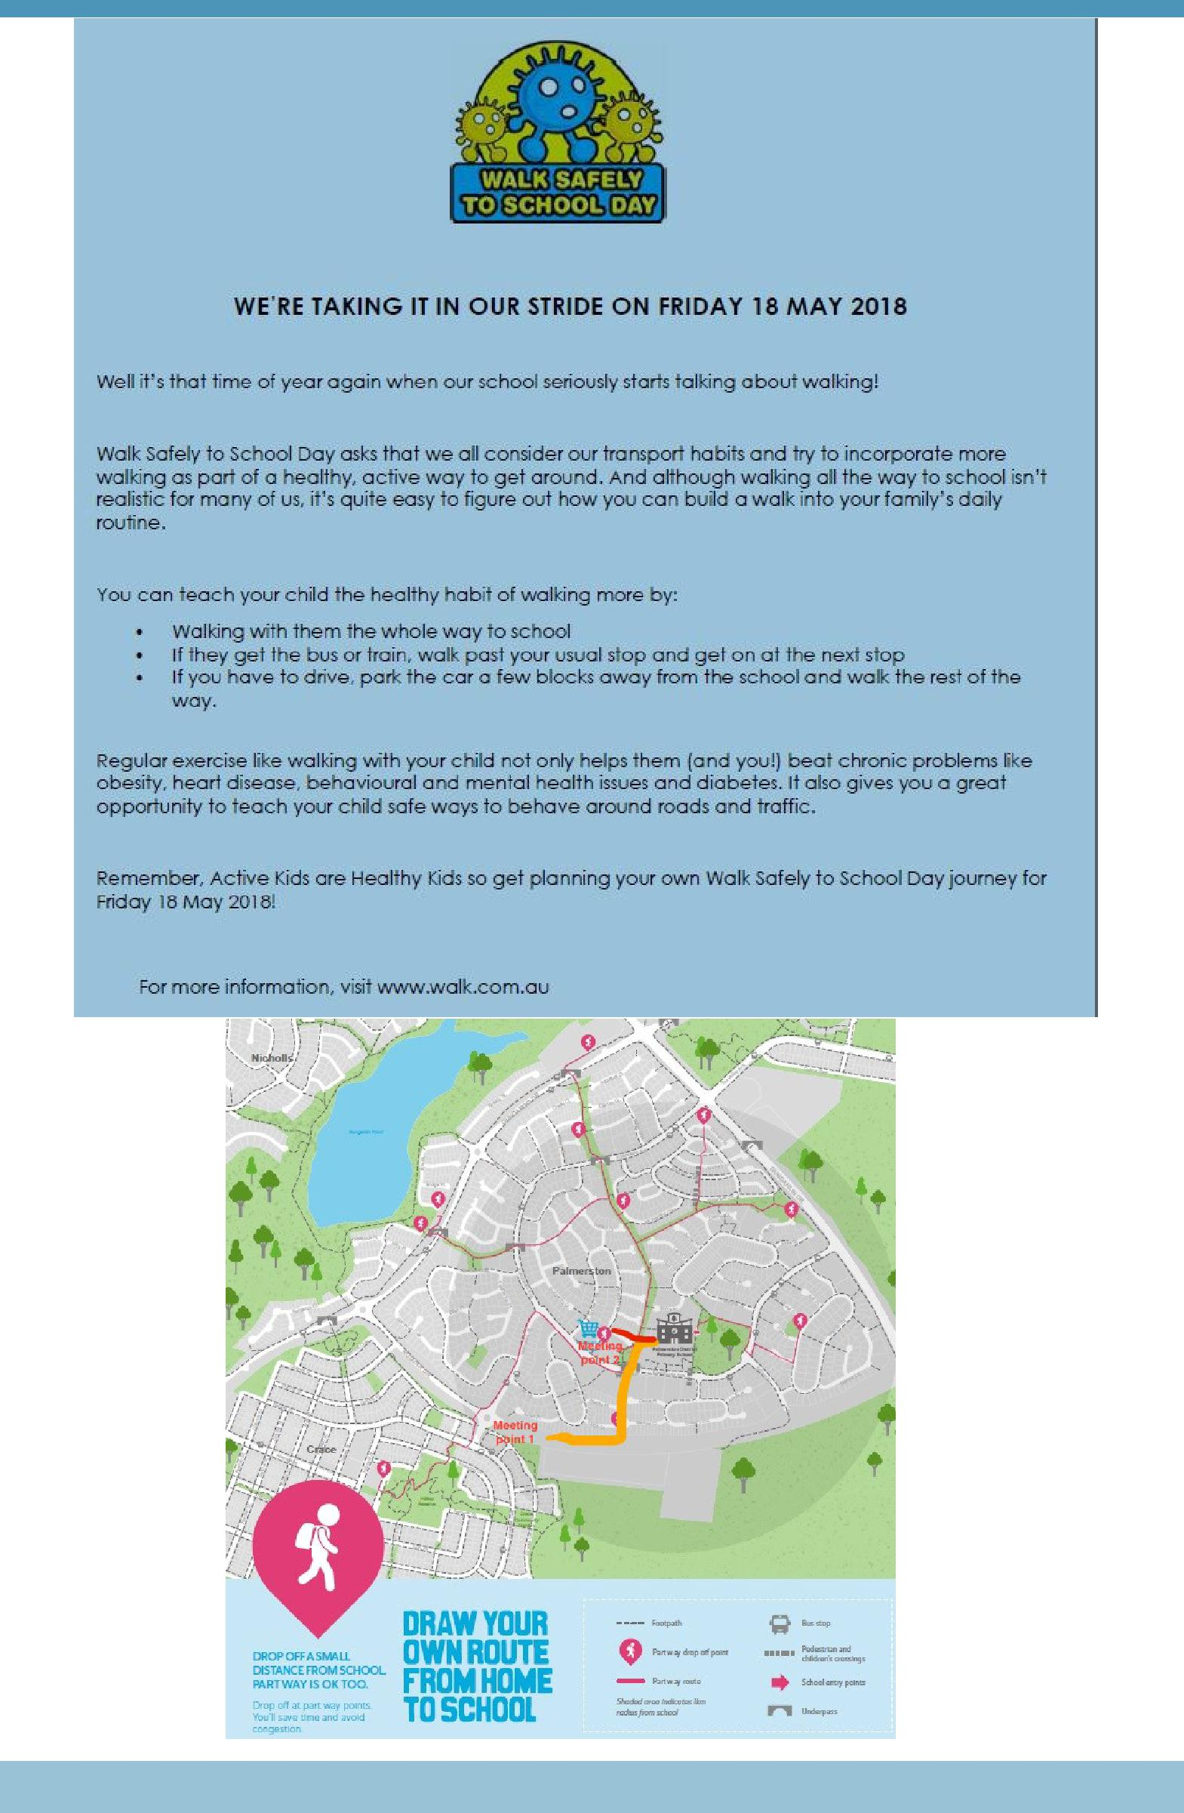

Together, we learn from each other

What’s On Page 7

The Prime Minister gets behind Walk Safely to School Day
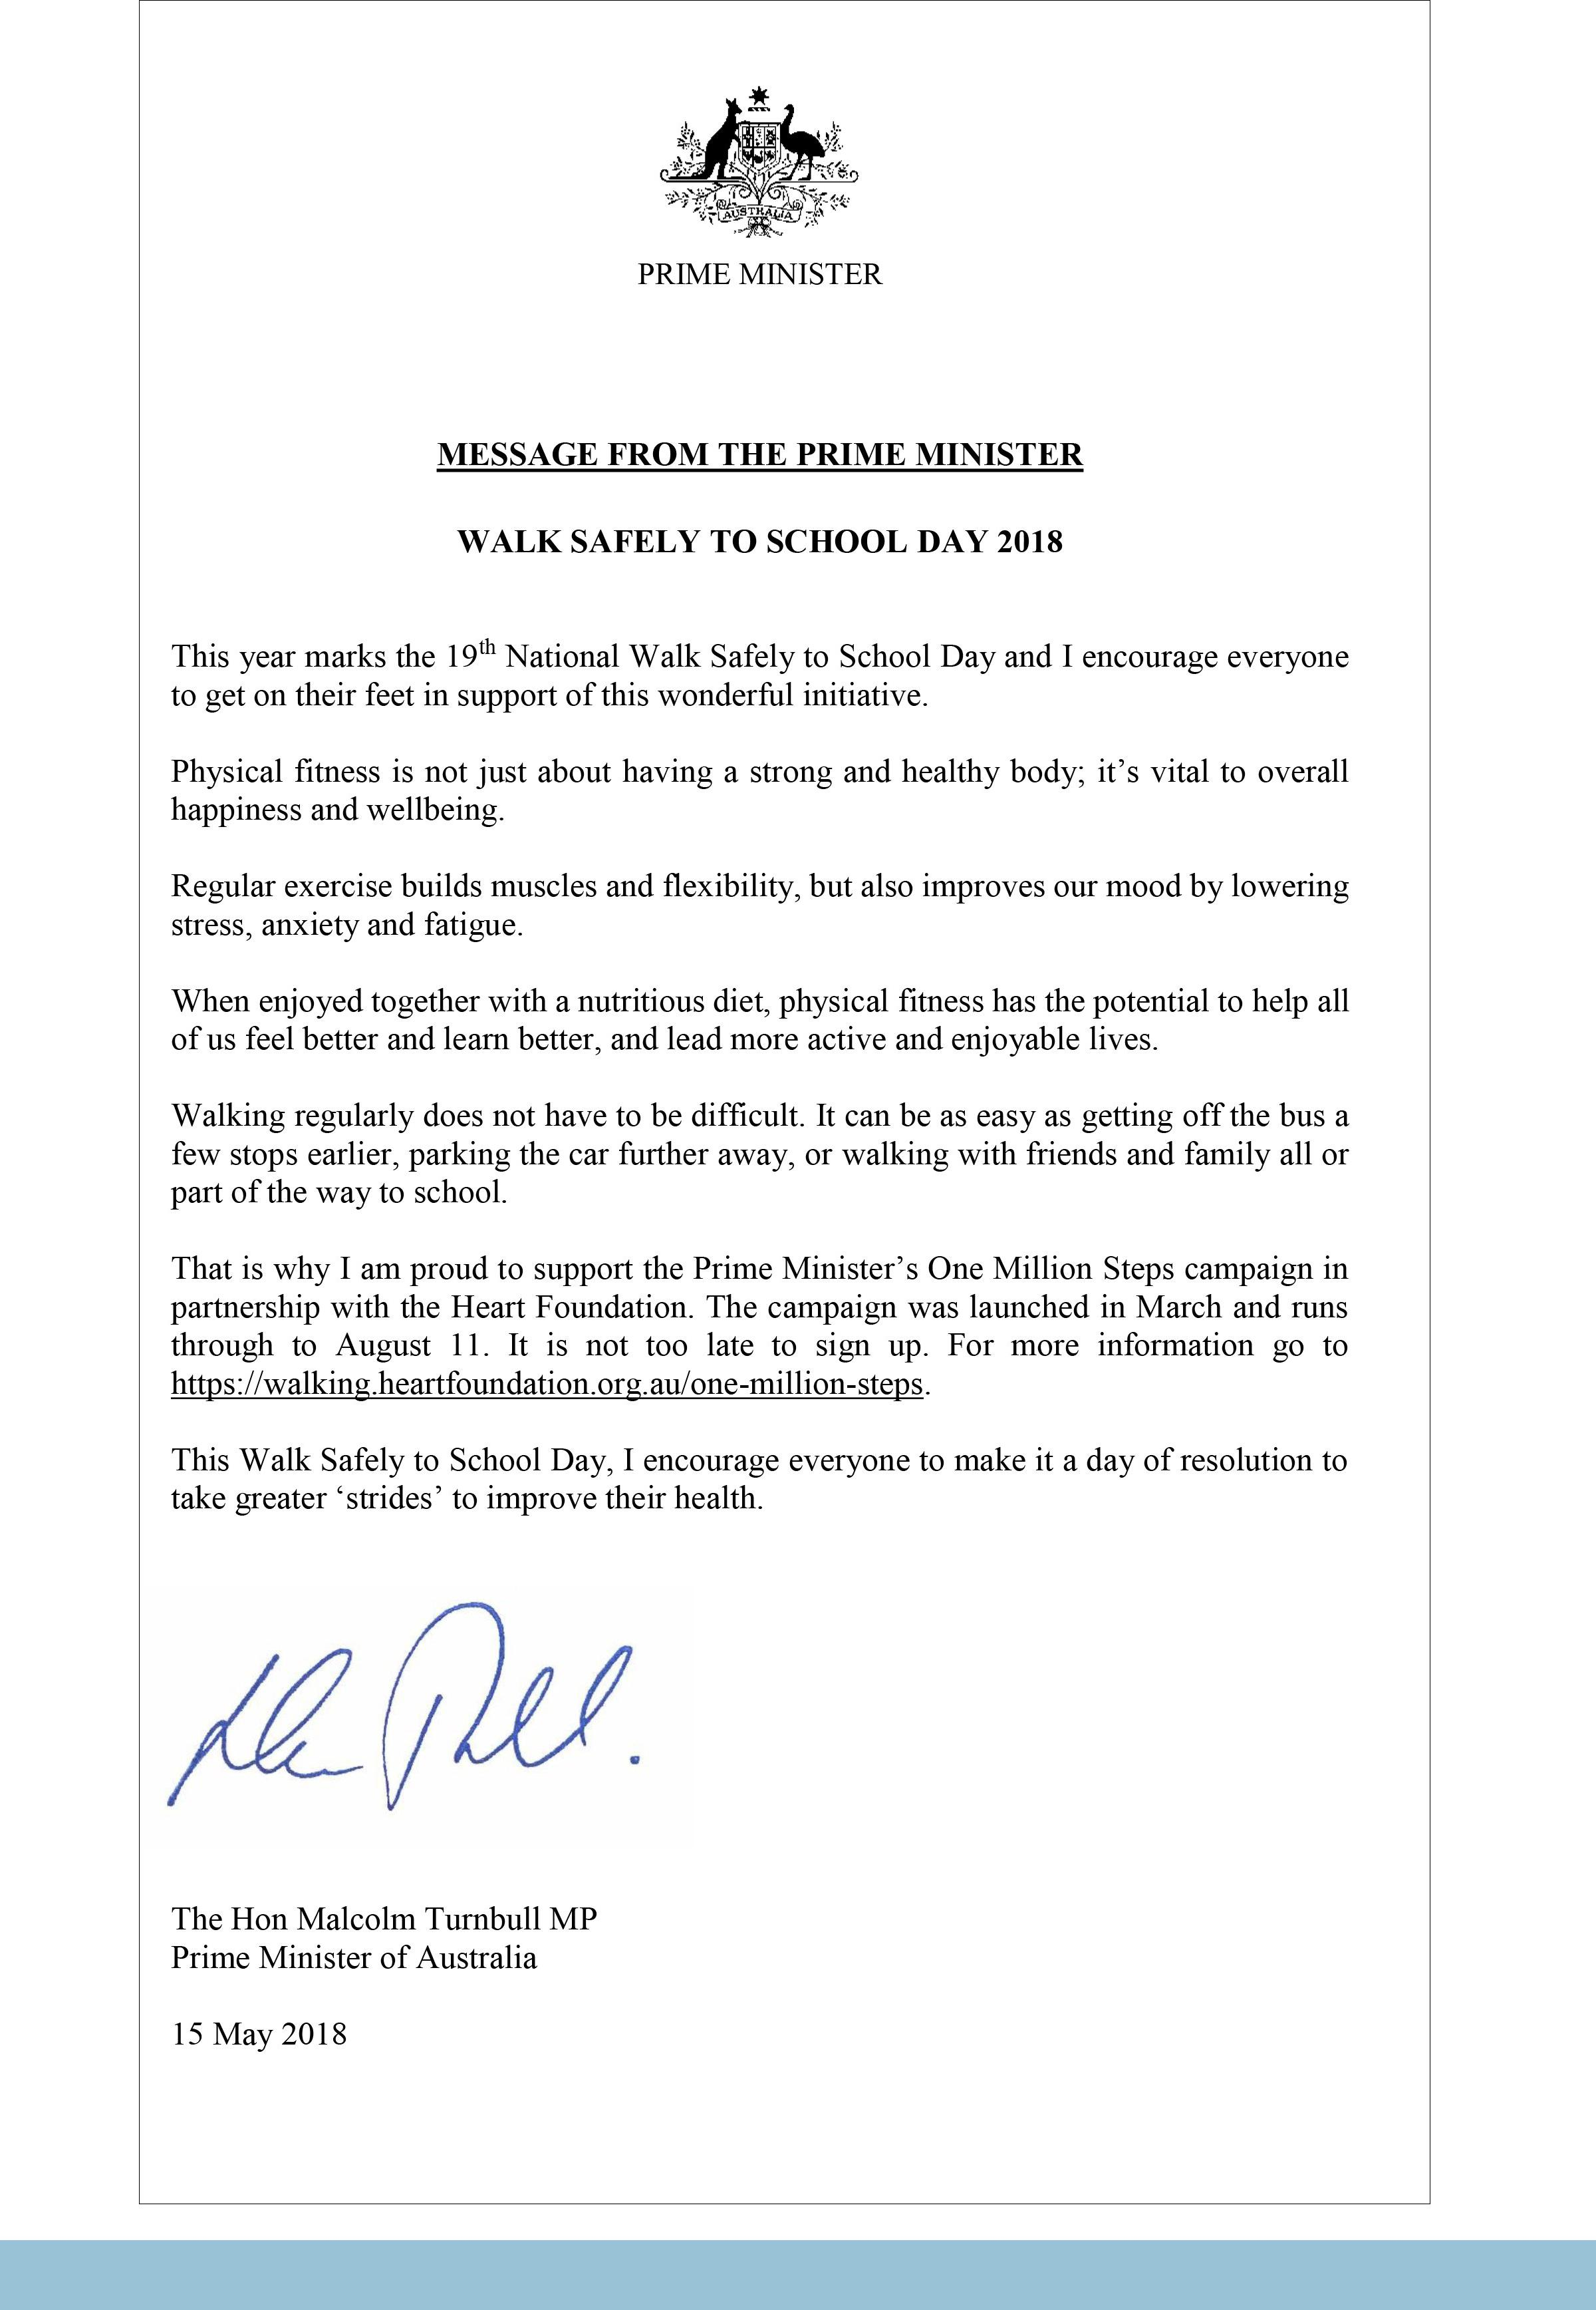

Together, we learn from each other

What’s On Page 8
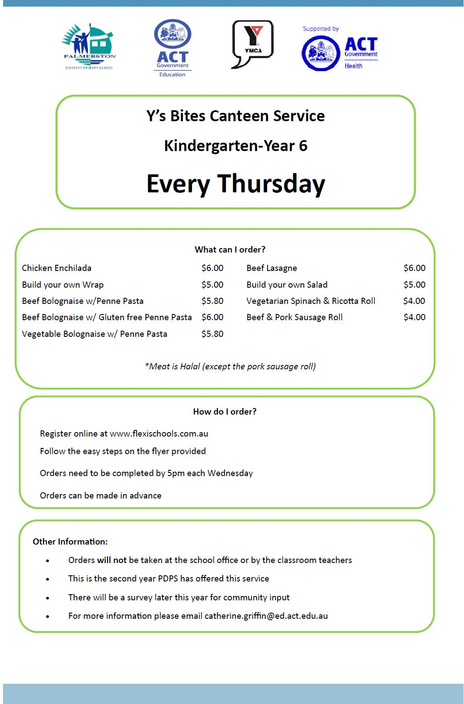

Together, we learn from each other

What’s On Page 9
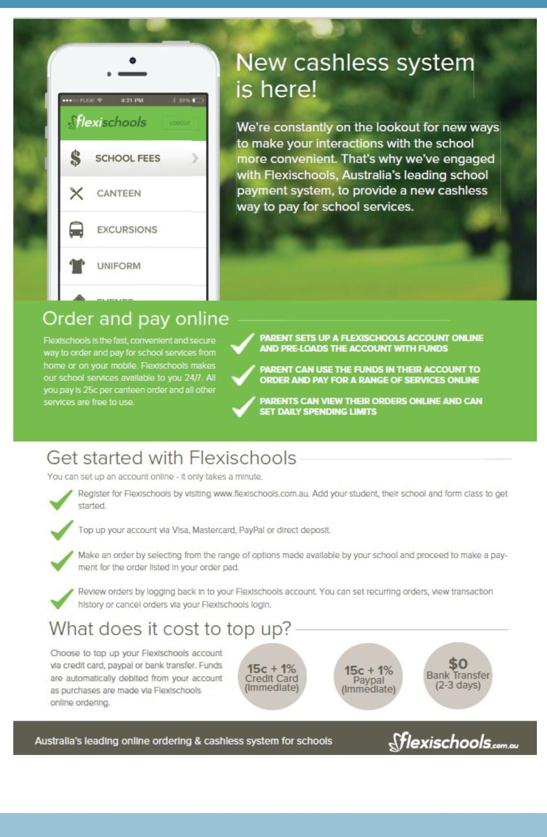

Together, we learn from each other

What’s On Page 10

COMMUNITY NEWS
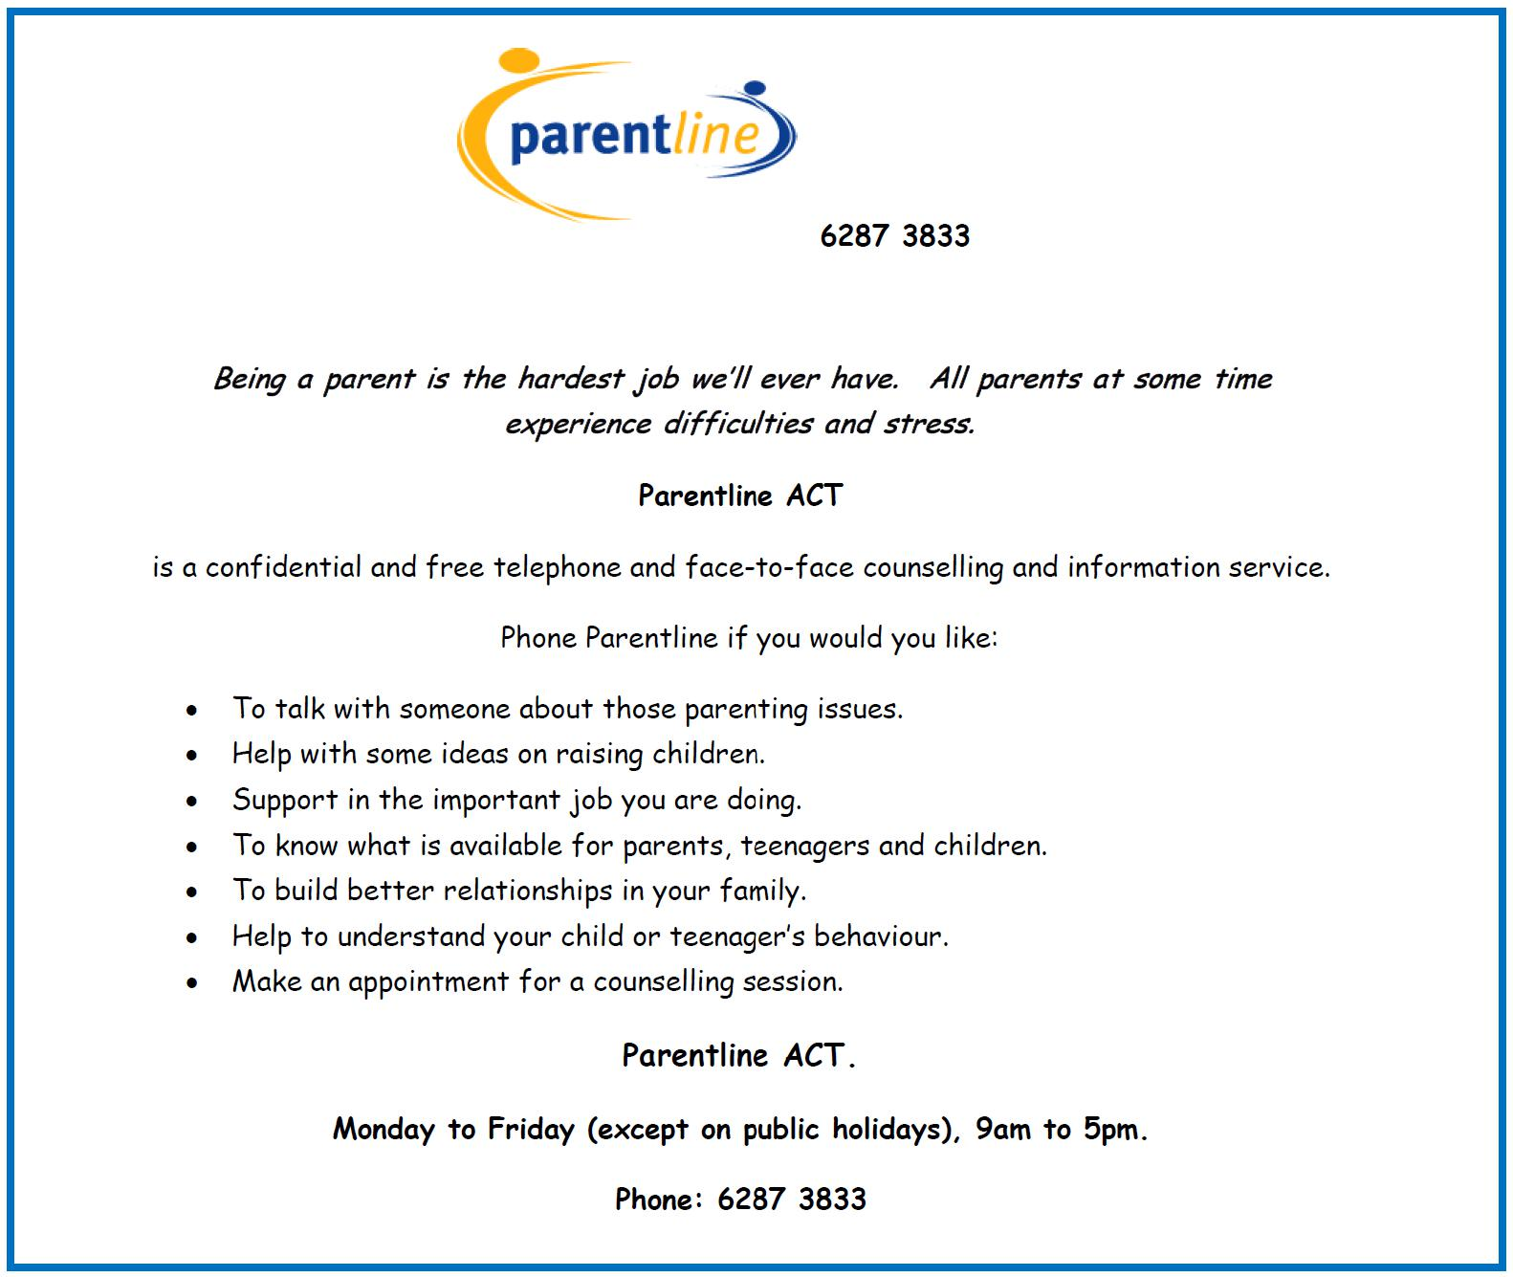

Together, we learn from each other

What’s On Page 11
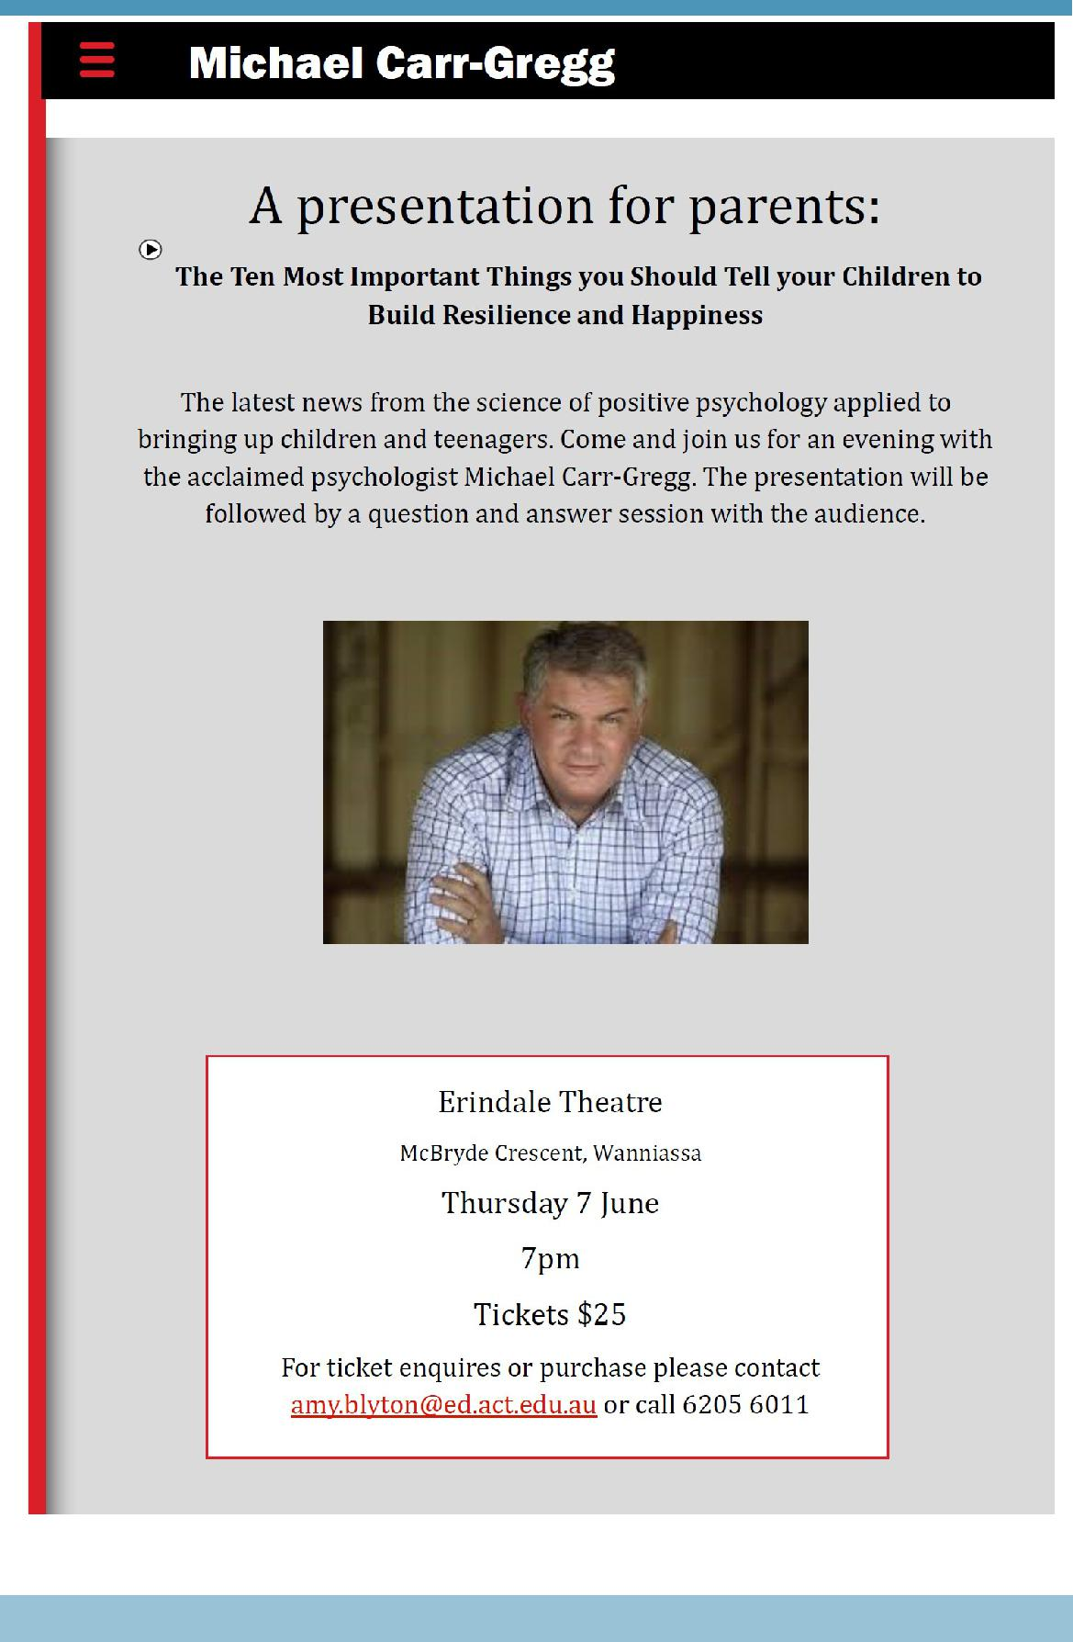

Together, we learn from each other

What’s On Page 12

Reconciliation in the Park

Monday 28 May 2018

Glebe Park, Civic

10am to 2pm

Reconciliation in the Park celebrates the ACT’s historic first Reconciliation Day public holiday to be held in Australia. Join this free community event in Glebe Park in the city which features headline folk inspired pop duo Busby Marou performing live on stage.

The ARIA award-nominated stars will be joined by an array of local Indigenous performers and dancers including the Wiradjuri Echoes. Also performing is Canberra’s own The Voice finalist, teen sensation Lucy Sugerman, The Chesterfield Band, Johnny Huckle and Hardcover.

The Glebe Park event offers something for all ages. Among the activities are basket weaving, bush tucker talks, storytelling and children’s art workshops. In addition to the cultural activities the kids can join in there will be a petting zoo, jumping castle and face painting.

Grab a bite to eat at the community barbecue or from the food trucks onsite.

You can also connect and chat with the many local community organisations who will be exhibiting in Glebe Park on the day.

Reconciliation Day is an opportunity for all Canberrans to learn about our shared histories, cultures and achievements and explore how we can contribute to achieving reconciliation in Australia.

The day’s activities reflect the National Reconciliation Week 2018 theme Don’t make history a mystery which invites Australians to Learn, Share, and Grow – by exploring our past, learning more about Aboriginal and Torres Strait Islander histories and cultures, and developing a deeper understanding of our national story.

Program performers at a glance

Main stage

10am Welcome to country

11am Griffyn Ensemble

11:30am Michael Weir

12pm Busby Marou

1pm Wiradjuri Echoes

Rotunda Stage pop up performers

10am Dale Huddlestone

11am Johnny Huckle

1pm Lucy Sugerman

Main entrance pop up performers

10am Dominic Lavers

11am The Chesterfield Band

1pm Hardcover

Getting there

Transport Canberra will be running on a public holiday schedule to get you to and from the city, with concession card holders able to travel free on the public holiday.

The free City Loop service will be operating, stopping at the Akuna Street (City Walk) stop.

The Aboriginal and Torres Strait Islander Community Bus service will be operating a free shuttle service from select locations in Queanbeyan between 9:30am and 2:30pm.

Parking options include Canberra Centre, Civic Pool and city centre precinct car parks as well as the National Convention Centre.

Share your Reconciliation Day

Use #NRW2018 when sharing your day on social media.

Learn more about National Reconciliation week.

Together, we learn from each other

