What’s On

4 April 2019

Week 9, Term 1

ASSEMBLY:

05 Apr |  | Junior - 2SH & 2RC
12 | Apr | No assembly - Easter
 |  | Hat Parade
DATES TO REMEMBER:
5 Apr |  | P&C Disco
9 Apr |  | P/S Easter Hat Parade
10 | Apr | K - Yr6 Cross Country
11 | Apr | Yr5/6 Touch Football
 |  | Gala Day
12 | Apr | K-Yr2 Easter Hat Parade
13 | Apr - 28 Apr School Holidays
29 | Apr | Term 2 starts

NOTES:

- Library Trust Fund receipts

- Yr3 - 6 Rostrum

P&C BOARD NEWS P&C: 13 May 2019

All P&C activities, meeting agendas and minutes are available from the school website at – Parent Corner

School Board:

PRINCIPAL’S MESSAGE

Firstly I’d like to thank everyone for the warm welcome I’ve received here at Palmerston. My name is Will Johnston and I have been appointed as acting Principal for the remainder of Term 1. The selection process for the new principal will occur in the very near future and once finalised, the community will be informed of the successful applicant. In the meantime, should you see me around the site, please feel free to come up and introduce yourself. Alternatively I’m more than happy to receive emails and can be contacted at william.johnston@ed.act.edu.au .

During my first few days at the school I’ve spent time in classrooms across the school and have been impressed with the willingness of students to share their learning with me. This morning I read with a number of the Kindergarten students and was so happy to see the large amount of parent volunteers supporting our young readers. I also attended Monday night’s P&C Meeting where again a number of parents were working hard to support and provide opportunities for the children of the school. Palmerston certainly is a community school!

I’d like to remind families that supervision before school starts from 8:30am on the black top. Please do not send students to school before this time, unless they are attending before school care. As a reminder this service is provided by Communities at Work where information can be found by visiting their website at https:// commsatwork.org/services/children/palmerston-district-primary-school/.

For parents of students in Kindergarten, you will soon receive results of your child’s start of year Performance Indicators in Primary School (PIPS) assessment. Students will complete the assessment again at

the end of the year. Please speak to your child’s teacher should you have any queries regarding this.

William Johnston

Together, we learn from each other

What’s On

PALMERSTON PRIDE AWARDS

Congratulations to the following students who received a PRIDE Award at assembly on 29 March 2019.

PARTICIPATION – becoming involved, “having a go” and cooperating with others

Leo - KMC Karina - KKA Andy - 1HD Eloise - 1HD

Omar - LSU Lincoln - 1AS Ryder - 1DE Atreya - 2RC

RESPECT – having respect for self, others and their property

Artie - KMC Joanna - 1DE Aynalem - 2RC

INTEGRITY – being honest, fair, responsible and loyal
Finlay - 1KW | Hannah - 1DE
DETERMINATION - being persistent and resilient
Vincent - KMC | Violet - KMC | Emma - 1AS | Lily - 1DE
Benjamin - 1HD | Kai - 1KW | Antoinette - 2RC | Adi - 2RC

EMPATHY - understanding and supporting others regardless of our differences Matea - 1DE

2020 PRESCHOOL TOURS

Come and walk through Palmerston Preschool on a guided tour.

Meet the Executive teacher and Preschool staff.

Learn about the Early Years Framework and Preschool program.
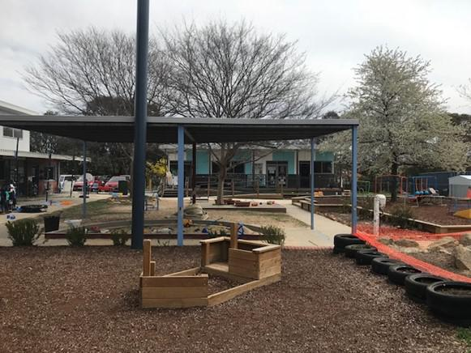

Observe the Preschool program in action.

Thursday 4th April 2:00 pm

Wednesday 10th April 2:00 pm

Tuesday 7th May 9:30 am

Thursday 9th May 9:30 am

Monday 13th May 2:00 pm

Please call the front office: 6142 1440 to book a preschool tour.

Together, we learn from each other

What’s On

UPCOMING EVENTS

P&C ‘Sports Fans / Sports Team’ Disco

Date: Friday 5 April 2019

Location: PDPS, Hall

Easter Hat Parades

Date: Tuesday 9 April 2019 - Itchy, Noisy & Brave Bears Friday 12 April 2019 - Preschool - Yr2 Location: PDPS

K - Yr6 Cross Country

Date: Wednesday 10 April 2019

Location: PDPS

Yr5/6 Touch Football Gala Day

Date: Thursday 11 April 2019

* Reminder *

School banking is every Wednesday morning

TRAFFIC UPDATE

Thank you for the ongoing support of the community in ensuring Palmerston’s carpark is a safe and friendly place to be. A reminder to be patient and park safely in the allocated bays. We have recently met with Traffic and Asset Management and they are finalising plans to improve the flow of our carpark. We are expecting this to occur in the second half of the year. There will be some disruption but it will give us a better flowing car park. Palmerston is a part of the active schools program and this is parked with blue stencils, these provide safer routes for walking to school. We are lucky that at Palmerston we also have an underpass which allows students to not have to cross over the busy road. Under the parking requirements we are required to have a total of 84 car spaces, we are lucky that at Palmerston we have a total of 107 car spaces. Remember key suggestions for avoiding car park congestion are: Pick your child up at five or ten minutes later in the afternoon or park at the shops. A parking van has again been patrolling the area and is issuing tickets for those who park on the kerb.
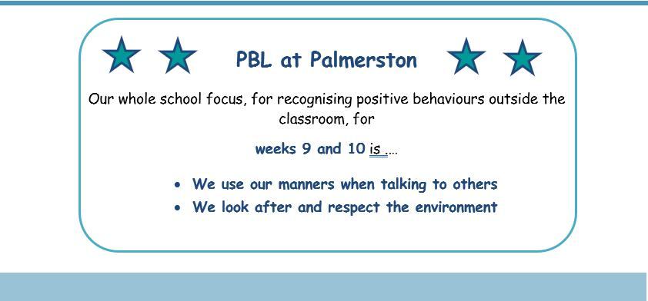

Together, we learn from each other

What’s On
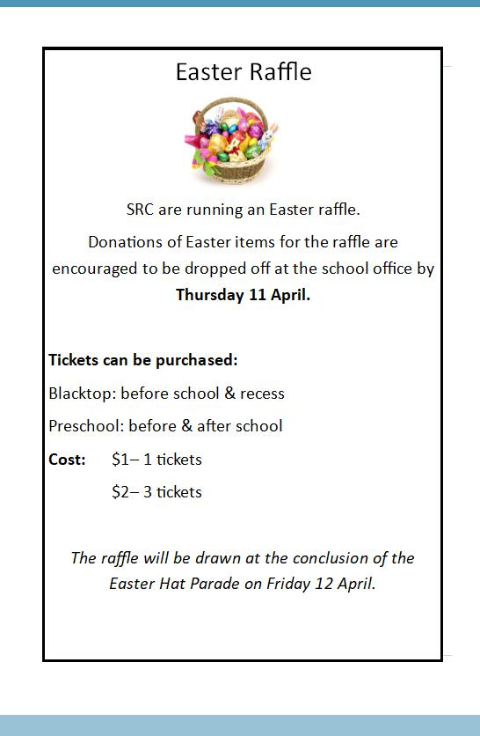

Together, we learn from each other

What’s On
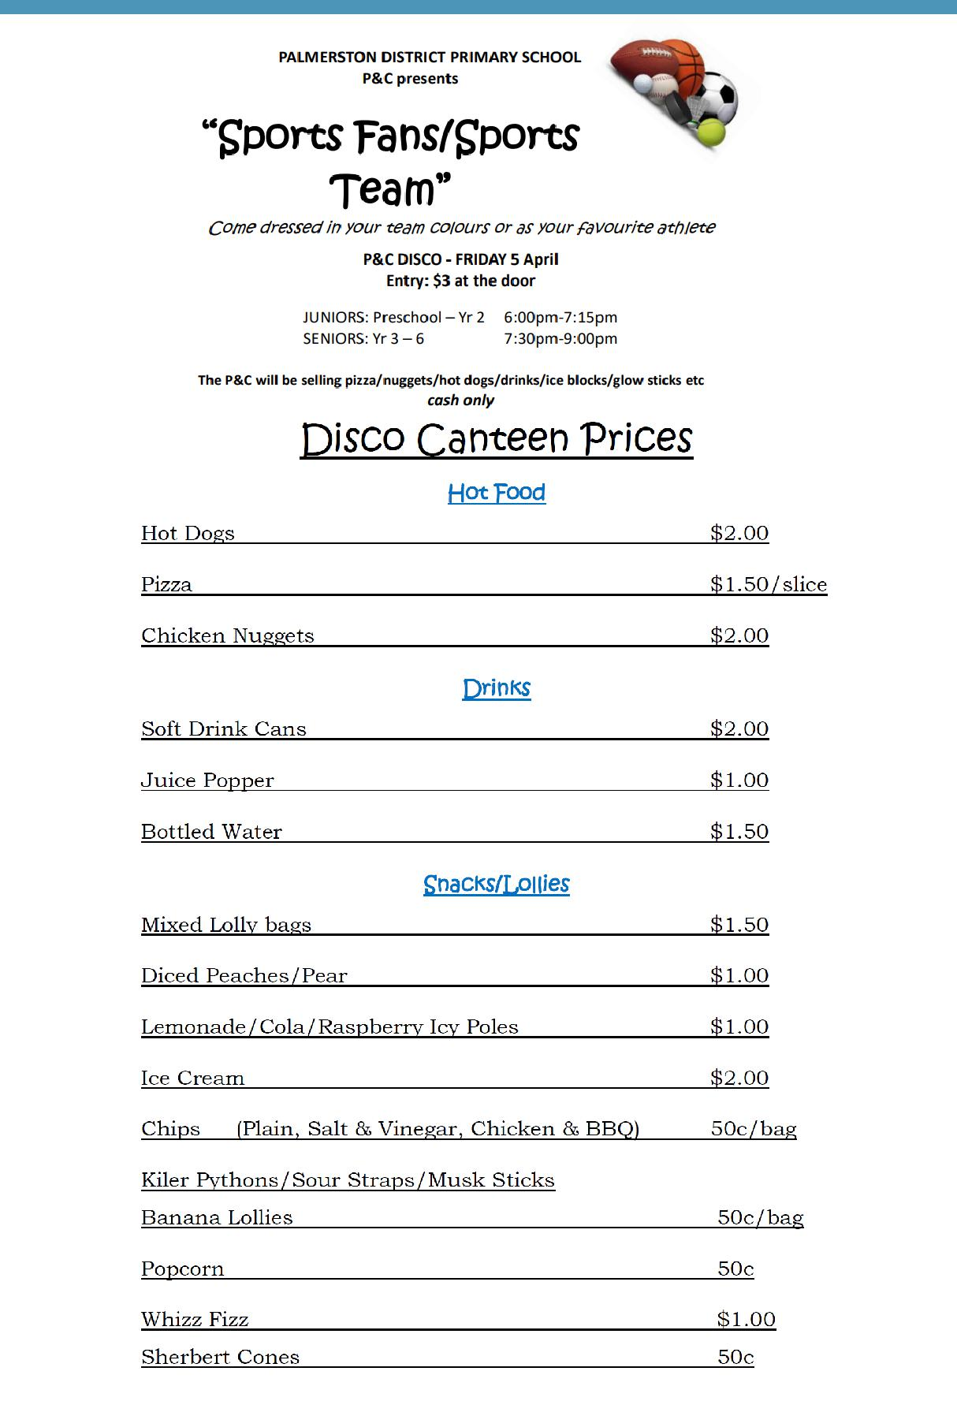

P&C NEWS

Together, we learn from each other

What’s On

P&C Uniform Shop Price List 2019

New Merchandise

Polar Fleece Beanies (with logo) | $10
Dresses (Winter Navy) | $30
Library Bags (with logo) | $15
Round Palmerston logo Sew-on Badges (Small) | $2.50
Round Palmerston logo Sew-on Badges (Large) | $3.50
Palmerston Teaspoons | $5
Palmerston Coffee Mugs | $10 | (money to front office)
Palmerston Travel Mugs | $15 | (money to front office)

Second Hand Items

Hats | $2
Palmerston Polo Shirts | $2
Palmerston Long Sleeve Shirts | $3
Skivvies | $2
Jumpers – No Logo | $3
Jumpers - Logo | $5
Vest – Logo | $3
Trousers/Trackpants | $3
Shorts | $2
Skorts | $2
Sports Skirts | $2
Girls Bike Pants | $2
Dresses (navy winter and checked summer) | $5
School Bag with Logo | $10

P&C Uniform Shop is located just inside the Hall Entrance

Contact the Front Office, or P&C contact below, to make an appointment outside of standard opening hours.

Kate: 0404 675 508 Franki: 0431 675 725

Opening Times: Tuesday 2:45 - 3:15pm

Friday 8:30 – 9:00am

Together, we learn from each other

What’s On

HIRERS NEWS
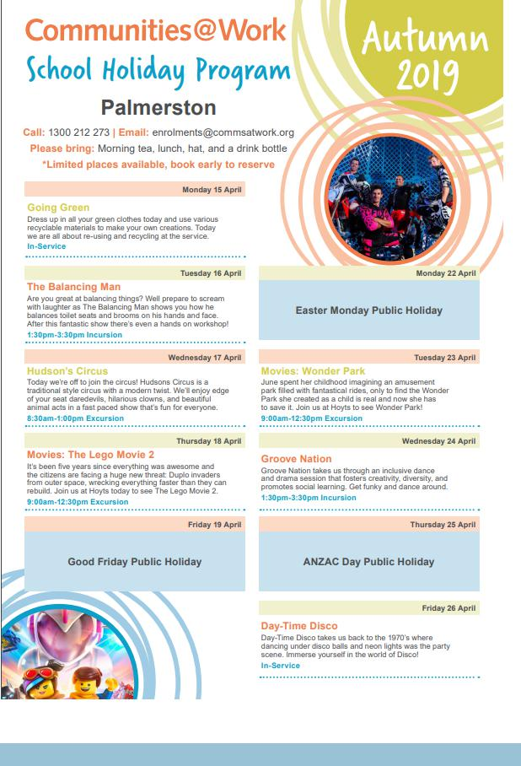

Together, we learn from each other

What’s On

COMMUNITY NEWS
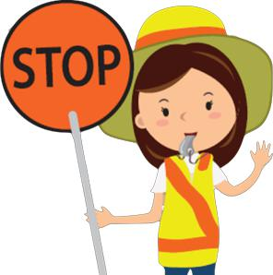

School travel and safety survey

Transport Canberra and City Services has engaged First Person Consulting to conduct research into parents’ attitudes to their children's active travel to and from schools. Part of this is investigating the role that crossing supervisors have in improving safety around schools, and the extent to which parent’s attitudes to children travelling actively change as a result.

You may have completed a similar survey last year, this is the final survey as part of the evaluation to gauge parent perceptions about safety around schools.
To complete the survey please click here, or copy and paste the following link into your browser:

https://www.surveygizmo.com/s3/4828047/School-Crossing-Supervisor-Survey-Control-Feb19

The survey should take about five minutes. The survey will not collect any identifiable information, and all responses will be kept confidential.

Thank you in advance for your time in completing this survey. If you have any questions please contact

the TCCS Schools Program.

Together, we learn from each other

