***What’s On***



**16 May 2019**

**Week 3, Term 2**



**ASSEMBLY:**

17 May Senior - 3JL & 3FB

24 May Junior - 1AS & 1HD

**DATES TO REMEMBER:**

17 May National Walk Safely

to School Day

21-24 May Naplan

22 May Simultaneous

Storytime

24 May Yr3/4 & IEC Theatre

Excursion

27 May Reconciliation Day

28 May Rostrum School Final

31 May Athletics Carnival

**NOTES:**

* Athletics Carnival

**P&C BOARD NEWS P&C: 24 June 2019**

All P&C activities, meeting agendas and minutes are available from the school website at – Parent Corner

**School Board: 13 June 2019**

**PRINCIPAL’S MESSAGE**

Week 3 already! I am looking forward to the first community event this Saturday when we open our doors for voters to come in and hopefully be tempted by the aroma of a sausage sizzle and the sight of many delicious cakes to purchase and take home to enjoy with a cuppa. If you have the time to cook some goodies for sale, please help us out, every cent raised will come back to the school and benefit our students. Cakes, biscuit, slices - wrapped up and looking tempting, can be dropped to the Canteen between 3pm and 4pm Friday. I’ll be

there to accept them and store them overnight.

If you have some time to spare on Saturday to cook or serve sausages, and sell the goods at the Cake Stall…please join us. Ring Helen on 0406 378 294, she will pop you on the schedule. I will be there early in

the morning for a few hours too.

I was thrilled to be a part of the P&C meeting on Monday night and was so pleased to meet such a dedicated group of Mums who are working

together to give our students really meaningful experiences.

I would love to see our numbers grow, for more parents, grandparents, next door neighbours to join the P&C as it is a terrific way to share your expertise. Building numbers means sharing the load…come along and join in the discussions. Our meetings are Monday in weeks 3 and 9 of each term from 7.00-8.00pm., in the staffroom. Having representatives from every class would be a goal to aspire to, please

come along.

The School Board meets before the P&C and I look forward to discussing the strategic direction forwards for our school. All positions

are filled as we move to work in this highly interesting space.

School Communities are a fascinating body of expertise, passion and support. I would love to get to know ways you would feel confident to add value to this beautiful community. If you have a particular talent, skill or passion that you would like me to know about, - that could assist our school, please always feel free to reach out via email to

kate.smith@ed.act.edu.au and we can connect.

If you are enjoying the Facebook posts, please like and comment. Spread the word and let’s get our FB page out there for everyone to



see.

Until next time, keep on being curious…

***Kate Smith***

***Together, we learn from each other***

*What’s On*

**PALMERSTON PRIDE AWARDS**



Congratulations to the following students who received a PRIDE Award at assembly on 29 March 2019.

***PARTICIPATION*** – becoming involved, “having a go” and cooperating with others

|  |  |  |  |
| --- | --- | --- | --- |
| Sergei - 5/6CW | Maggie - 3FB | Aman - 5/6DT | Callum - 5/6DT |
| Evander - 3AP | Joanne - 3AJ | Logan - 3JL | Jane - 3JL |
| ***RESPECT*** –having respect for self, others and their property | | |  |
| Pranavi - 5/6CH | Bridie - 5/6CW | Cooper - 3JL | Chaela - 4MG |
| Yusra - 3AJ | Mylee - 4MG |  |  |
| ***INTEGRITY*** –being honest, fair, responsible and loyal | | |  |
| Aamer - 3FB | Ayan - 4VS | Luka - 3AJ |  |
| ***DETERMINATION* -**being persistent and resilient | | |  |
| Emerson - LSU | Tegan *-* 5/6CH | James - 5/6DT | Ruqayya - 5/6DT |
| Abigail - 3FB | Daniel - 5/6CH | Indy - 3AP | Yaak - 4MG |
| Jemimah - 3AJ | Reuben - 4VS | Zaim - 3AJ |  |
| ***EMPATHY* -**understanding and supporting others regardless of our differences | | | |
| Phillip - 3FB | Kimia - 3AJ |  |  |

**PBL**

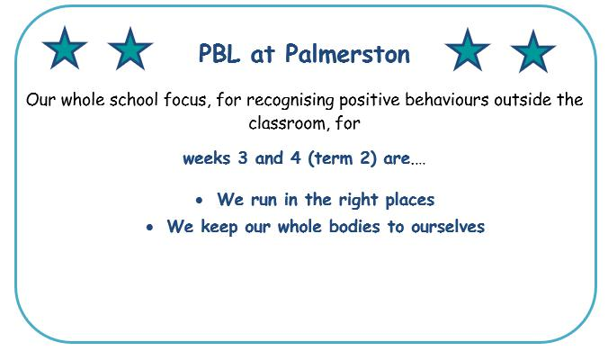

***Together, we learn from each other***

*What’s On*

**Semester One Reports 2019**

Palmerston District Primary School has been selected to pilot the new Education Directorate report format. This format will be common for students across all Kindergarten to Year 10 schools. The report is generated through the Student Administration System (SAS). Semester One reports will be emailed to parents. Please read the fact sheet attached. There will be more information to come in following newsletters and PDPS will conduct parent information sessions about the reporting process in coming weeks.

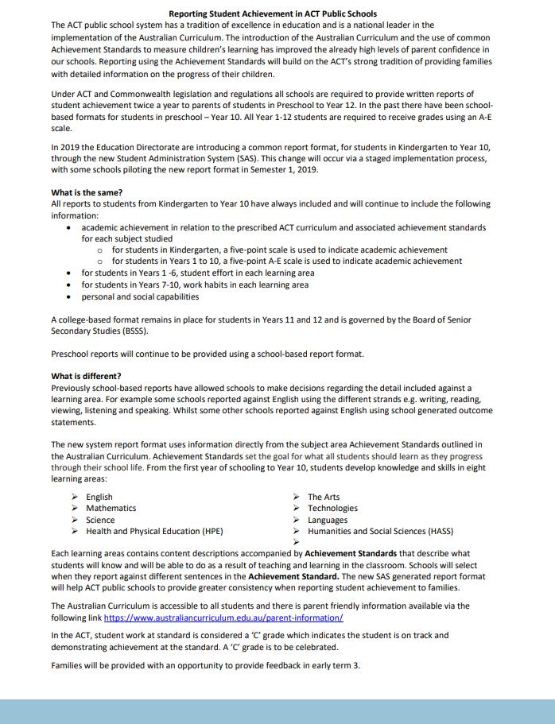

***Together, we learn from each other***

*What’s On*

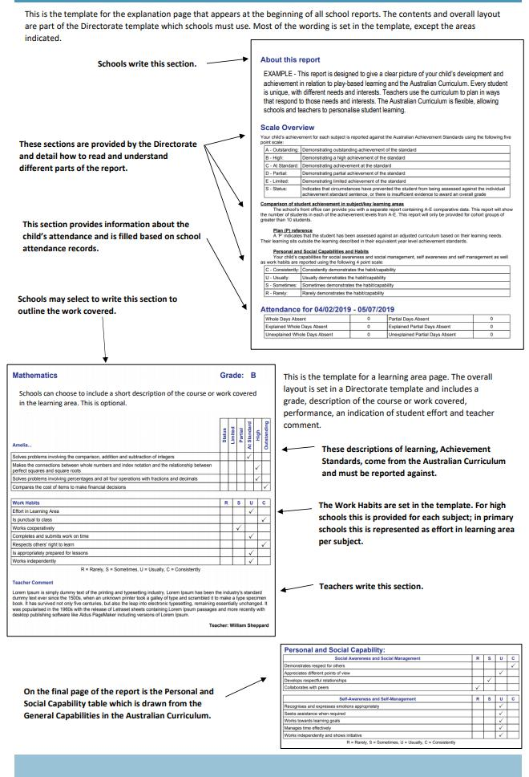

***Together, we learn from each other***

*What’s On*

**Defence News and Events**

**Defence School Mentor – News and Events**

**Duntroon Community Centre Family Fun Night**



**Friday 17th May 5 – 7pm, Duntroon Community Centre, Gymkhana Rd, Duntroon.**

To help Duntroon Community Centre celebrate National Families Week, please join us from 5-7pm on Friday 17th May for an evening of family fun. Included in your ticket will be dinner, disco, kids’ games, face painting and raffles.

Event is open to Duntroon Community Centre members only.

More information located on DCC Facebook Page.

**Defence Community Organisation**

**The Home Team Canberra**



Details: This event is organised for partners of ADF members who are absent from home (MWDU, deployed or absent for extended periods).

ADF Partners of serving members absent from home are invited to join us for brunch on the last payday of every month to strengthen your support network while you manage the home front. This is a self-funded event and children are welcome.

Tickets available Eventbrite to RSVP on Canberra Defence Community Organisation Facebook Page.

**Location: The Lakes Gungahlin, Cnr Gundaroo Drive and Gungahlin Drive Nicholls.**

**Date: Thursday 30th May 2019**

**Time 10am – 1130am**

**Coffee Connections – Canberra**



ADF Partners and families in Canberra are invited to join us at our regular coffee group. Come along to this child friendly café and relax and chat with other ADF families and meet the DCO Canberra team.

**Where The Lakes Gungahlin**

**Date Tuesday 4th June 2019**

**Time 10am – 1130am**

***Together, we learn from each other***

*What’s On*

**UPCOMING EVENTS**

**Simultaneous Story Day**

Date: **Wednesday 22 May 2019**

Location: PDPS

**North Gungahlin Cross Country**

Date: **Wednesday 29 May 2019**

Location: Stromlo

**Athletics Carnival**

Date: **Friday 31 May 2019**

Location: PDPS

**\* Reminder \***

School banking is every Wednesday morning

**TRAFFIC UPDATE**

Thank you for the ongoing support of the community in ensuring Palmerston’s carpark is a safe and friendly place to be. A reminder to be patient and park safely in the allocated bays. We have recently met with Traffic and Asset Management and they are finalising plans to improve the flow of our carpark. We are expecting this to occur in the second half of the year. There will be some disruption but it will give us a better flowing car park. Palmerston is a part of the active schools program and this is marked with blue stencils, these provide safer routes for walking to school. We are lucky that at Palmerston we also have an underpass which allows students to avoid crossing over the busy road. Under the parking requirements we are required to have a total of 84 car spaces. We are lucky that at Palmerston we have a total of 107 car spaces. Remember key suggestions for avoiding car park congestion are: Pick your child up at five or ten minutes later in the afternoon or park at the shops. A parking van has again been patrolling the area and is issuing tickets for those who park on the kerb.

***Together, we learn from each other***

*What’s On*



**P&C NEWS**

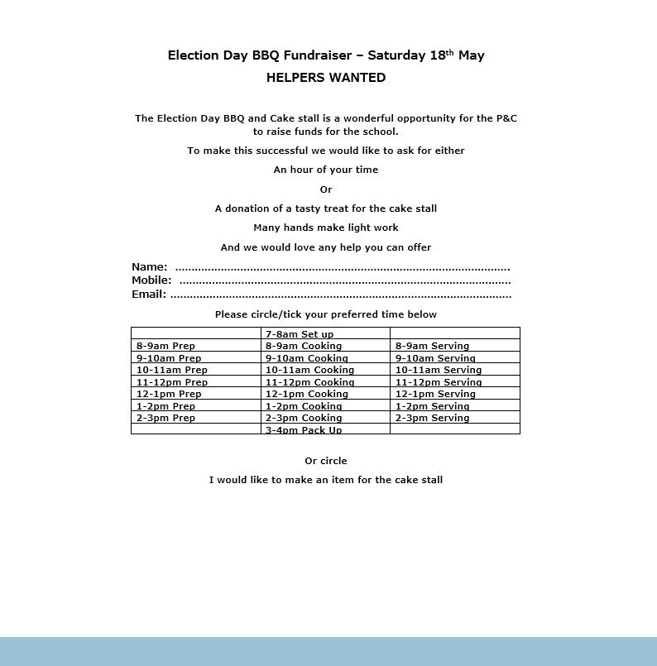

***Together, we learn from each other***

*What’s On*

**Community News**



***Together, we learn from each other***