Palmerston Post

11 April 2019

Week 10, Term 1

Board Chair: Lisa Fior

Teacher Reps: Jessica Lago and Maxine Green

P&C President: Lisa Fior

Principal: Melissa Travers, Will Johnston (A/g) Deputy Principals: Haeley Simms (A/g) & Kylie Moller (A/g)

Executive Teachers: Matt Gowen, Felicity McNeice, Catherine Griffin (A/g)

ASSEMBLY:

12 | Apr | No assembly -
 |  | Easter Hat Parade
03 May |  | Anzac Day
 |  | assembly
DATES TO REMEMBER:
11 Apr |  | Yr5/6 Touch
 |  | Football Gala Day
12 | Apr | K-Yr2 Easter Hat
 |  | Parade
13 | Apr - 28 Apr School
 |  | Holidays
29 | Apr | Term 2 starts
02 | May | K-Yr6 Ridiculous
 |  | Rhyme Show

NOTES:

- Mother’s Day

Celebrations

P&C BOARD NEWS P&C: 13 May 2019

All P&C activities, meeting agendas and minutes are available from the school website at – Parent Corner

School Board: TBA

DEPUTY PRINCIPALS’ MESSAGE

What a wonderful term one. On behalf of the executive team we would like to thank all of the parents and carers for making this another successful term of teaching and learning. We have continued with our Positive Behaviours for Learning journey. This has involved the introduction of ‘Palmy’, our PBL mascot, to the students and the continued teaching of the PBL expectations: Be safe, Be respectful and Be a learner. Every fortnight we include the school’s PBL focus in the newsletter. Next term PBL is looking at continuing this work within the classroom. We will also be introducing tokens for our PBL positive rewards system.

This term Palmerston teachers have been working in professional learning teams on using inquiry to assist them to improve teaching and learning around the school. As we have sat with teachers and engaged in professional discussions on where the students are in their learning journeys and what is the next step, it is fantastic to see the depth of knowledge that our teachers’ have on the students in their classes.

We have met with Traffic and Asset management who are finalising plans to further improve our carpark. Our carpark already has more than the required amount of car spaces so this will just add to the smooth flow of the carpark. This will include repainting of key lines and better signage. We are expecting this to take place in September. We will keep you updated as we find out further information.

Yesterday was our Cross Country Carnival. It was a resounding success. The students had a fantastic time, although we are sure they came home tired from such a great race. Thank you to the Cross Country organising team. Tomorrow is our annual Easter Hat Parade, which is a wonderful community event here at Palmerston. We will also draw our Easter raffle tomorrow. Thank you to Catherine Griffin who works hard every year to ensure this event is an amazing success.

Next term in week one we will have our ANZAC Day ceremony on Friday. We hope to see lots of you there. We are looking forward to introducing you to the new principal which will be announced next term. Have a safe and relaxing holiday.
Haeley and Kylie

Together, we learn from each other

Palmerston Post

UPCOMING EVENTS

Preschool (end) - Yr2 Easter Hat Parade

Date: Friday 12 April 2019

Location: PDPS, black top

P&C Sausage Sizzle Lunch & Hot Cross Buns

Date: Friday 12 April 2019

Location: PDPS

K - Yr6 Ridiculous Rhyme Show

Date: Thursday 2 May 2019 (term 2, week 1)

Location: PDPS

DEFENCE NEWS

ANZAC Commemorative Assembly

All Defence families are invited to attend the ANZAC Commemorative Assembly on Friday 3 May at 9:10am, followed by a morning tea in the staff room, please

RSVP Kristy.retzlaff@ed.act.edu.au for catering purposes.

Mother’s Day Celebrations

Defence Community Organisation – Mother’s Day Morning Tea

For Australian Defence Force members and their families.

Date: Thursday, 9 May 2019

Time: 10:00am – 12:00pm

Location: Soldier On, Robert Poate Centre, 80 Bellenden Street, Gunghalin, ACT

RSVP: Defence Community Organisation, PH: 02 6265 8777

DefenceFamilyHelpline@defence.gov.au or call the all-hours Defence Family Helpline on 1800 624 608.

Tickets can be purchased on the blacktop before school.

Cost:

$1 - 1 ticket

$2 - 3 tickets

The raffle will be drawn at the conclusion of the Easter Hat Parade on Friday 12 April.

Together, we learn from each other

Palmerston Post

2020 PRESCHOOL TOURS

Come and walk through Palmerston Preschool on a guided tour.

Meet the Executive teacher and Preschool staff.

Learn about the Early Years Framework and Preschool program.
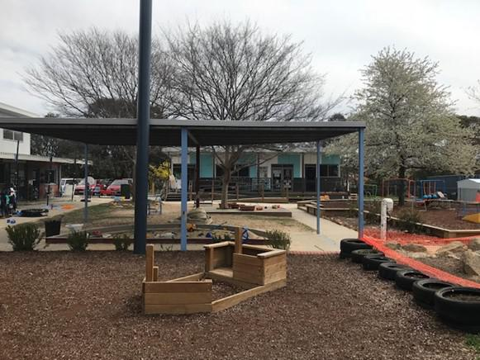

Observe the Preschool program in action.

Thursday 4th April 2:00 pm

Wednesday 10th April 2:00 pm

Tuesday 7th May 9:30 am

Thursday 9th May 9:30 am

Monday 13th May 2:00 pm

Please call the front office: 6142 1440 to book a preschool tour.

TRAFFIC UPDATE

Thank you for the ongoing support of the community in ensuring Palmerston’s carpark is a safe and friendly place to be. A reminder to be patient and park safely in the allocated bays. We have recently met with Traffic and Asset Management and they are finalising plans to improve the flow of our carpark. We are expecting this to occur in the second half of the year. There will be some disruption but it will give us a better flowing car park. Palmerston is a part of the active schools program and this is parked with blue stencils, these provide safer routes for walking to school. We are lucky that at Palmerston we also have an underpass which allows students to not have to cross over the busy road. Under the parking requirements we are required to have a total of 84 car spaces, we are lucky that at Palmerston we have a total of 107 car spaces. Remember key suggestions for avoiding car park congestion are: Pick your child up at five or ten minutes later in the afternoon or park at the shops. A parking van has again been patrolling the area and is issuing tickets for those who park on the kerb.
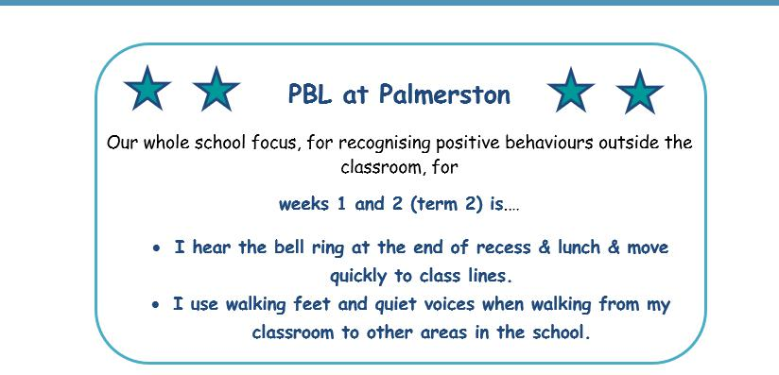

Together, we learn from each other

Palmerston Post

P&C Uniform Shop Price List 2019

New Merchandise

Polar Fleece Beanies (with logo) | $10
Dresses (Winter Navy) | $30
Library Bags (with logo) | $15
Round Palmerston logo Sew-on Badges (Small) | $2.50
Round Palmerston logo Sew-on Badges (Large) | $3.50
Palmerston Teaspoons | $5
Palmerston Coffee Mugs | $10 | (money to front office)
Palmerston Travel Mugs | $15 | (money to front office)

Second Hand Items

Hats | $2
Palmerston Polo Shirts | $2
Palmerston Long Sleeve Shirts | $3
Skivvies | $2
Jumpers – No Logo | $3
Jumpers - Logo | $5
Vest – Logo | $3
Trousers/Trackpants | $3
Shorts | $2
Skorts | $2
Sports Skirts | $2
Girls Bike Pants | $2
Dresses (navy winter and checked summer) | $5
School Bag with Logo | $10

P&C Uniform Shop is located just inside the Hall Entrance

Contact the Front Office, or P&C contact below, to make an appointment outside of standard opening hours.

Kate: 0404 675 508 Franki: 0431 675 725

Opening Times: Tuesday 2:45 - 3:15pm

Friday 8:30 – 9:00am

Together, we learn from each other

Palmerston Post

HIRERS NEWS
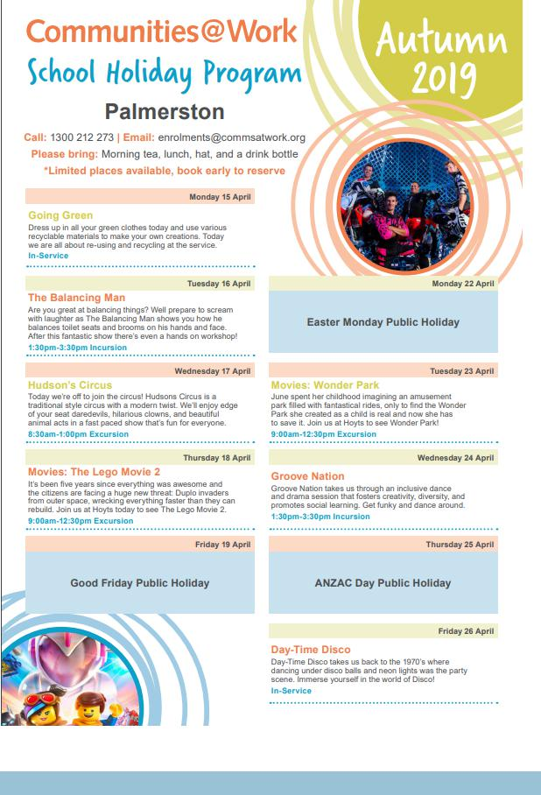

Together, we learn from each other

Palmerston Post

COMMUNITY NEWS
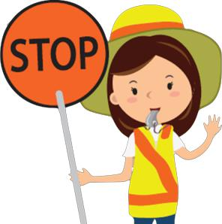

School travel and safety survey

Transport Canberra and City Services has engaged First Person Consulting to conduct research into parents’ attitudes to their children's active travel to and from schools. Part of this is investigating the role that crossing supervisors have in improving safety around schools, and the extent to which parent’s attitudes to children travelling actively change as a result.

You may have completed a similar survey last year, this is the final survey as part of the evaluation to gauge parent perceptions about safety around schools.
To complete the survey please click here, or copy and paste the following link into your browser:

https://www.surveygizmo.com/s3/4828047/School-Crossing-Supervisor-Survey-Control-Feb19

The survey should take about five minutes. The survey will not collect any identifiable information, and all responses will be kept confidential.

Thank you in advance for your time in completing this survey. If you have any questions please contact

the TCCS Schools Program.
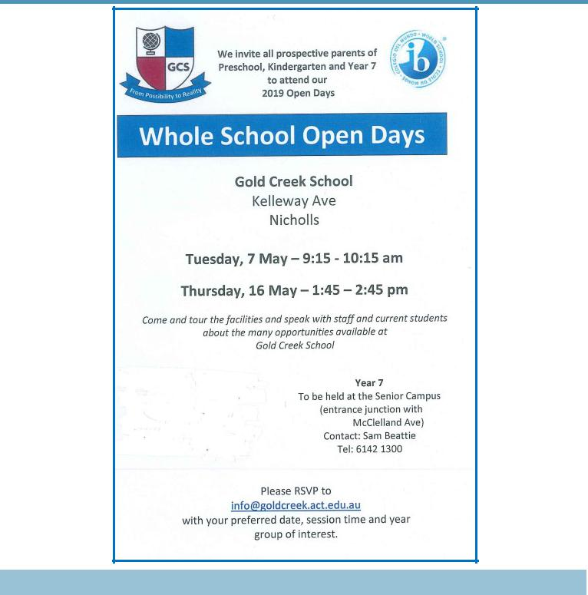

Together, we learn from each other

Palmerston Post
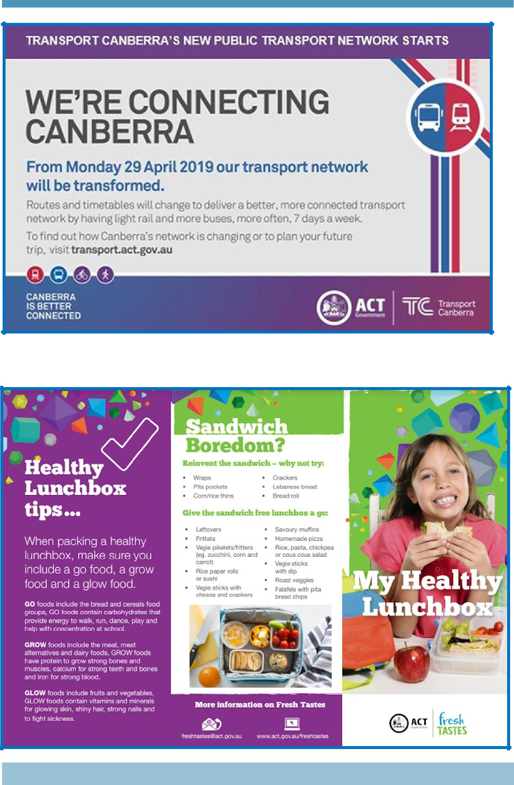

Together, we learn from each other

Palmerston Post
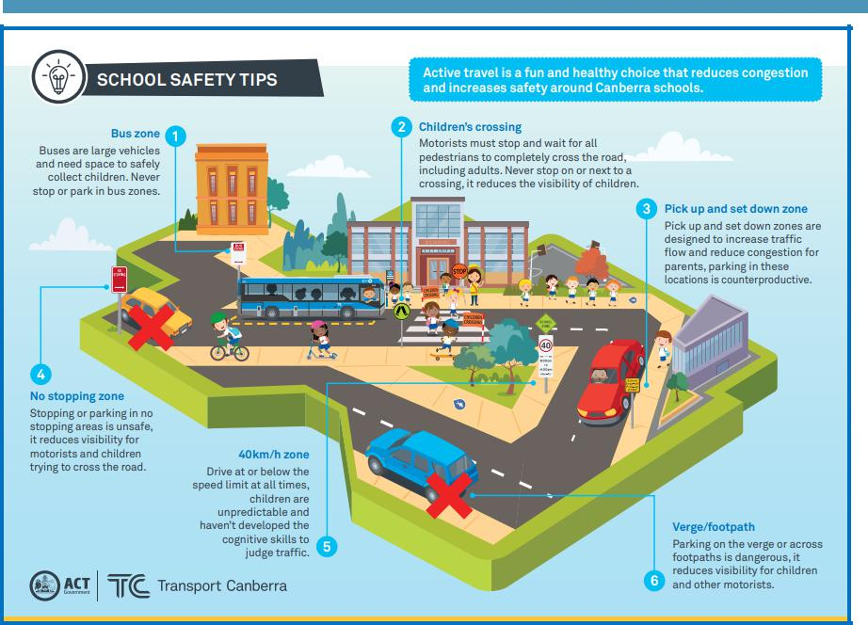

Together, we learn from each other

