Palmerston Post
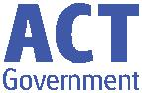

20 June 2019

Week 8, Term 2

Board Chair: Lisa Fior Board Members: Parent Reps: Adam Davidson and Kate Baron

Teacher Reps: Jessica Lago and Maxine Green

P&C President: Lisa Fior

Principal: Kate Smith Deputy Principals: Haeley Simms (A/g) & Kylie Moller (A/g)

Executive Teachers: Matt Gowen, Felicity McNeice, Catherine Griffin (A/g)
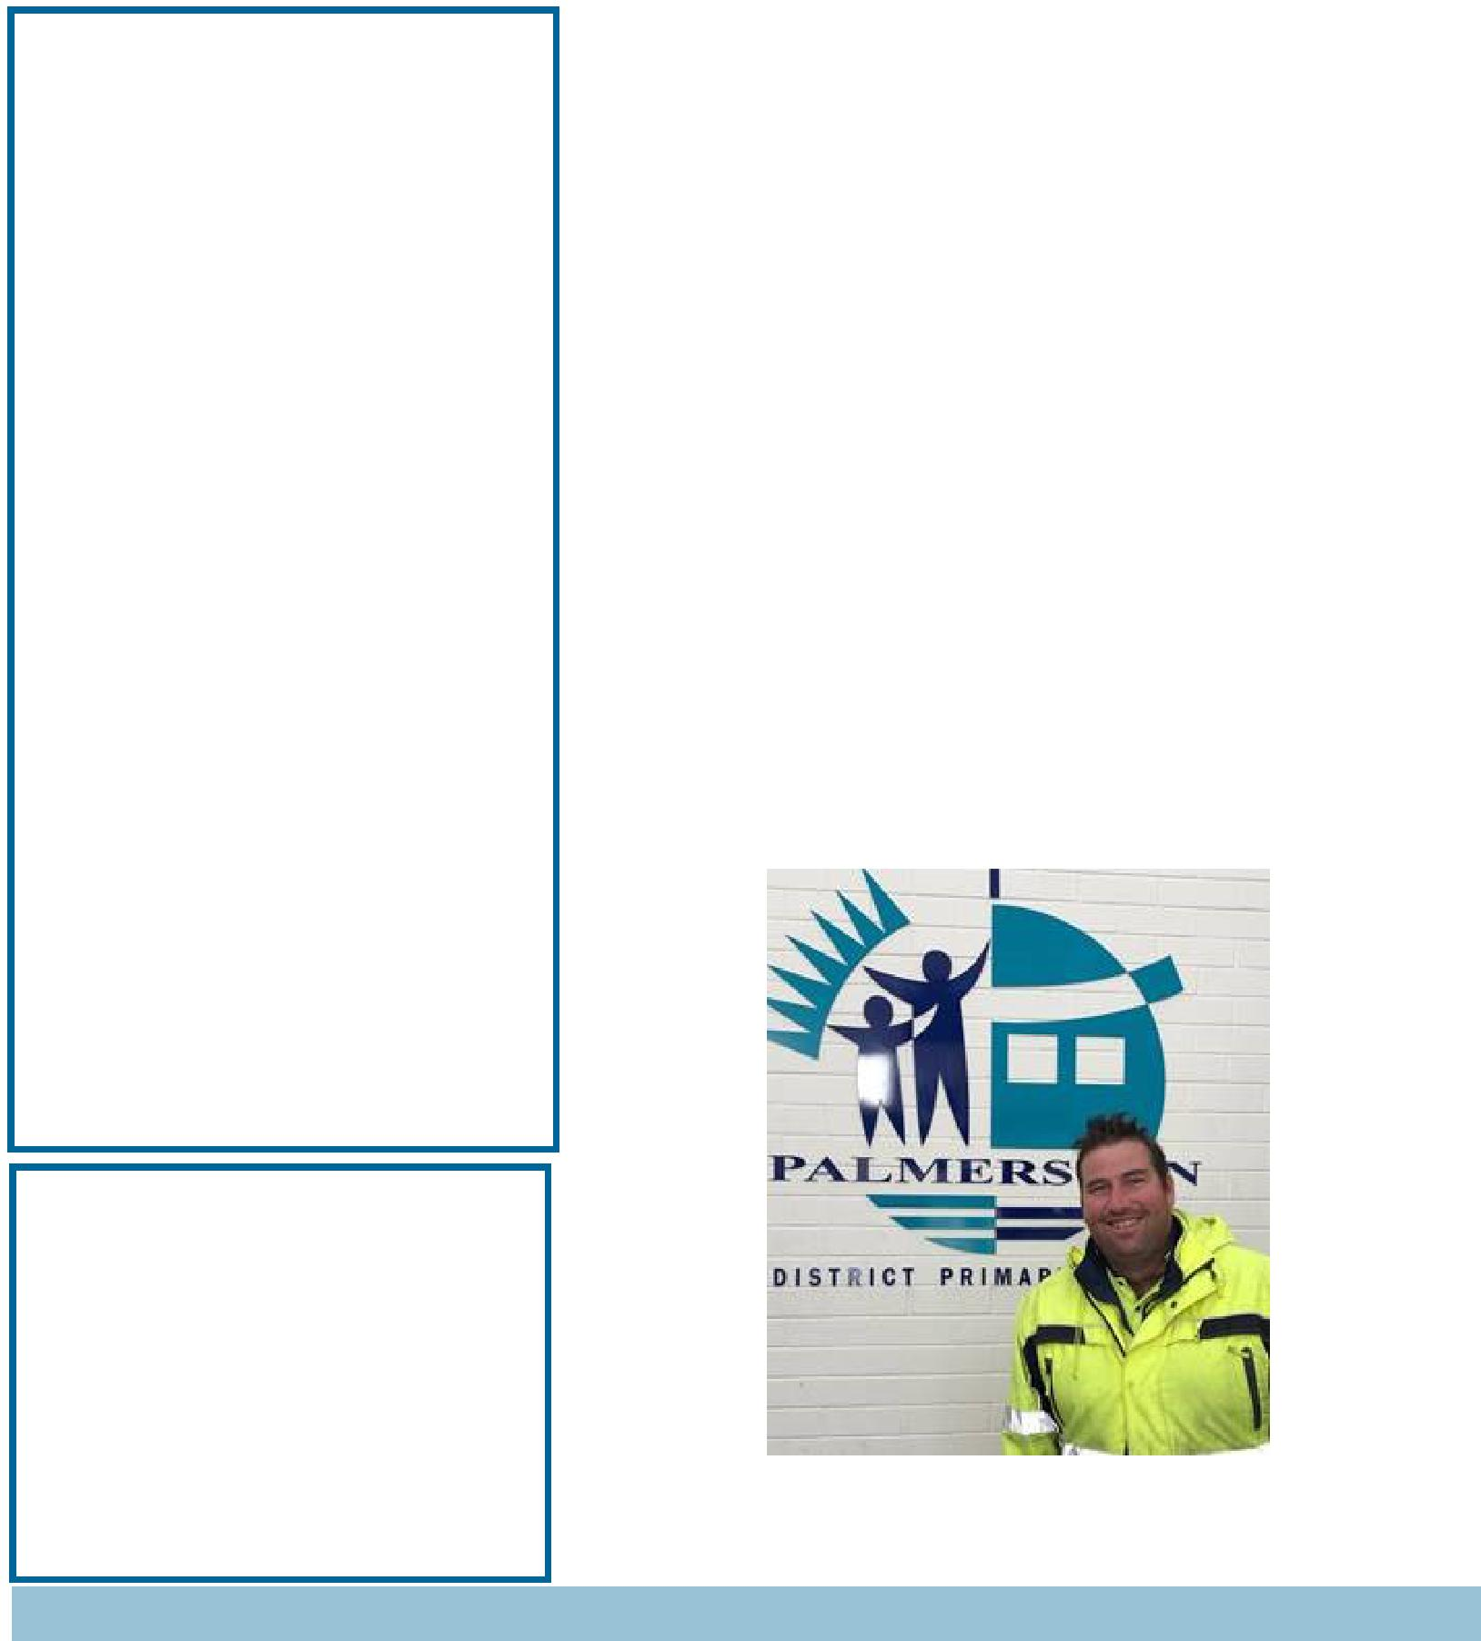

ASSEMBLY:

21 June Junior - KGM, KMC & KGS

28 June Senior - 3AP & 3AJ

5 July Junior - IEC

DATES TO REMEMBER:

21June Year 3/4 Indonesian Arts

Workshop

24 June Hatching Chicks (Preschool)

- &

- June Kindergarten Health Checks

- June Reports home

- &

5 July P/S Healthy food challenge

4 July Year 2 theatre excursion

5 July P&C Lunch order day

1-5 July Parent teacher interviews

NOTES:

P&C Lunch Order

P&C BOARD NEWS P&C: 24 June 2019

All P&C activities, meeting agendas and minutes are available from the school website at – Parent Corner

School Board: 24 June 2019

PRINCIPALS’ MESSAGE

First of all, I would like to start by congratulating the students who recently represented our school in a Soccer Gala day at Harrison School. Mr Joy was overjoyed to hear from many external teachers how beautifully behaved, well mannered and positive our students were across the day! That certainly makes me very proud – to know we are growing our students, in partnership with you as parents and carers, to be exemplary role models out in the world – well done to everyone.

Another definite highlight for our week, was the ‘Superstar status" that Mr Phil has elevated to through the recent Mix 106.3 Suburb Song of Palmerston. So many people nominated Mr Phil to be a feature of the song and we applaud these nominations. When a school has a BSO that cares deeply not only for the buildings and grounds, but also everyone inside the gates – it really is something to celebrate!

Together, we learn from each other

Palmerston Post

As a school we are working toward building a culture of PBL – Positive Behaviours for Learning . Mrs Simms and the PBL team, including students, have been busily working on designing and putting up large PBL boards around the school, with expectations for behaviour for everyone to aim for – and this in turn adds largely to an environment where everyone can be safe, respectful learners. Students will see these large metal boards appearing all over the school soon as reminders for the best behaviour to show.

A week of celebrations, congratulations to the students seen in the photo for the recognition from their teachers and myself for their amazing work with various aspects of their academic program. It was a delight to be part of the recent Yr 5/6 assembly, and to see these students receive this award. Congratulations to each

of you, it was super lovely to then meet for a morning tea and learn more about you!
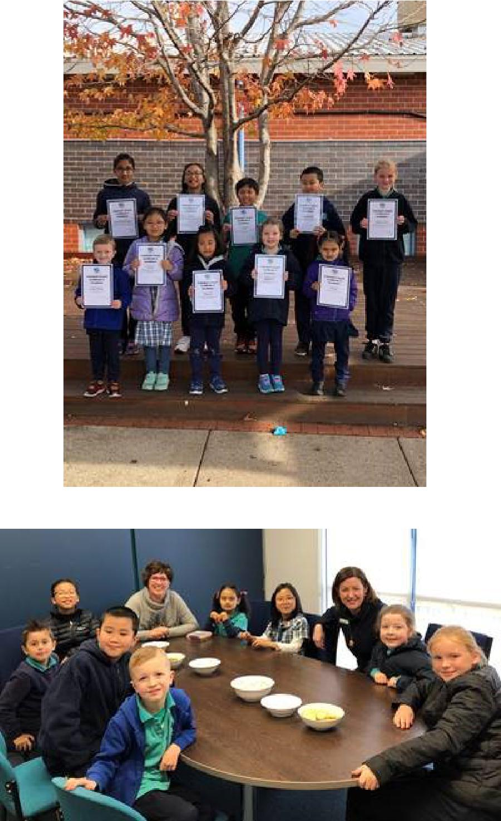

Kate Smith

Together, we learn from each other

Palmerston Post
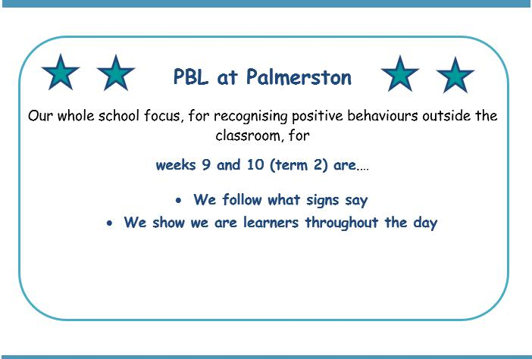

UPCOMING EVENTS

Preschool Hatching Chicks Program
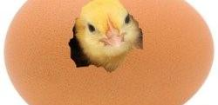

Date: Monday 24 June 2019

Location: Palmerston Preschool

Kindergarten Health Checks

Date: Wednesday 26 June & Thursday 27 June

Location: PDPS

Year 2 Theatre Excursion

Date: Thursday 4 July 2019

Location: Canberra Theatre

P&C Lunch Order Day

Date: Friday 5 July 2019

Location: PDPS

Together, we learn from each other

Palmerston Post

Environmental Science

Students participating in environmental science classes with Mrs Campbell this week made San Choy Bau. This dish proved very successful and popular amongst the students. The recipe was modified to be inclusive by using halal chicken mince, olive oil and water chestnuts. The lettuce, parsley and garlic were sourced from the school kitchen garden and the limes and mint were sourced from a community member, the "chicken lady" Michelle. The recipe is designed to be modified for taste and favourite vegetable, spice and herb. Children

enjoyed the fresh taste experience. Enjoy making your own version of this tasty recipe!

San Choy Bau

Ingredients

- Lettuce leaves

- Vegetable oil – 1 tablespoon

- Garlic – 2 cloves finely chopped

- Ginger – 2cm piece grated

- Parsley – small bunch – finely chopped

- Celery leaves – finely chopped

- Brown onion -1 finely chopped

- Spring onion – 2 thinly sliced

- Chicken mince- 300 grams

- Soy sauce – 1 tablespoon

- Hoisin sauce – 2 tablespoons

- Lime -1 juiced

- Water chestnuts- ¼ cup finely chopped

- Celery – chopped finely

- Carrots - grated

- Rice Noodles- 1 square soaked in hot water

- Coriander- ¼ cup fresh leaves - roughly chopped for topping

- Mint – 1 small bunch – finely chopped – for topping

Optional: fresh red chilli finely chopped and /or sweet chilli sauce – for topping Method

Step 1 Wash lettuce leaves, pat dry and prepare leaves on a tray.

Step 2 Heat wok or frypan. Add oil and fry garlic, ginger, parsley, celery leaves, brown and spring

onion. Add chicken mince and fry until mince changes colour. Break up chicken mince into small pieces.

Step 3 Add soy sauce, hoisin sauce, lime juice, celery, carrot and water chestnuts and fry until all

combined

Step 4 Stir noodles through the chicken mix. Break into small pieces

Step 5 Spoon chicken and noodle mix into lettuce leaves. Sprinkle with coriander and mint leaves

before serving. Add fresh chilli or sweet chilli sauce - optional
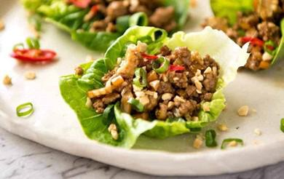

Mrs Campbell

Together, we learn from each other

Palmerston Post

Year 2 News
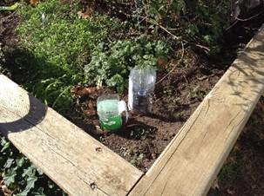

Year two have been wondering about water. During term one, we explored the needs of living things and how all living things need water to survive.

This term, we have gained a deeper understanding of water as a precious resource. We have incorporated the key vocabulary about the water cycle into our writing, using words such as collection, evaporation, condensation and precipitation.

As we know, fresh water is so precious, so we have been exploring ways to save water around our school and homes.
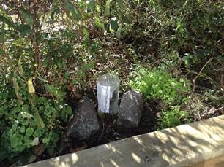

Some ideas year two have brainstormed include:

- Turning off taps and bubblers when we are not using them

- Taking shorter showers

- Reusing water in the garden, when we can

- Not wasting our drinking water

As part of our inquiry unit, we made rain gauges to measure rainfall. We explored how to ensure our measurements were accurate and we are recording the rainfall in a graph.
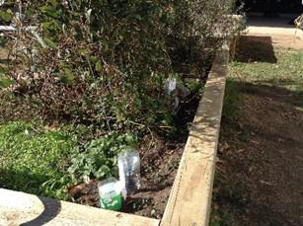

We look forward to continuing to consider ways to be sustainable at our school.
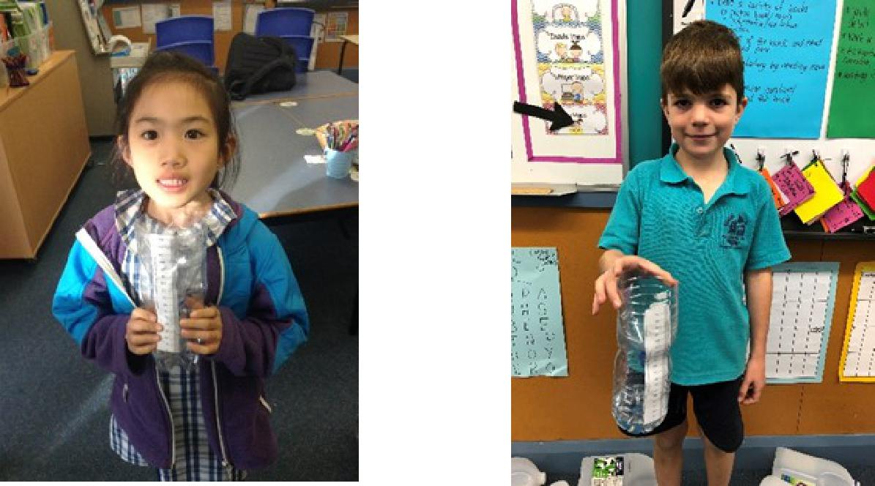

Together, we learn from each other

Palmerston Post

Defence News
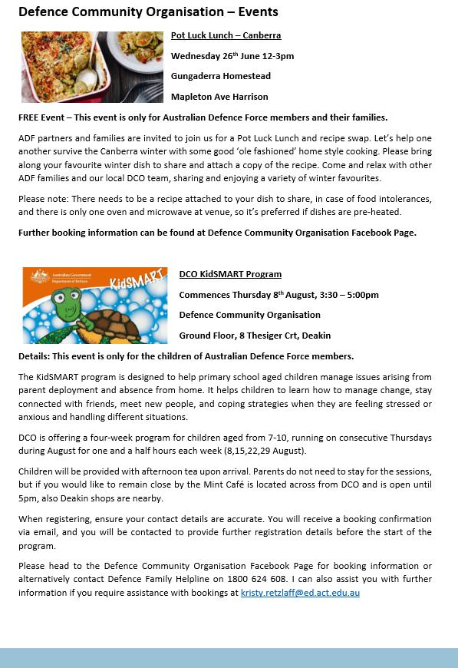

Together, we learn from each other

Palmerston Post

Defence News
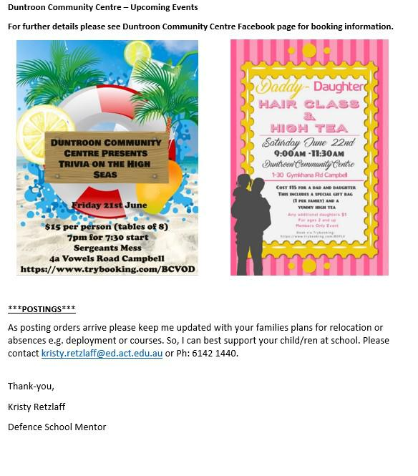

Together, we learn from each other

Palmerston Post

Protect yourself and your family from the flu

Getting vaccinated is the best way to prevent your family getting the flu this winter.

The flu vaccine can save a child’s life.

The vaccine is safe, and everyone 6 months of age and over, including pregnant women and young children, should get the vaccination.

Children are more likely to contract the flu, spread it around, and are at a higher risk of serious complications if they get sick. The flu is highly contagious and is spread easily through childcare centres and schools.

The flu vaccine is free in the ACT for:

- children aged 6 months to under 5 years

- pregnant women

- people 65 years of age and older

- all Aboriginal and Torres Strait Islander people aged 6 months and older, and

- people aged 6 months and older with some medical conditions such as severe asthma, heart or lung disease, diabetes or weakened immune systems.

Where to get your flu vaccination

Everyone can get a flu vaccine from their GP or immunisation provider.

People over 16 years of age can also get a vaccine at some pharmacies.

ACT Government Early Childhood Immunisation Clinics provide a free flu vaccination for children aged 6 months to under 5 years. To book an appointment, call Community Health Intake on 02 5124 9977.

Learn more about influenza and where to get your vaccination at health.act.gov.au/flu

P&C NEWS
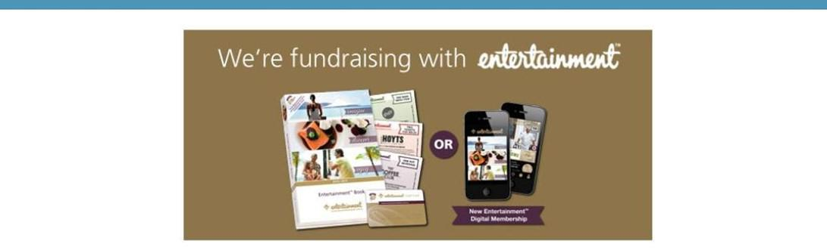

The P&C are fundraising with the Entertainment book. The Entertainment™ Book is a local restaurant and activity guide which provides hundreds of up to 50% off and 2-for-1 offers from the finest restaurants, cafes, attractions, activities, retailers and hotel accommodation. The Membership entitles buyers to exclusive offers that are virtually restriction-free, and is valid through to 1 June 2020!

The Entertainment™ Digital Membership (app) puts all of the value of the Entertainment ™ Book into the customer's smartphone. With 'near me' technology and the ability to show and save using a phone, this is perfect for the person on-the-go, with no card or voucher to present.

You can purchase a book through the front office or download the app via this link

https://www.entertainmentbook.com.au/orderbooks/2487s6

Together, we learn from each other

Palmerston Post

P&C NEWS
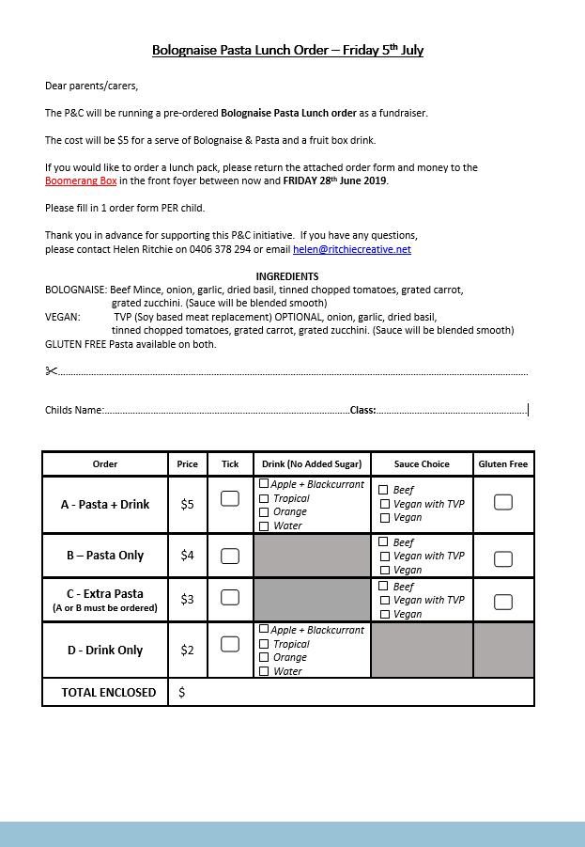

Together, we learn from each other

Palmerston Post

P&C NEWS

Together, we learn from each other

Palmerston Post

With winter upon us, it’s important to remember that Canberra has lots of health options that don’t involve a trip to a hospital emergency department. Many of these are free and available after hours.

Walk-in Centres provide free, one-off treatment of minor injury and illness, including colds and flu. They’re a great choice for children over 2 years of age – children under 2 should see their GP.

Walk-in Centres are open from 7.30am to 10pm, every day of the year. They are staffed by highly skilled nurses who can provide you with a sick certificate and in some cases, medication, saving you time and money.

The service is free and no appointments are necessary.

Walk-in Centres are located in Tuggeranong, Belconnen and Gungahlin.

To find out more about getting the right health care for your symptoms, visit

www.act.gov.au/yourhealthoptions
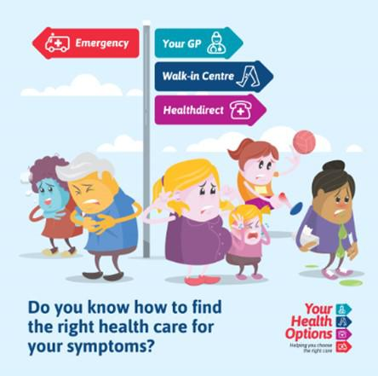

Together, we learn from each other

Palmerston Post
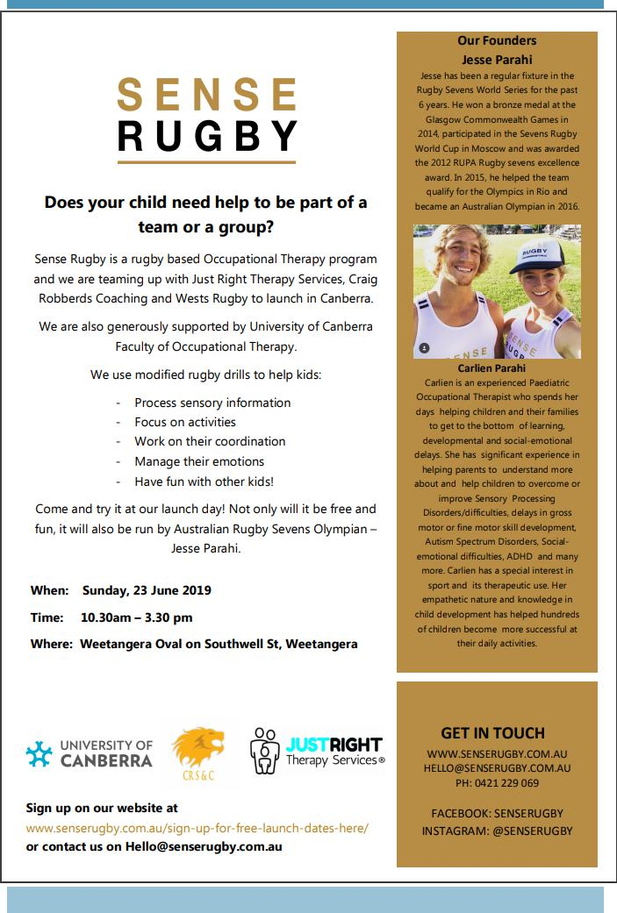

Together, we learn from each other

Palmerston Post

COMMUNITIES @ WORK
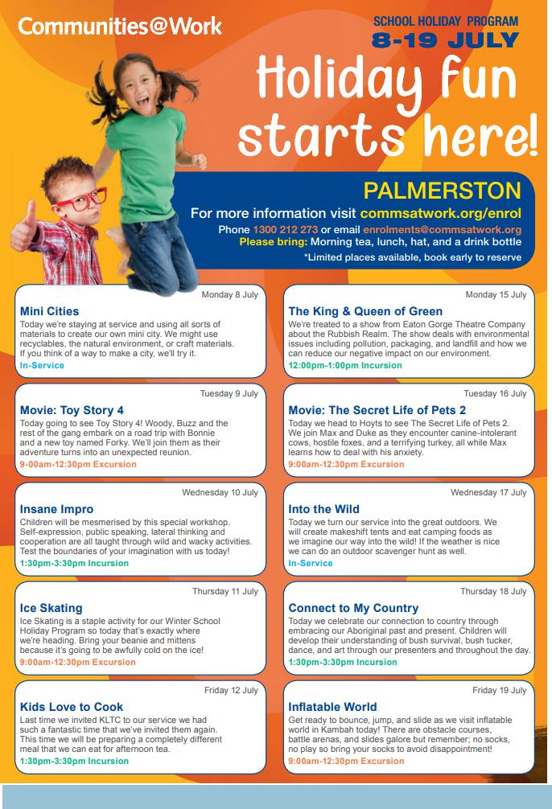

Together, we learn from each other

Palmerston Post

HIRERS NEWS
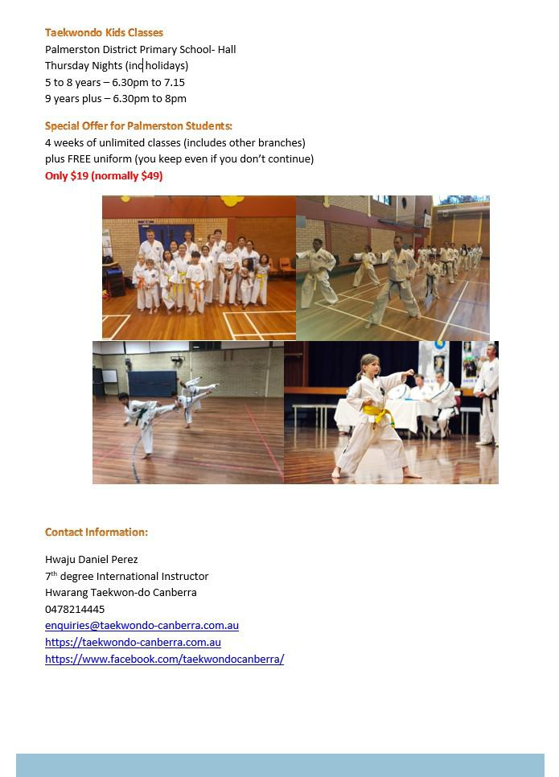

Together, we learn from each other

Palmerston Post

ParentLink

ParentLink provides parenting education to the community, from birth to teenage years. It is available for parents, carers, kin, teachers, and the broader community, providing information and links to local resources and services.

The ParentLink website provides links to all ParentLink guides including a variety of topics - Start-ing School, More than Reading and Writing, Optimism and Cyber Safety.

The ParentLink suite of resources includes guides specifically for Aboriginal and Torres Strait Islander families, and access to resources for diverse cultural groups.

ParentLink guides are available to view and order via the website at, https:// www.parentlink.act.gov.au/
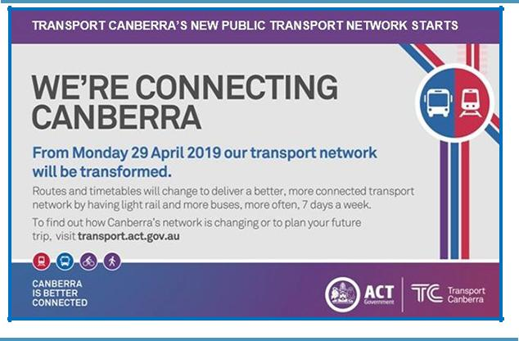

PARKING AROUND SCHOOLS

As we drive and park our cars around schools we all need to ensure the safety of school students is our priority. Parking ille-gally and unsafely across pedestrian crossings, corners and verges puts children at risk. We all need to help keep our chil-dren safe. Here is a short video demonstration: https:// youtu.be/AslMVXpA9Zc
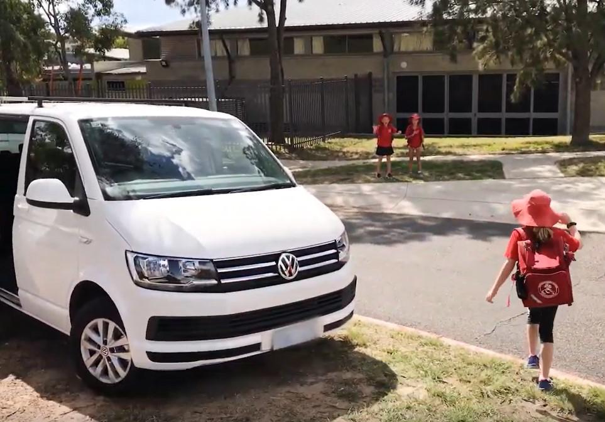
Access Canberra inspectors will be patrolling our school zones to help us ensure drivers do the right thing.

Together, we learn from each other

