What’s On
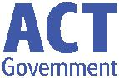

7 March 2019

Week 5, Term 1

ASSEMBLY:

8 Mar | Senior - Year 4
15 Mar | No assembly
22 Mar | Whole school - 1KW &
 | 1DE
DATES TO REMEMBER:
11 Mar | Canberra Day - public
 | holiday
13 Mar | K-Yr2 Questacon
 | incursion
15 Mar | Yr3-6 Questacon
 | incursion
19 Mar | Yr3-6 Author visit -
 | Katrina Nannestad
20 Mar | Christian Education
21 Mar | Harmony Day / Bulling
 | No Way Day
25 Mar | Yr2 - Kenny Koala visit
27 Mar | Special Farewell
 | Assembly for Melissa
 | Travers

NOTES:

- K-Yr6 Questacon incursion

- Yr3/4 Expression of interest - Drumming

DEPUTY PRINCIPALS MESSAGE

We are halfway through term one. Can you believe it? There is a

definite shift in the weather as we head into the second part of

term. Please ensure that if your child is bringing a jumper, it is clearly

labelled, so that we can easily return it to you child if it gets left

behind.

Last week we had the visiting ‘Billy Tea Bush Dance’ band come in to

teach all students how to bush dance. Classes buddied up across the school and had such a lovely time learning these traditional Australian dances. The day culminated in a community bush dance, which was a whole lot of fun. Thank you to all who participated in this event and to our P&C and staff members for providing all with a sausage sizzle on the night.

This week, we have held some ‘Reading With your Child’ workshops for parents with children in preschool to year two. Again, thank you to those who could attend and to our staff for sharing their expertise in this area. Students in these year levels will find a book mark with their notes home next week, which provides some reminders of strategies for students to use when they are reading at home. If you would like any further information or were unable to attend a workshop, please approach your child’s teacher.

Next week we are fortunate enough to have Questacon visit our school for an incursion. This incursion will focus on chemical and physical science and is free of charge. A goal in our school plan is to foster the growth in learning for all students in Science, Technology, Engineering and Maths (STEM) and this incursion is just one way that we are supporting students to achieve growth in this area.

Don’t forget that Monday is the Canberra Day public holiday, which

means that there will be no school.

We hope you all enjoy a relaxing, safe long weekend,

P&C BOARD NEWS P&C: 18 March 2019

All P&C activities, meeting agendas and minutes are available from the school website at – Parent Corner

School Board:

Kylie Moller & Haeley Simms

Together, we learn from each other

What’s On

SCHOOL BOARD NOMINEES

Voting period: 8 March - COB 22 March 2019

Voting forms will be available from the front office.

Board Nominee Introductions

Kate Baron

My name is Kate Baron and I have a daughter in year 2 and a 3 year old at home. I have previously worked as a teacher in the ACT public education system. I am passionate about evidence-based teaching practice and student, teacher and staff wellbeing. I believe that a school where parents, teachers and staff work together provides the best outcomes for students and would use my place on the board to further promote community involvement in all areas of school life. I would appreciate the opportunity to help Palmerston continue to flourish as a fun, happy and engaging place for students to learn, staff to work and the community to enjoy.

Adam Davidson

As Chief Financial Officer for a large Canberra business I have experience in the financial and operational requirements for an organisation to reach its goals and objectives. I also have a keen interest in high performing organisations and what is required for teams to take their performance to the next level.

My entire life has been spent surrounded by family members who are part of the teaching profession at various levels and from this I have a solid knowledge of the ups and downs of schools and what areas require focus in order to create a great school. My aim as a board member would be to combine this with my passion for organisational performance to see continual improvement in the school’s performance across all areas be it academic, social and emotional needs, co-curricular and community engagement.

With two children already at the school and another one who will be attending in the coming years I have a vested interest in the school continuing to go from strength to strength over the long term. If elected I will be committed to accountability and a solutions-based approach to the role as parent representative on the school board.

Amy Phillips

In the past I have held both Parent Representative and Board Chair positions on the Palmerston School Board and I am keen to renew my connection with the Board again this year. In my working life I am an executive with the Department of Finance and have spent my career leading and driving improvements across many facets of public administration. I believe in quality education and providing children with a safe environment in which to learn and grow as confident members of the wider community. In my experience Palmerston provides this and much more.

I have a long association with Palmerston Primary, with my eldest starting in Kindergarten in 2009, the term after Melissa Travers took over the reins. During this time my husband Simon and I have watched the school blossom and participated in many fantastic events including assemblies, information sessions, trivia nights, Twilight Fairs, discos, graduation ceremonies, Remembrance Day activities, performance reporting sessions and the carols extravaganzas. With our youngest, Hamish, in year 2 this year we look forward to many more memorable occasions going forward.

I would cherish the opportunity to once again represent your interests, and look forward to your support.

Together, we learn from each other

What’s On

UPCOMING EVENTS

Questacon incursion

Date: K-Yr2 , Wednesday 13 March 2019

Yr3-6 Friday 15 March 2019

Location: PDPS

CLEAN UP AUSTRALIA DAY

Date: Friday 22 March 2019

Location: PDPS

SPECIAL FAREWELL ASSEMBLY FOR MELISSA TRAVERS Date: Wednesday 27 March 2019

Location: PDPS
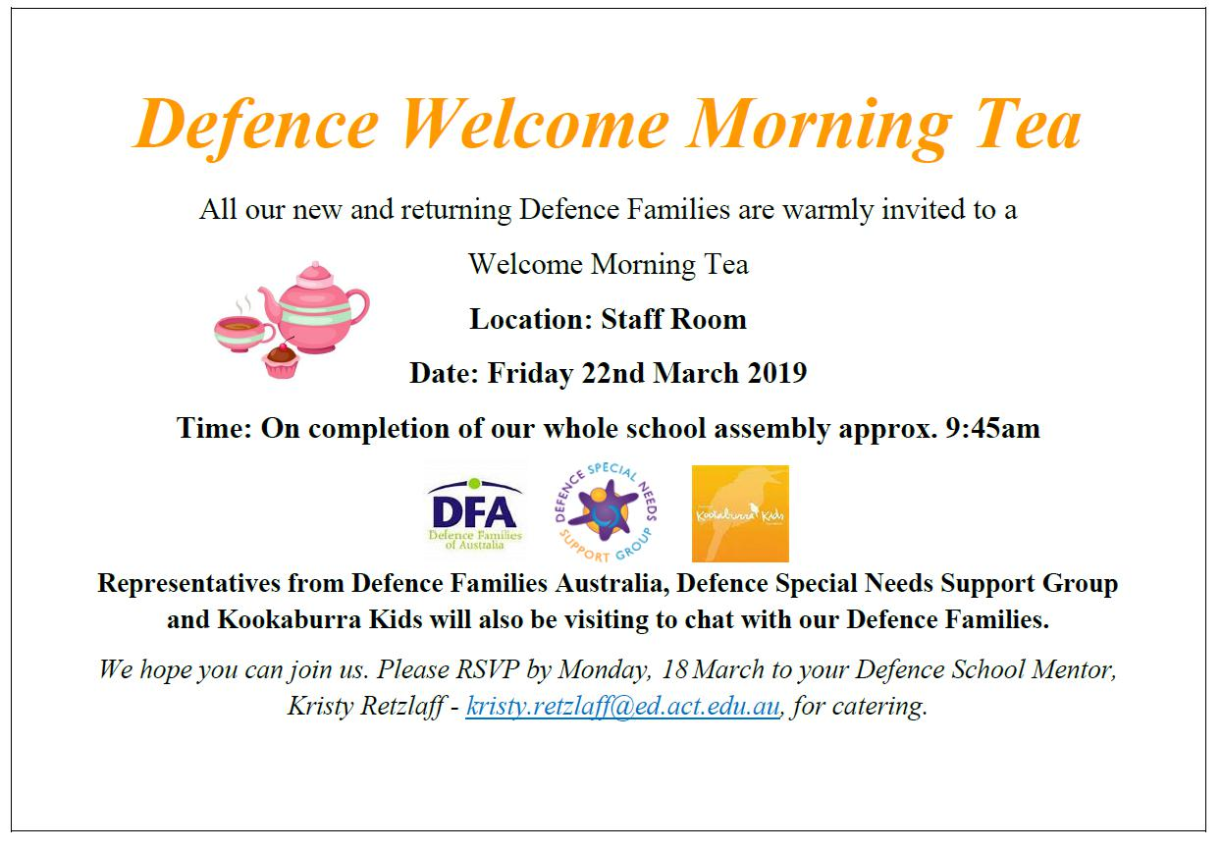

Together, we learn from each other

What’s On
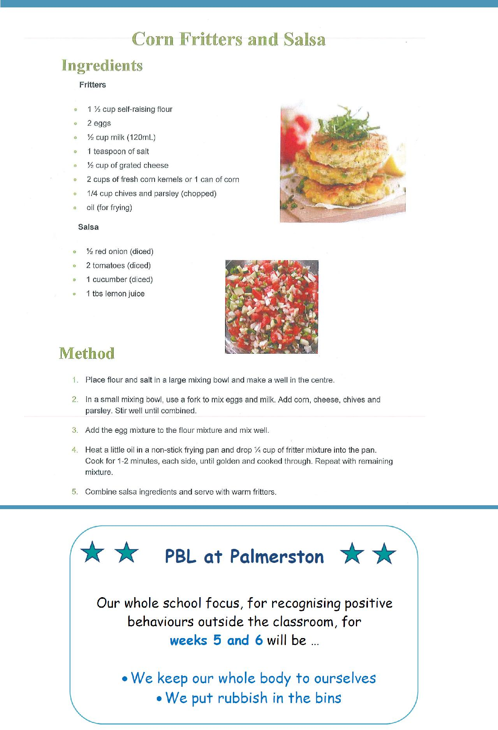

RECIPE FROM MRS CAMPBELL’S COOKING CLASS

Together, we learn from each other

What’s On

COMMUNITY NEWS
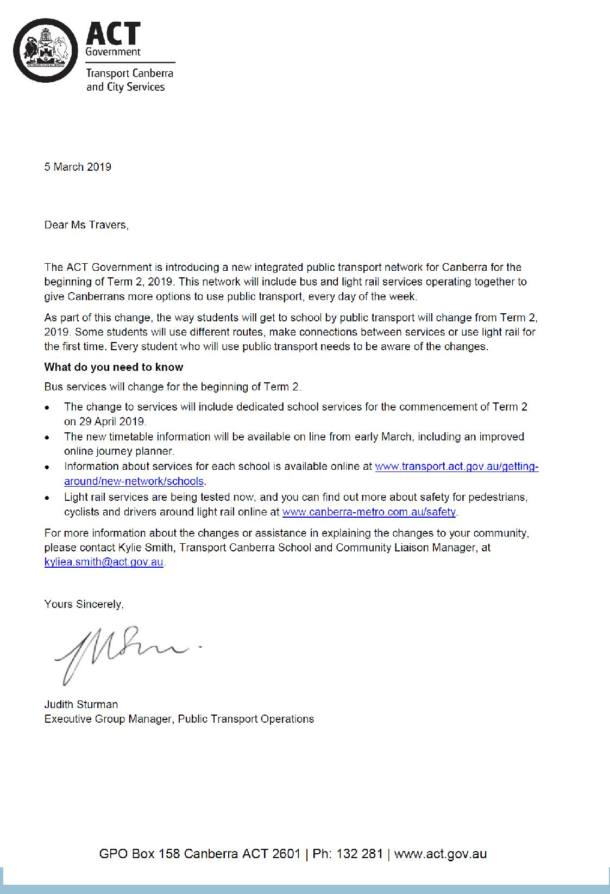

What’s On

Parents & Carers’ Support Group

Connect with other parents and carers of children and young adults on the autism spectrum.

Evening support groups on the south side will be held on the second Thurs-day of the month at Marymead, located at the Rheinbeger Centre, Corner Loch and Weston Streets, Yarralumla (view map) from 7:00 pm to 9:00 pm. You are welcome to join in on the day, no need to pre-register.

See Marymead’s website for more details: https:// www.marymeadautismcentre.org.au/activities/support-groups/autism-carers-support-group

Together, we learn from each other

What’s On

School travel and safety survey

Transport Canberra and City Services has engaged First Person Consulting

to conduct research into parents’ attitudes to their children's active trav-el to and from schools. Part of this is investigating the role that crossing supervisors have in improving safety around schools, and the extent to which parent’s attitudes to children travelling actively change as a result. You may have completed a similar survey last year, this is the final survey as part of the evaluation to gauge parent perceptions about safety around schools.

To complete the survey please click here, or copy and paste the following link into your browser:

https://www.surveygizmo.com/s3/4828047/School-Crossing-Supervisor-Survey-Control-Feb19

The survey should take about five minutes. The survey will not collect any identifiable information,

and all responses will be kept confidential.

Thank you in advance for your time in completing this survey. If you have any questions please contact

the TCCS Schools Program.

Together, we learn from each other

