Palmerston Post

23 May 2019

Week 4, Term 2

Board Chair: Lisa Fior Board Members: Parent Reps: Adam Davidson and Kate Baron

Teacher Reps: Jessica Lago and Maxine Green

P&C President: Lisa Fior

Principal: Kate Smith Deputy Principals: Haeley Simms (A/g) & Kylie Moller (A/g)

Executive Teachers: Matt Gowen, Felicity McNeice, Catherine Griffin (A/g)

ASSEMBLY:
24 May |  | Junior 1AS & 1HD
31 May |  | Senior 3/4DJ &
 |  | 5/6JM
DATES TO REMEMBER:
24 May |  | Yr3/4 & IEC Theatre
 |  | Excursion
27 May |  | Reconciliation Day
28 May |  | Rostrum School Final
31 May |  | Athletics Carnival

NOTES:

P&C BOARD NEWS P&C: 13 May 2019

All P&C activities, meeting agendas and minutes are available from the school website at – Parent Corner

School Board: TBA

PRINCIPAL’S MESSAGE

Hi everyone,

Being curious is a favourite hobby of mine. I was very curious on Saturday to see how the Democracy Sausage Sizzle would be supported by our community. Can I say how thrilled I was to see such a wonderful team of parents from many different classes across our school attend and help across the day. I’d like to extend my personal thanks to each and every one of you who braved the brisk chilly morning to set up and start cooking, for those who served all day, and those who packed up too. Thank you for the generous donations for the Cake stall, we appreciate

the efforts that folk went to, given lives are very busy.

Thanks lastly to the P&C who arranged the day and due to their finely tuned organisational skills – it was a great success.

Community is so important for a school to thrive. I am thrilled to see so many parents, family and grandparents who come along regularly to support the learning in early childhood classes of a morning. Your assistance and love is gratefully appreciated. To have generations of families still coming into the school gates and adding value to our learning programs is just a beautiful

thing.

If are interested in joining the P&C, I’d love to welcome you in, maybe you have a particular talent you can offer, feel free to contact us at any time if you have questions. Building numbers in our P&C is a proactive way to ensure great things can happen.

Teamwork makes the dream work. Together we can do so much.

Our school nestles very closely to the Palmerston Shops I have been approached by a representative of the Body Corporate, who have asked for my support in informing our families of the need to keep parks open for their customers during times when we have events and of course the busy time at the end of the day. Exciting news is that we are getting a carpark upgrade at the end of term 3, so that should streamline and maximise our

carpark flow.

Together, we learn from each other

Palmerston Post

Parking tends to be a concern in many schools across our territory, but could I please ask, if you can park a little further away from the school – walk a little bit, that is a great opportunity for a walk and talk before hopping in the car and driving home. If we can support our local shops with less cars that would mean a lot to

them.

Effective communication between school and our community is so important. I am curious to hear your views on how “our reach” could be improved, what do you like about how we communicate to you. What could be improved? I am very happy for you to email me directly with any ideas you may have. I have received one terrific email from a parent in POD 2, with some excellent ideas – thanks for being so proactive. Things you could ponder are: newsletter, notes home, SeeSaw, Facebook…and any other comments you might like to

make. Your voice counts – so please drop me a line: kate.smith@ed.act.edu.au

Public Education Week is a time for us to celebrate the learning that happens inside and outside of our classrooms. We also held the National Simultaneous Reading session…this involved all classes reading the same book at the same time – in our school and across Australia. Our Mystery Reader read the book over the

school PA system – someone who loves reading and gave Alpacas with Maracas her best shot!

Until next time, be curious,

Kate Smith

Positive Behaviours for Learning (PBL)
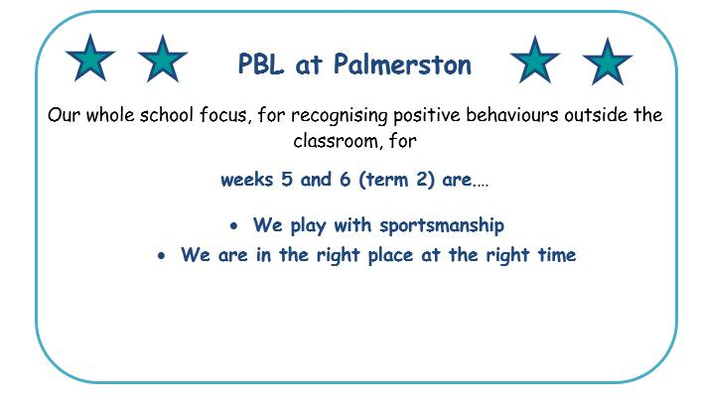

Together, we learn from each other

Palmerston Post

Semester One Reports 2019

Palmerston District Primary School has been selected to pilot the new Education Directorate report format. This format will be common for students across all Kindergarten to Year 10 schools. The report is generated through the Student Administration System (SAS). Semester One reports will be emailed to parents. Please read the fact sheet attached. There will be more information to come in following newsletters and PDPS will conduct parent information sessions about the reporting process in coming weeks.

Reporting Student Achievement in ACT Public Schools

In 2019 the Education Directorate are introducing a common report format, for students in Kindergarten to Year 10, through the new Student Administration System (SAS). This change will occur via a staged

implementation process, with some schools piloting the new report format in Semester 1, 2019.

The new common report format uses information directly from the subject area Achievement Standards outlined in the Australian Curriculum. Achievement Standards set the goal for what all students should learn as they progress through their school life. From the first year of schooling to Year 10, students develop knowledge and skills in eight learning areas:
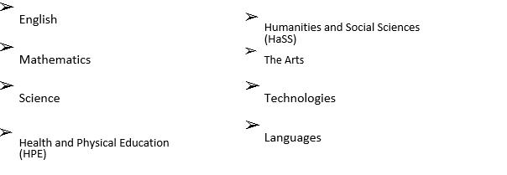

Below are some examples of Achievement Standard statements that may appear on a student report. Students will be allocated an achievement level against each sentence using a five-point scale: limited, partial, at standard, high or outstanding. The student will also receive an overall grade for the learning area using a five-point A-E scale.

Some example English statements that may appear on a report:

Foundation/ Kindergarten | Year 4 | Year 9
They read high-frequency words and | They fluently read texts that | They select evidence from texts to
blend sounds orally to read | include varied sentence | analyse and explain how language
consonant-vowel-consonant words. | structures, unfamiliar | choices and conventions are used
 | vocabulary including | to influence an audience.
 | multisyllabic words.
Their writing shows evidence of | Students create texts that | Students create texts that respond
sound and letter knowledge, | respond to issues, interpreting | to issues, interpreting and
beginning writing behaviours and | and integrating ideas from | integrating ideas from other texts.
experimentation with capital letters | other texts.
and full stops.

Together, we learn from each other

Palmerston Post

Some example Mathematics statements that may appear on a report:

Foundation/ Kindergarten | Year 4 | Year 9
Students count to and from 20 | They recognise common equivalent | They recognise the connections
and order small collections. | fractions in familiar contexts and | between similarity and the
 | make connections between fraction | trigonometric ratios.
 | and decimal notations up to two
 | decimal places.
Students connect events and the | Students use scaled instruments to | They make sense of the position of
days of the week. | measure temperatures, lengths, | the mean and median in skewed,
 | shapes and objects. | symmetric and bi-modal displays to
 |  | describe and interpret data.

Some example Science statements that may appear on a report:

Foundation/ Kindergarten |  | Year 4 | Year 9
They suggest how the environment |  | They describe how contact and non- | They explain global features and
affects them and other living things. |  | contact forces affect interactions | events in terms of geological
 |  | between objects. | processes and timescales.
 |  | They identify when science is used to | Students design questions that can
 |  | understand the effect of their | be investigated using a range of
 |  | actions. | inquiry skills.
Students share and reflect on |  | They use provided tables and column | They design methods that include the
observations, and ask and respond |  | graphs to organise data and identify | control and accurate measurement
to questions about familiar objects |  | patterns. | of variables and systematic collection
and events |  |  | of data and describe how they
 |  |  | considered ethics and safety.
 |  | They suggest reasons why their | They analyse trends in data, identify
 |  |  | relationships between variables and
 |  | methods were fair or not. | reveal inconsistencies in results.

Together, we learn from each other

Palmerston Post

Some example HPE statements that may appear on a report:

Foundation/ Kindergarten | Year 4 | Year 9
Students recognise how they are | Students recognise strategies for | Students critically analyse contextual
growing and changing. | managing change. | factors that influence their identities,
 |  | relationships, decisions and
 |  | behaviours.
They identify actions that help them | They investigate how emotional | They evaluate the outcomes of
be healthy, safe and physically | responses vary and understand how | emotional responses to different
active. | to interact positively with others in a | situations
 | variety of situations.
They describe how their body | They use decision-making and | They apply and transfer movement
responds to movement. | problem-solving skills to select and | concepts and strategies to new and
 | demonstrate strategies that help | challenging movement situations.
 | hem stay safe, healthy and active.
They perform fundamental | They refine fundamental movement | They apply criteria to make
movement skills and solve movement | skills and apply movement concepts | judgements about and refine their
challenges. | and strategies in a variety of physical | own and other’s specialised
 | activities and to solve movement | movement skills and movement
 | challenges. | performances.

There is parent friendly information available on the Australian Curriculum via the following link https://www.australiancurriculum.edu.au/parent-information/

In the ACT, student work at Standard is considered a ‘C’ grade which indicates the student is on track and demonstrating achievement at the standard. A ‘C’ grade is to be celebrated.

You will be provided an opportunity to provide feedback on the new system generated common report format early in term 3.

Enrolments for 2020

Enrolments for the 2020 school year opened on 29 April 2019. All ACT children are guaranteed a place in their local public school for Kindergarten to year 12. However, due to growth in recent years in enrolments in the public system, some schools no longer have the capacity to take “out of area” enrolments. These schools have been identified as “Category A” schools and a list appears on the Education Directorate website.

You will not be able to seek enrolment for your child at one of these schools unless you live within the school’s priority enrolment area (i.e., the school’s geographic zone). All schools will, however, consider cases where there are legal issues, or exceptional circumstances based on student wellbeing. To avoid disappointment, you are encouraged to check the information on the Education Directorate’s website so you can make the best decision for your family from the options available.

Together, we learn from each other

Palmerston Post

Year 5/6 News

This week at Palmerston year five concluded their NAPLAN testing while year six students participated in team based learning activities. Students presented their Rostrum speeches and finalists have been selected to represent their year level in class groups. In class time we have been analysing and critiquing different text types and have been examining the language features found within them. During inquiry, students have been learning about the different types of governments including our own representative democracy. Here are some

various photos from inside the 5/6 classrooms where students are hard at work.
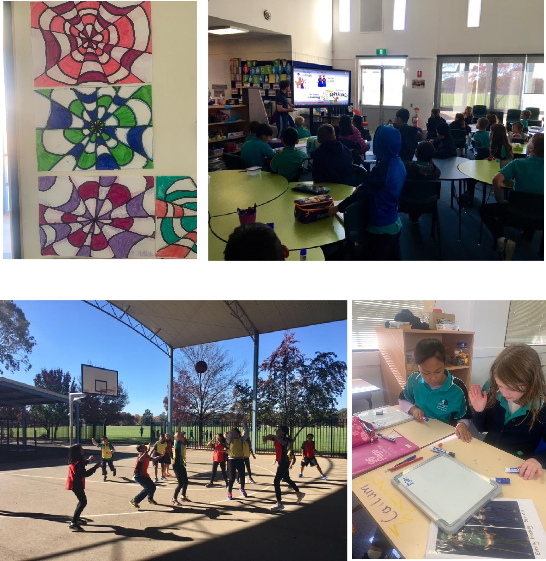

Together, we learn from each other

Palmerston Post

5/6 News
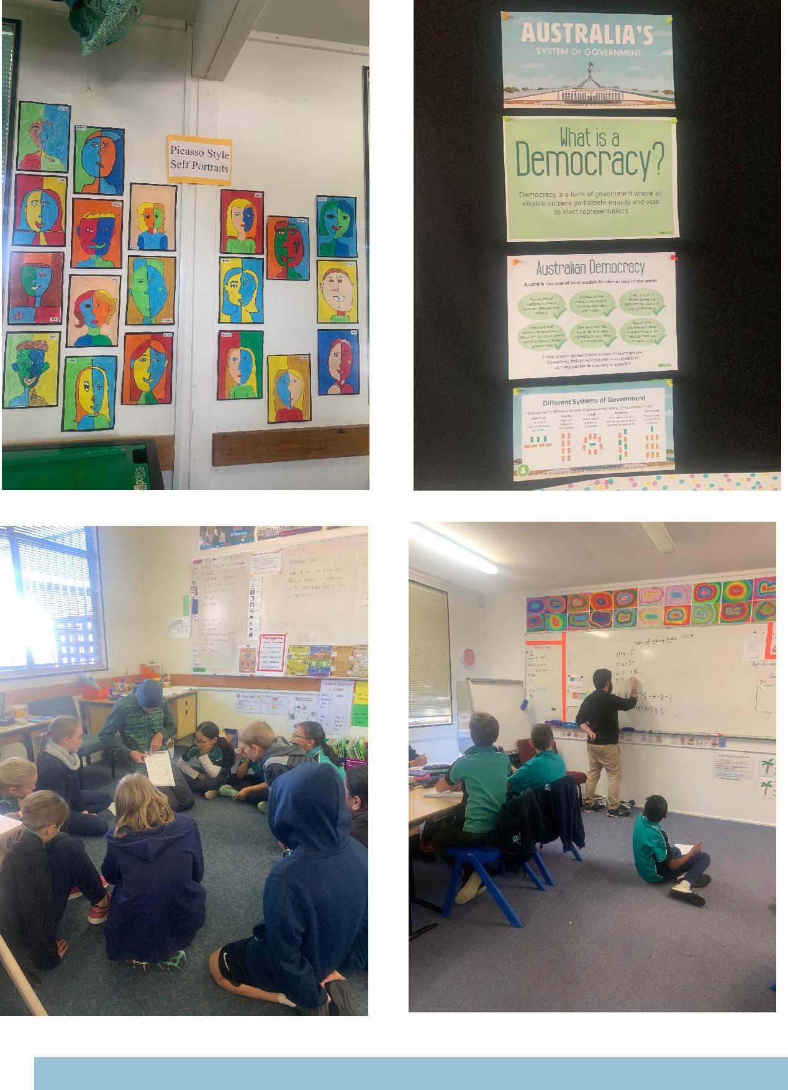

Together, we learn from each other

Palmerston Post

UPCOMING EVENTS

Year 3/4 Theatre Excursion

Date: Friday 24 May 2019

Location: Canberra Theatre

Athletics Carnival

Date: Friday 31 May 2019

Location: PDPS

Defence NEWS

Dear Defence Families,

As posting orders arrive please keep me updated with your family’s plans for relocation or absences e.g. redeployment or courses. So I can best support your child/ren at school. Please contact Kristy.retzlaff@ed.act.edu.au or Ph: 6142 1440.

Defence Family Helpline
1800 624 608

FORCENET For Families
Want up-to-date information from your ADF member’s unit and find out about other Defence support services.

FORCENET is here.

FORCENET is a Defence communication platform that lets families connect in a secure online environment from their mobile, tablet or computer.

Why Join? Families registered on FORCENET can keep up-to-date with Defence news, events and information relevant to them.

ADF members can sponsor up to three family members, like their partner, parents, siblings or children (must be over 18) to join FORCENET.

How to join - To keep up-to-date with information from your ADF member’s unit, Service and more, register by visiting forcenet.gov.au and click ‘Apply to join’. To register to FORCENET you will need the sponsorship of a current registered Defence FORCENET user.

Thank you,

Kristy Retzlaff
Defence School Mentor

Together, we learn from each other

Palmerston Post

Active Schools
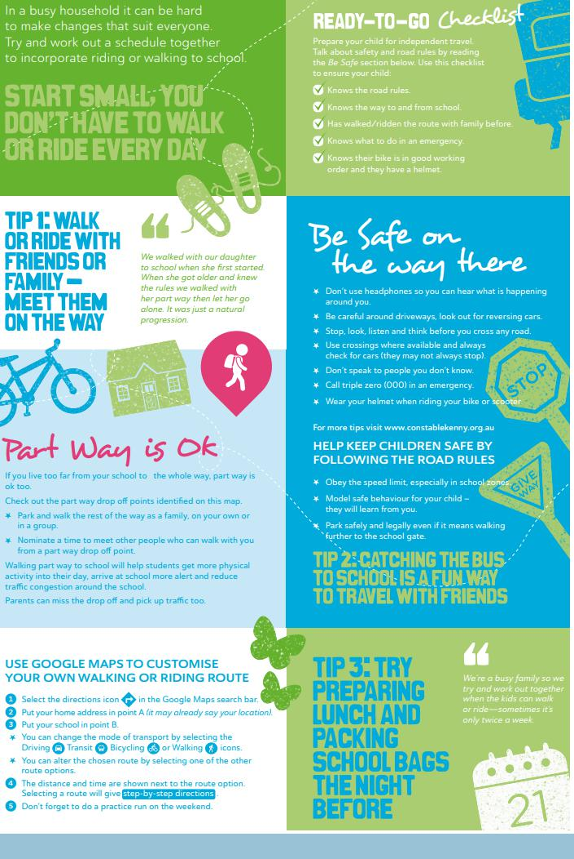

Together, we learn from each other

Palmerston Post

Active Schools
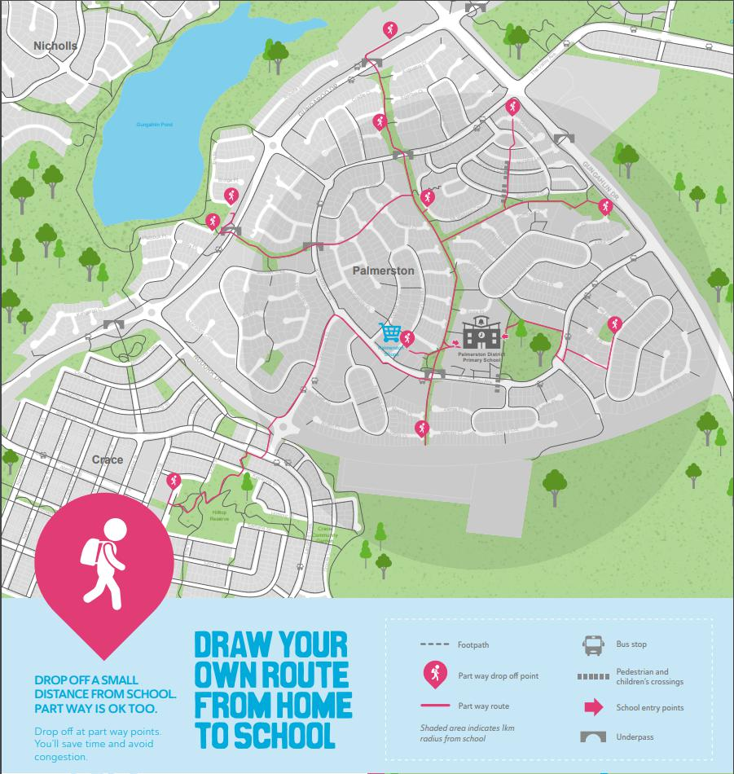

Together, we learn from each other

Palmerston Post

Protect yourself and your family from the flu

Getting vaccinated is the best way to prevent your family getting the flu this winter. The flu vaccine can save a child’s life.

The vaccine is safe, and everyone 6 months of age and over, including pregnant women and young children, should get the vaccination.

Children are more likely to contract the flu, spread it around, and are at a higher risk of serious complications if they get sick. The flu is highly contagious and is spread easily through childcare centres and schools.

The flu vaccine is free in the ACT for:

- children aged 6 months to under 5 years

- pregnant women

- people 65 years of age and older

- all Aboriginal and Torres Strait Islander people aged 6 months and older, and

- people aged 6 months and older with some medical conditions such as severe asthma, heart or lung disease, diabetes or weakened immune systems.

Where to get your flu vaccination

Everyone can get a flu vaccine from their GP or immunisation provider.

People over 16 years of age can also get a vaccine at some pharmacies.

ACT Government Early Childhood Immunisation Clinics provide a free flu vaccination for children aged 6 months to under 5 years. To book an appointment, call Community Health Intake on 02 5124 9977.

Learn more about influenza and where to get your vaccination at health.act.gov.au/flu

Together, we learn from each other

Palmerston Post

MyWay

Transport Canberra’s month long free trial comes to an end on Sunday 26 May 2019. With paid services starting next week on Monday May 27, students are being reminded to top up their MyWay cards or purchase tickets to avoid fines of up to $181 for travelling without a ticket. Tapping on and off is required by all customers travelling on light rail and buses, and also provides Transport Canberra with accurate data to plan and review services in the future.

 |  | A select number of newsagencies, post offices, and Access Canberra outlets. For
 |  | the full list visit: https://www.transport.act.gov.au/tickets-and-myway/get-myway/
 |  | recharge-agents
Where can I get a MyWay card?
I’m a student, how much does it cost? |  | A MyWay card is $2.50, and then you’ll need to top it up for travel.
 |  | Concession:
 |  | Tertiary: $1.61
 |  | School student – school day: $1.22
 |  | School student – non-school day: $1.61
 |  | Weekday cap: $4.80
 |  | Weekend/public holiday cap: $2.17
I want to catch a bus and light rail – will it |  | All MyWay fares include a free 90-minute transfer period so you can connect to a
cost me two tickets? |  | different bus or light rail service or commence your return journey using the same
 |  | ticket within 90 minutes of purchase. Daily tickets are valid until midnight on the
 |  | day of purchase.
What if I forget to tap on/off? |  | If you don’t tap on, you could be fined up to $181.
 |  | If you don’t tap off after a trip, you’ll be charged a default fare.
My balance is low, how do I recharge? |  | You can instantly top up your card at a recharge agent, set up an autoload direct
 |  | debit online, or top up at a ticket vending machine at all light rail platforms and
 |  | major bus stations.

Together, we learn from each other

Palmerston Post

HIRERS NEWS
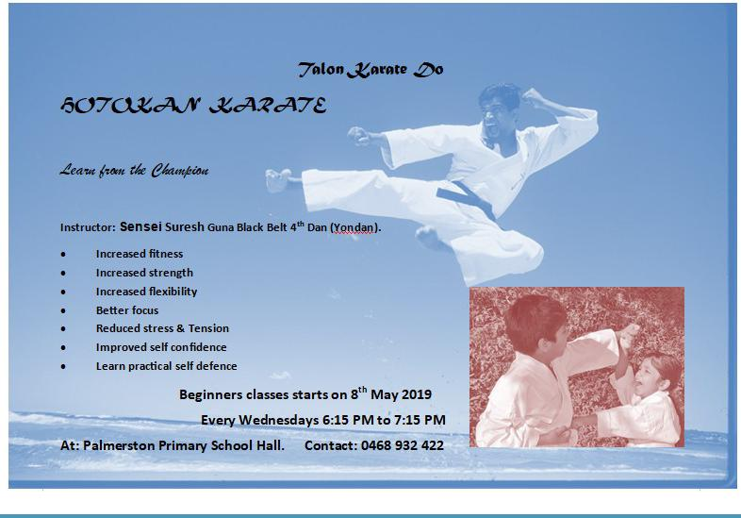

Together, we learn from each other

Palmerston Post

ParentLink

ParentLink provides parenting education to the community, from birth to teenage years. It is available for parents, carers, kin, teachers, and the broader community, providing information and links to local resources and services.

The ParentLink website provides links to all ParentLink guides including a variety of topics - Start-ing School, More than Reading and Writing, Optimism and Cyber Safety.

The ParentLink suite of resources includes guides specifically for Aboriginal and Torres Strait Islander families, and access to resources for diverse cultural groups.

ParentLink guides are available to view and order via the website at, https:// www.parentlink.act.gov.au/

PARKING AROUND SCHOOLS

As we drive and park our cars around schools we all need to ensure the safety of school students is our priority. Parking illegally and unsafely across pedestrian crossings, corners and verges puts children at risk. We all need to help keep our children safe. Here is a short video demonstra-tion: https://youtu.be/AslMVXpA9Zc

Access Canberra inspectors will be patrolling our school zones to help us ensure drivers do the right thing.
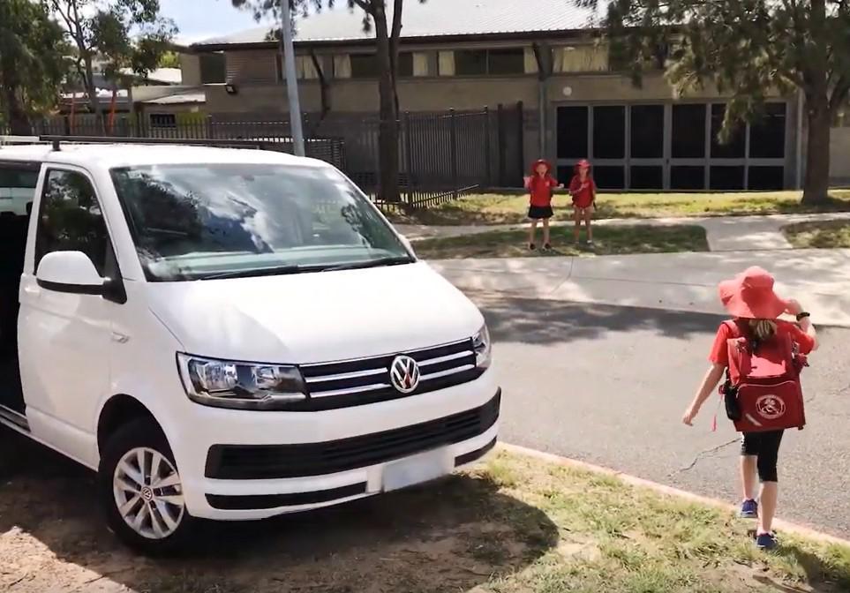

Together, we learn from each other

