Palmerston Post
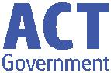

6 June 2019

Week 6, Term 2

Board Chair: Lisa Fior Board Members: Parent Reps: Adam Davidson and Kate Baron

Teacher Reps: Jessica Lago and Maxine Green

P&C President: Lisa Fior

Principal: Kate Smith Deputy Principals: Haeley Simms (A/g) & Kylie Moller (A/g)

Executive Teachers: Matt Gowen, Felicity McNeice, Catherine Griffin (A/g)

ASSEMBLY:

7 June Junior - KFD & KKA

14 June Whole school - 5/6CW & 5/6KB

21 June Junior - KGM, KMC & KGS

DATES TO REMEMBER:

10 June Queen’s Birthday public holiday

12June Christian Education

14 June Year 3/4 Birrigai Camp

14 June Whole School Assembly

17 June Preschool Photos (beginning)

20 June Whole School Photos

21June Year 3/4 Indonesian Arts

Workshop

24 June Hatching Chicks (Preschool)

- &

- June Kindergarten Health Checks

NOTES:

School Photos - Sibling photo and spare envelopes are available in the front office

Indonesian Arts Workshop (Year 3/4)

P&C BOARD NEWS P&C: 24 June 2019

All P&C activities, meeting agendas and minutes are available from the school website at – Parent Corner

School Board: 24 June 2019

PRINCIPALS’ MESSAGE

Can you believe we are over half way through term 2? I have now been here six weeks and every day I learn something new, meet someone new and try something new. I’d like to start off by expressing my gratitude to the parents, family and friends who came along to our Athletics carnival last Friday. It is wonderful to see support in timekeeping and cheering! I loved meeting a grandma who drove all the way from Orange, NSW early that

morning to support her grand-daughters! How beautiful is that?

I loved the manner in which our house captains cheered and inspired their teams ALL day with fabulous war cries, encouragement and indeed, it was not surprise that by the end of the day voices were very hoarse. Congratulations again to all our athletes for a speedy day, and also for the positive sporting

attitude expressed by so many of our students.

This week we celebrate another junior school assembly and I ask respectfully, that audience members, and their younger children – please show respect for the class who are hosting, by remaining in your seats. We know these times can be very exciting, but is quite distracting to have little people running and making noise – thank you for your cooperation. We are a PBL school - Positive Behaviours for Learning – so helping with being a great audience

means this is excellent modelling for our host class.

Please remember to get in touch with any ways you might be willing to further support the learning programs at our school. I am particularly keen to send out a survey shortly to find out your thoughts around technology in the classroom, so please keep an

eye out for that.

Until next time, enjoy the long weekend, keep warm and keep curious!

Kate Smith

Together, we learn from each other

Palmerston Post

Year 3 News

Year 3 ventured to the theatre to watch Billionaire Boy. Much fun was had on the bus trip with the race to see Telstra Tower! We were all dazzled by the acting, props and drama which brought the story to life.
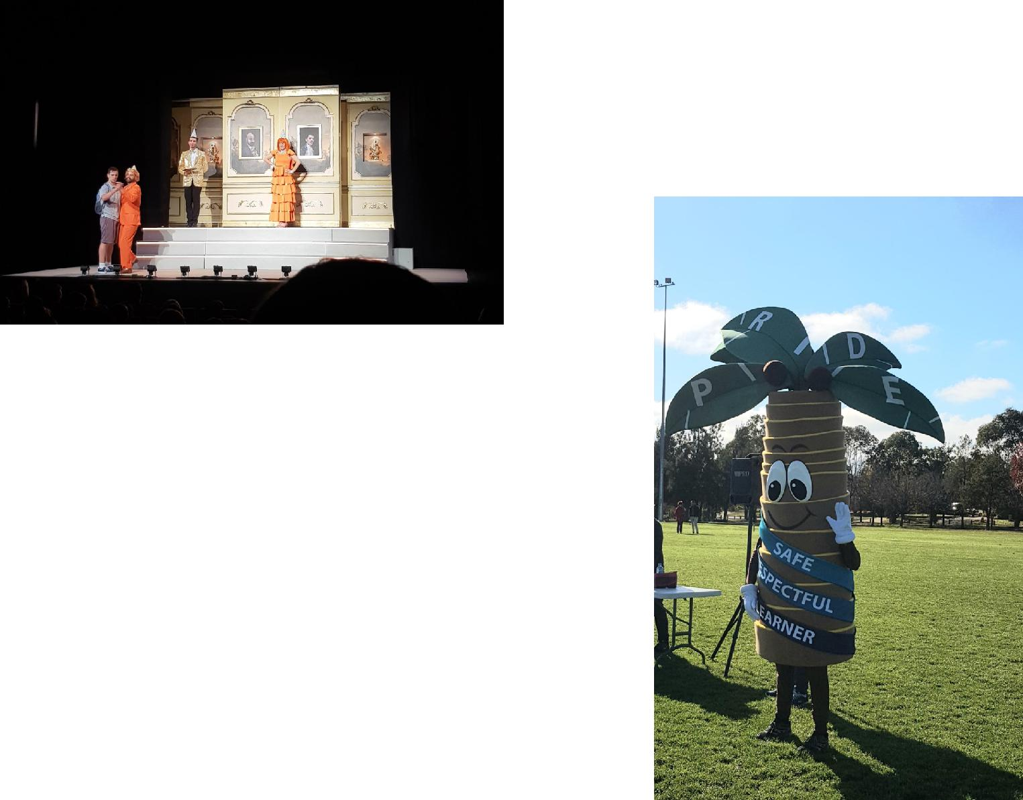

Recently we had so much fun participating in the Athletics carnival. Palmy joined us and we all showed our PRIDE and PBL values by cheering for our teams and schoolmates and showing great

sportsmanship.
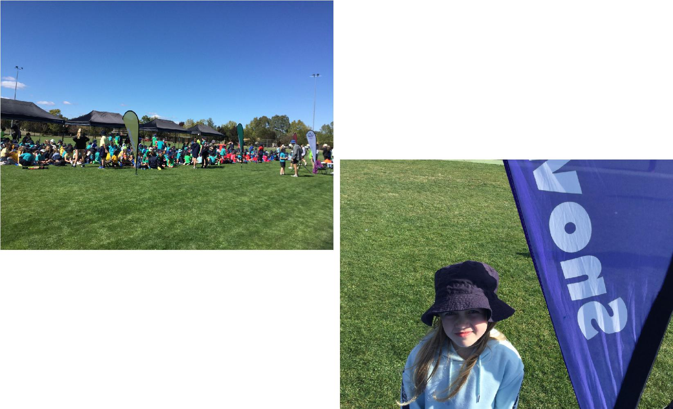

Our year 3 students were amazing speakers and listeners during the 2019 Rostrum. Congratulations to everyone who participated and our year 3 finalists.

Together, we learn from each other

Palmerston Post

Defence News

Big thanks to our Defence Kids Club and friends who assisted making Care Packages for Defence Force members deployed over in Afghanistan. We recently received a couple of badges and a letter of thanks from

Glen Burcher, a Wing Commander in the Royal Australian Air Force.
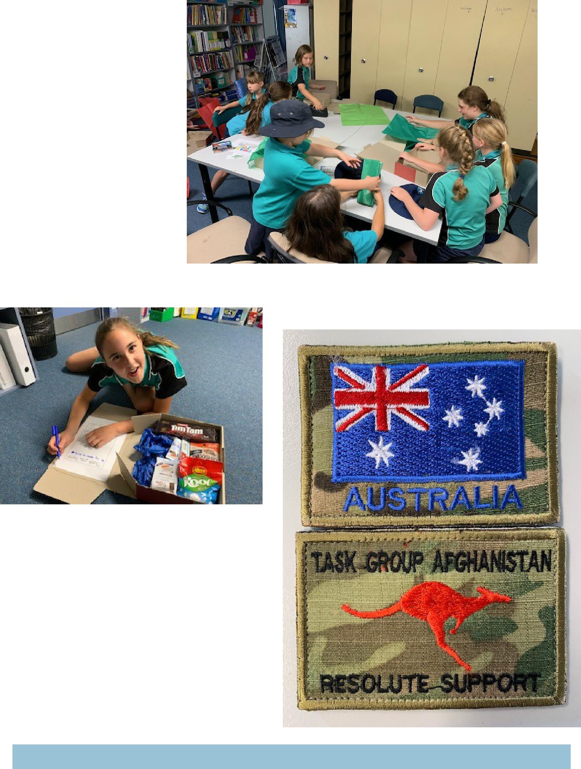

Together, we learn from each other

Palmerston Post
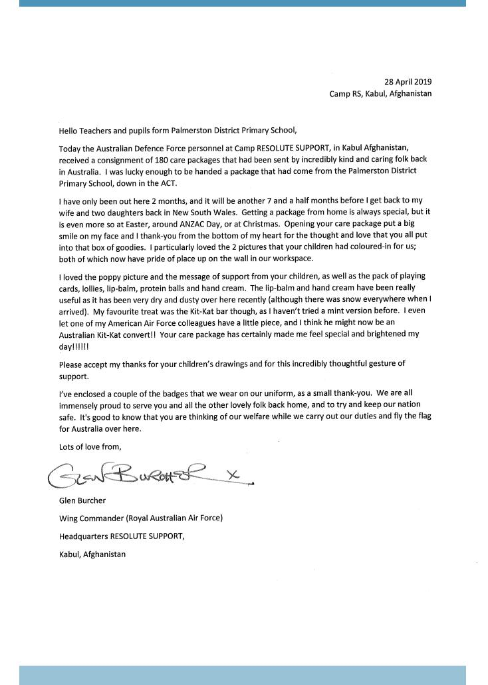

Together, we learn from each other

Palmerston Post

Positive Behaviours for Learning (PBL)
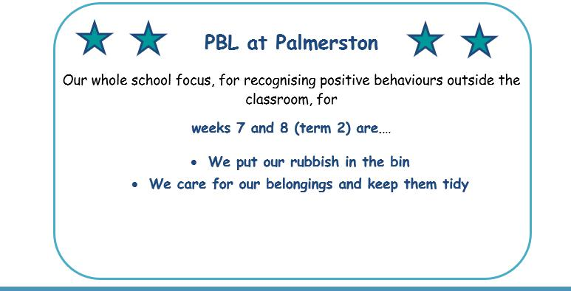

Enrolments for 2020

Enrolments for the 2020 school year opened on 29 April 2019. All ACT children are guaranteed a place in their local public school for Kindergarten to year 12. However, due to growth in recent years in enrolments in the

public system, some schools no longer have the capacity to take “out of area” enrolments. These schools have been identified as “Category A” schools and a list appears on the Education Directorate website.

You will not be able to seek enrolment for your child at one of these schools unless you live within the school’s priority enrolment area (i.e., the school’s geographic zone). All schools will, however, consider cases where

there are legal issues, or exceptional circumstances based on student wellbeing. To avoid disappointment, you are encouraged to check the information on the Education Directorate’s website so you can make the best decision for your family from the options available.

Semester One Reports 2019: Parent Information Sessions

Palmerston District Primary School has been selected to pilot the new Education Directorate report format. This format will be common for students across all Kindergarten to Year 10 schools. The report is generated through the Student Administration System (SAS). Semester One reports will be emailed to parents. Please read the two fact sheets attached.

We will be holding parent information sessions to provide further information regarding the changes in the reporting process for K-6 students. If you feel you need more information in addition to the fact sheets provided or have questions, please feel welcome to attend an information session.

Wednesday June 12, 5:30 – 6:00pm in the Library

Reporting Student Achievement in ACT Public Schools

In 2019 the Education Directorate are introducing a common report format, for students in Kindergarten to Year 10, through the new Student Administration System (SAS). This change will occur via a staged

implementation process, with some schools piloting the new report format in Semester 1, 2019.

Together, we learn from each other

Palmerston Post
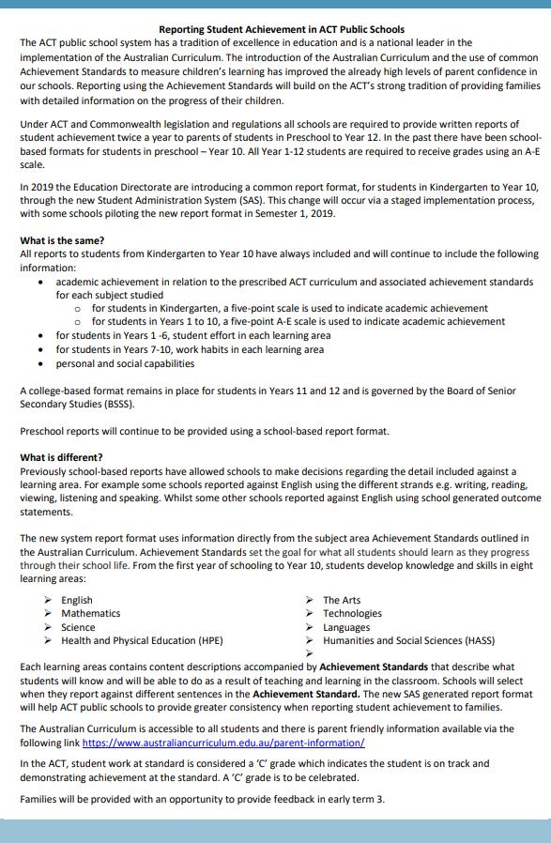

Together, we learn from each other

Palmerston Post
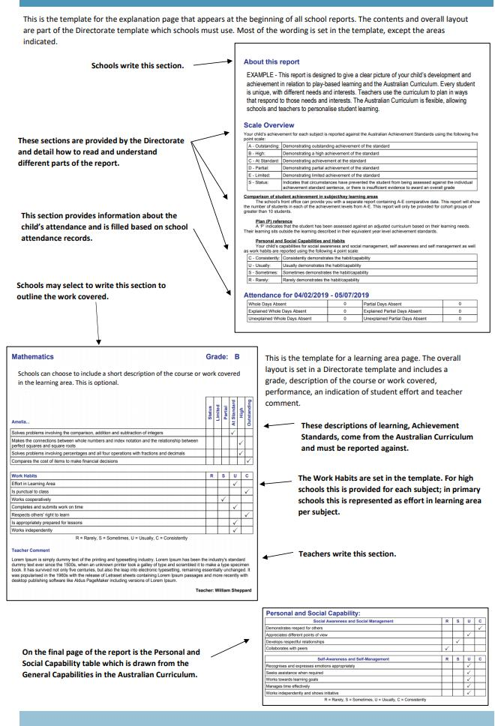

Together, we learn from each other

Palmerston Post

The new common report format uses information directly from the subject area Achievement Standards outlined in the Australian Curriculum. Achievement Standards set the goal for what all students should learn as they progress through their school life. From the first year of schooling to Year 10, students devel-

op knowledge and skills in eight learning areas:
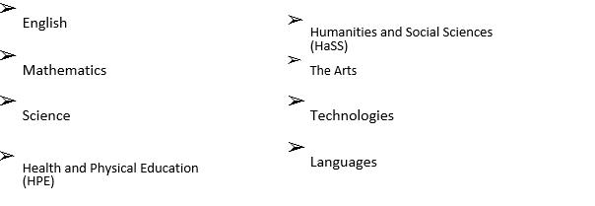

Below are some examples of Achievement Standard statements that may appear on a student report. Students will be allocated an achievement level against each sentence using a five-point scale: limited, partial, at standard, high or outstanding. The student will also receive an overall grade for the learning area using a five-point A-E scale.

Some example English statements that may appear on a report:

Foundation/ Kindergarten | Year 4 | Year 9
They read high-frequency words and | They fluently read texts that | They select evidence from texts to
blend sounds orally to read | include varied sentence | analyse and explain how language
consonant-vowel-consonant words. | structures, unfamiliar | choices and conventions are used to
 | vocabulary including | influence an audience.
 | multisyllabic words.
Their writing shows evidence of | Students create texts that | Students create texts that respond
sound and letter knowledge, | respond to issues, interpreting | to issues, interpreting and
beginning writing behaviours and | and integrating ideas from | integrating ideas from other texts.
experimentation with capital letters | other texts.
and full stops.

Some example Mathematics statements that may appear on a report:

Foundation/ Kindergarten | Year 4 | Year 9
Students count to and from 20 | They recognise common equivalent | They recognise the connections
and order small collections. | fractions in familiar contexts and | between similarity and the
 | make connections between | trigonometric ratios.
 | fraction and decimal notations up
 | to two decimal places.
Students connect events and the | Students use scaled instruments to | They make sense of the position of
days of the week. | measure temperatures, lengths, | the mean and median in skewed,
 | shapes and objects. | symmetric and bi-modal displays to
 |  | describe and interpret data.

Together, we learn from each other

Palmerston Post

Some example Science statements that may appear on a report:

Foundation/ Kindergarten | Year 4 | Year 9
They suggest how the environment | They describe how contact and | They explain global features and
affects them and other living | non- contact forces affect | events in terms of geological
things. | interactions between objects. | processes and timescales.
 | They identify when science is used | Students design questions that
 | to understand the effect of their | can be investigated using a range
Students share and reflect on | They use provided tables and | They design methods that include
observations, and ask and | column graphs to organise data | the control and accurate
respond to questions about | and identify patterns. | measurement of variables and
familiar objects and events |  | systematic collection of data and
 |  | describe how they considered
 |  | ethics and safety.
 | They suggest reasons why their | They analyse trends in data,
 | methods were fair or not. | identify relationships between
 |  | variables and reveal

Some example HPE statements that may appear on a report:

Foundation/ Kindergarten | Year 4 | Year 9
Students recognise how they are | Students recognise strategies for | Students critically analyse
growing and changing. | managing change. | contextual factors that influence
 |  | their identities, relationships,
 |  | decisions and behaviours.
They identify actions that help | They investigate how emotional | They evaluate the outcomes of
them be healthy, safe and | responses vary and understand | emotional responses to different
physically active. | how to interact positively with | situations
 | others in a variety of situations.
They describe how their body | They use decision-making and | They apply and transfer movement
responds to movement. | problem-solving skills to select and | concepts and strategies to new
 | demonstrate strategies that help | and challenging movement
 | hem stay safe, healthy and active. | situations.
They perform fundamental | They refine fundamental | They apply criteria to make
movement skills and solve | movement skills and apply | judgements about and refine their
movement challenges. | movement concepts and strategies | own and other’s specialised
 | in a variety of physical activities | movement skills and movement
 | and to solve movement | performances.
 | challenges.

There is parent friendly information available on the Australian Curriculum via the following link https://www.australiancurriculum.edu.au/parent-information/

In the ACT, student work at Standard is considered a ‘C’ grade which indicates the student is on track and demonstrating achievement at the standard. A ‘C’ grade is to be celebrated.

You will be provided an opportunity to provide feedback on the new system generated common report format early in term 3.

Together, we learn from each other

Palmerston Post

UPCOMING EVENTS

Christian Education:

Date: Wednesday 12 June 2019

Location: PDPS Hall

Year 3/4 Day Camp

Date: Friday 14 June 2019

Location: Birrigai

Preschool (beginning) - School Photos

Date: Monday 17 June 2019

Location: PDPS

Whole School Photos (including end of week Preschool)

Date: Thursday 20 June 2019

Location: PDPS

Preschool Hatching Chicks Program

Date: Monday 24 June 2019

Location: Palmerston Preschool

Kindergarten Health Checks

Date: Wednesday 26 June & Thursday 27 June

Location: PDPS

Protect yourself and your family from the flu

Getting vaccinated is the best way to prevent your family getting the flu this winter. The flu vaccine can save a child’s life.

The vaccine is safe, and everyone 6 months of age and over, including pregnant women and young children, should get the vaccination.

Children are more likely to contract the flu, spread it around, and are at a higher risk of serious complications if they get sick. The flu is highly contagious and is spread easily through childcare centres and schools.

The flu vaccine is free in the ACT for:

- children aged 6 months to under 5 years

- pregnant women

- people 65 years of age and older

- all Aboriginal and Torres Strait Islander people aged 6 months and older, and

- people aged 6 months and older with some medical conditions such as severe asthma, heart or lung disease, diabetes or weakened immune systems.

Where to get your flu vaccination

Everyone can get a flu vaccine from their GP or immunisation provider.

People over 16 years of age can also get a vaccine at some pharmacies.

ACT Government Early Childhood Immunisation Clinics provide a free flu vaccination for children aged 6 months to under 5 years. To book an appointment, call Community Health Intake on 02 5124 9977.

Learn more about influenza and where to get your vaccination at health.act.gov.au/flu

Together, we learn from each other

Palmerston Post

With winter upon us, it’s important to remember that Canberra has lots of health options that don’t involve a trip to a hospital emergency department. Many of these are free and available after hours.

Walk-in Centres provide free, one-off treatment of minor injury and illness, including colds and flu. They’re a great choice for children over 2 years of age – children under 2 should see their GP.

Walk-in Centres are open from 7.30am to 10pm, every day of the year. They are staffed by highly skilled nurses who can provide you with a sick certificate and in some cases, medication, saving you time and money.

The service is free and no appointments are necessary.

Walk-in Centres are located in Tuggeranong, Belconnen and Gungahlin.

To find out more about getting the right health care for your symptoms, visit

www.act.gov.au/yourhealthoptions
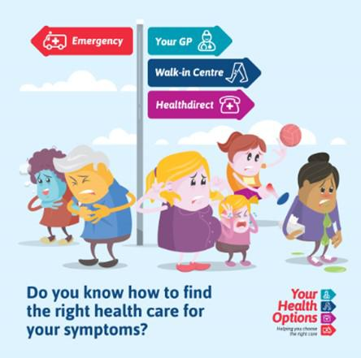

Together, we learn from each other

Palmerston Post
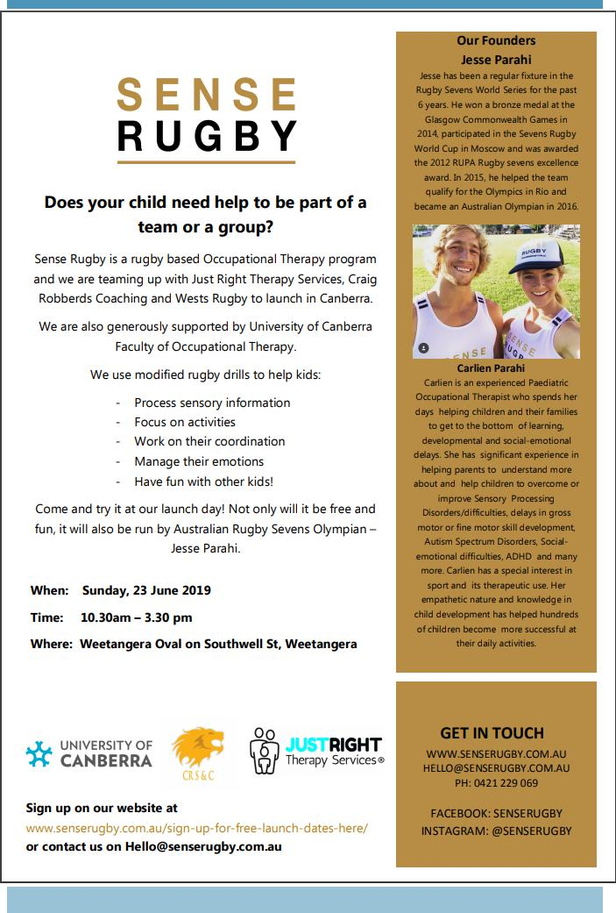

Together, we learn from each other

Palmerston Post
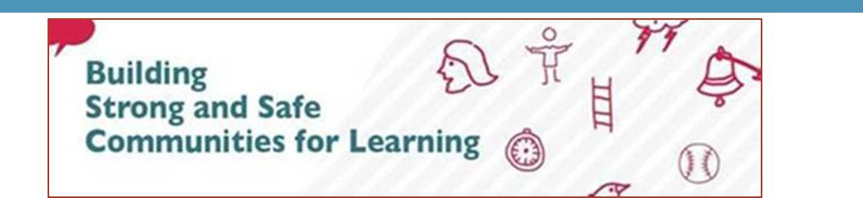

Upcoming Ideas X Change on how we can all help reduce violence and bullying in schools
Building Strong and Safe Communities for Learning is a partnership project between the ACT Education

Directorate and the ACT Council of Parents and Citizens Associations (P&C Council). Parents, students,

principals and teachers are working together to reduce violence and bullying in schools. Initial workshops
received amazing feedback, join us to have your say.

Details: www.education.act.gov.au/ideas-xchange
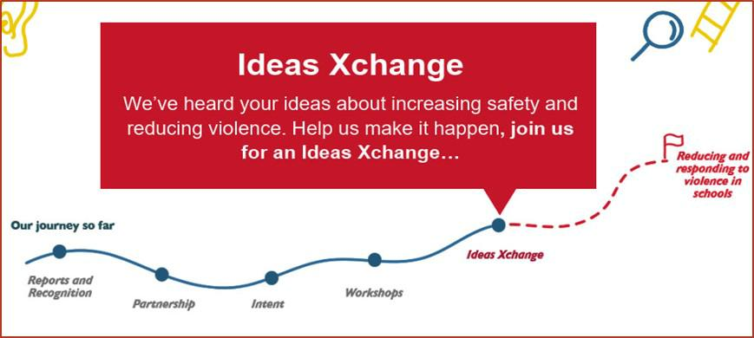

You are invited to the Ideas Xchange..A Different Conversation

We’ve heard your ideas about reducing violence and increasing safety in schools, help us make it happen, join us for an Ideas Xchange…

Purpose: Help us build strong and safe communities for learning.

We need your: experience and insights to test and provide feedback on the suggestions and ideas to reduce and better respond to violence in our schools.

 | Location: | Meeting room 11, Hedley Beare Centre for Teaching and Learning, Fremantle Drive Stirling, 2611
 | Hosts: | P&C Council and Education Directorate
 | Time |  | Date
 | 6:45 - 8:30 pm |  | Wed 12 June
 | 8:00 – 9:30 am |  | Thurs 13 June
 | 3:45 – 5:30 pm |  | Thurs 13 June
 | 9:45 – 11:30 am |  | Fri 14 June
 | 6:45 – 8:30 pm |  | Mon 17 June
 | Catering: | Light refreshments post event
 | Parking: | Free Onsite

RSVP/Bookings: https://www.education.act.gov.au/ideas-xchange

If you require any further information relating to the Ideas XChange, please don’t hesitate to contact Ms Leanne Ballard, Assistant Director Strategic Policy on Leanne.ballard@act.gov.au or 62052912. We look forward to working with you to build strong and safe communities for learning.

Together, we learn from each other

Palmerston Post

COMMUNITIES @ WORK
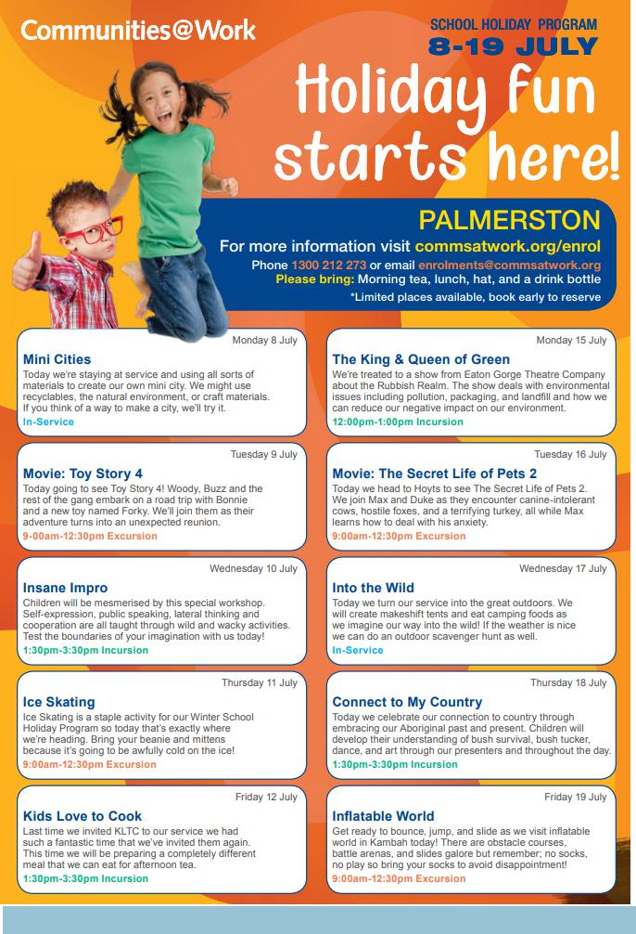

Together, we learn from each other

Palmerston Post

HIRERS NEWS
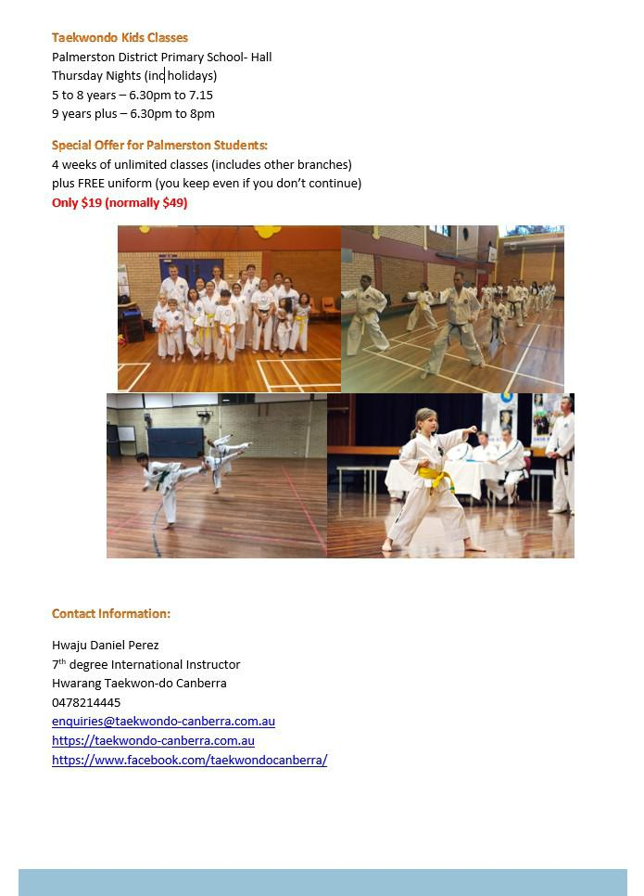

Together, we learn from each other

Palmerston Post

HIRERS NEWS
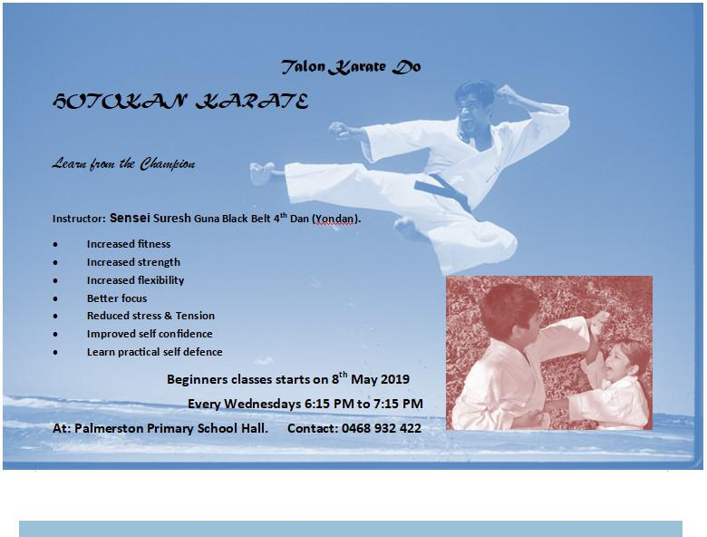

Together, we learn from each other

Palmerston Post

ParentLink

ParentLink provides parenting education to the community, from birth to teenage years. It is available for parents, carers, kin, teachers, and the broader community, providing information and links to local resources and services.

The ParentLink website provides links to all ParentLink guides including a variety of topics - Start-ing School, More than Reading and Writing, Optimism and Cyber Safety.

The ParentLink suite of resources includes guides specifically for Aboriginal and Torres Strait Islander families, and access to resources for diverse cultural groups.

ParentLink guides are available to view and order via the website at, https:// www.parentlink.act.gov.au/
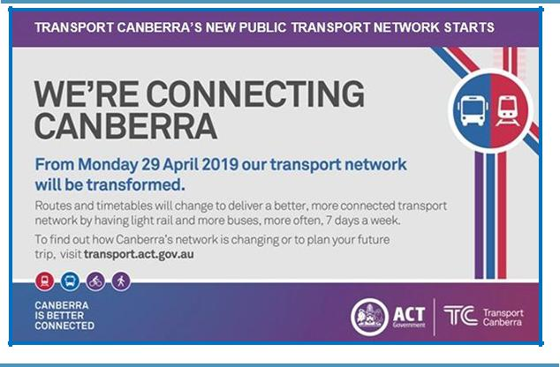

PARKING AROUND SCHOOLS

As we drive and park our cars around schools we all need to ensure the safety of school students is our priority. Parking ille-gally and unsafely across pedestrian crossings, corners and verges puts children at risk. We all need to help keep our chil-dren safe. Here is a short video demonstration: https:// youtu.be/AslMVXpA9Zc
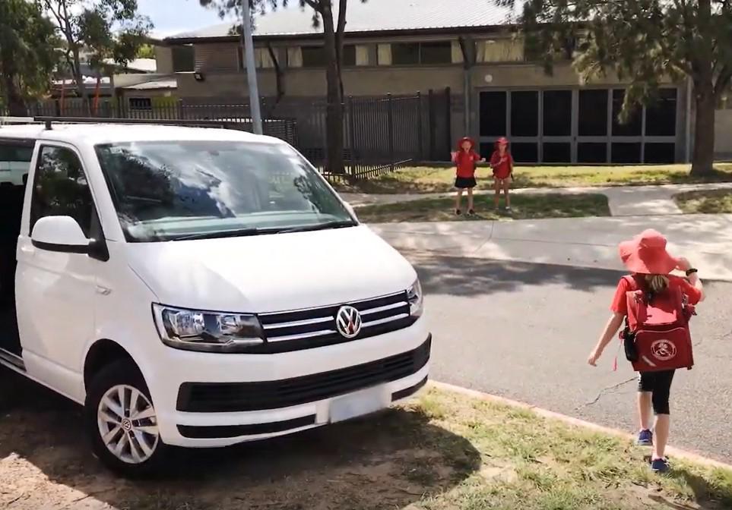
Access Canberra inspectors will be patrolling our school zones to help us ensure drivers do the right thing.

Together, we learn from each other

