Palmerston Post
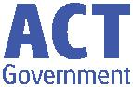

2 May 2019

Week 1, Term 2

Board Chair: Lisa Fior

Teacher Reps: Jessica Lago and Maxine Green

P&C President: Lisa Fior

Principal: Kate Smith Deputy Principals: Haeley Simms (A/g) & Kylie Moller (A/g)

Executive Teachers: Matt Gowen, Felicity McNeice, Catherine Griffin (A/g)

ASSEMBLY:

3 May Anzac Day

Assembly

10 May Mother’s Day

Concert

DATES TO REMEMBER:

7 May P/S (beginning)

Nutrition

Magician

10 May P/S (end)

Nutrition

Magician

22 May Simultaneous

Storytime

24 May Yr3/4 & IEC

Theatre

excursion

NOTES:

- Mother’s Day

- Yr3/4 & IEC theatre excursion

P&C BOARD NEWS P&C: 13 May 2019

All P&C activities, meeting agendas and minutes are available from the school website at – Parent Corner

School Board: TBA

PRINCIPALS’ MESSAGE

Hello everyone, can I start off by saying how thrilled I am to be your new Principal! This is my 32nd year as either a teacher or leader, and I cannot think of a better place to be than at Palmerston Primary. Back in 1995, I was a teacher here when this school opened. I joined a highly enthusiastic staff, under the leadership of Mr John Griffin. I lived in Palmerston, I watched the school being built, and dreamed one day to be Principal. I seem to have now also joined a very enthusiastic staff and want to thank Ms Melissa Travers for her fabulous leadership.

Across 32 years, I have been in a unique position to have taught every year level from preschool to Yr 10. I have belonged to Gillen Primary (NT), Curtin Primary, Evatt Primary, Palmerston Primary, Gold Creek Senior Site, Charnwood Dunlop School as Deputy Principal, Hughes Primary as Principal and most recently, Director of School Improvement for the 21 Tuggeranong public schools.

Within this time, my instinctive drive has been to build trusting, respectful and synergistic relationships with all members of each school community. Parents, carers and families are so important when establishing and nurturing the partnership we have in ensuring each child’s needs are met and that they love their learning environment. I relish the opportunity to build the capabilities of teachers and staff, prioritising we are “all on the same page and singing from the same song-sheet”. As a teacher and leader the most magical element has been working with hundreds of students over the years and the beauty there is in watching children learn.

My vision for the school is ‘to be curious together’, and I am curious to know where this will lead us! Together we can do so much.

A little bit about me – I have fabulous three grown up children, Sam, Molly and Jeb. My husband Darren is in IT and he supports me greatly. I have a real interest in the Performing Arts- particularly singing, choirs and musicals. I am highly invested in STEM and the curiosities associated with STEM/ STEAM. I love Rugby Union and am an avid Brumbies supporter. I believe deeply in service leadership and global connections and to this end,

Together, we learn from each other

Palmerston Post

I have developed a preschool in Nepal and, with fundraising, will continue to financially support the students throughout their schooling years. This gives me great pleasure.

Returning to Palmerston this week has been incredibly joyful and students are ready to learn – thank you for the massive part you play as parents/carers to instil in your children a love of learning – it is clear to me, that our students value their time spent at school. I have been in classrooms and on the playground meeting students and their broad smiles make me leave work each day smiling too.
I am so thankful already to Kylie, Haeley, Sonya, Matt, Felicity and Catherine for the warm welcome into the school. I am very excited about the next chapter of Palmerston Primary.

I eagerly look forward to meeting you all, seeing you inside the school, and beginning my journey with you,

Until next time, keep curious,

Kate
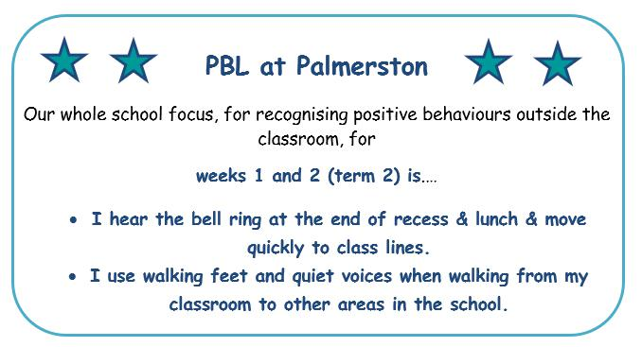

Together, we learn from each other

Palmerston Post

UPCOMING EVENTS

Anzac Day Assembly

Date: Friday 3 May 2019

Location: PDPS

Preschool (beginning) - Nutrition Magician

Date: Tuesday 7 May 2019

Location: Preschool

Preschool (end) - Nutrition Magician

Date: Friday 10 May 2019

Location: Preschool

Mother’s Day Concert

Date: Friday 10 May 2019

Location: PDPS, hall

DEFENCE NEWS

ANZAC Commemorative Assembly

All Defence families are invited to attend the ANZAC Commemorative Assembly on Friday 3 May at

9:10am, followed by a morning tea in the staff room, please RSVP Kristy.retzlaff@ed.act.edu.au for catering purposes.

Mother’s Day Celebrations

Defence Community Organisation – Mother’s Day Morning Tea

For Australian Defence Force members and their families.

Date: Thursday, 9 May 2019

Time: 10:00am – 12:00pm

Location: Soldier On, Robert Poate Centre, 80 Bellenden Street, Gunghalin, ACT

RSVP: Defence Community Organisation, PH: 02 6265 8777

DefenceFamilyHelpline@defence.gov.au or call the all-hours Defence Family Helpline on 1800 624 608.

Together, we learn from each other

Palmerston Post

HIRERS NEWS
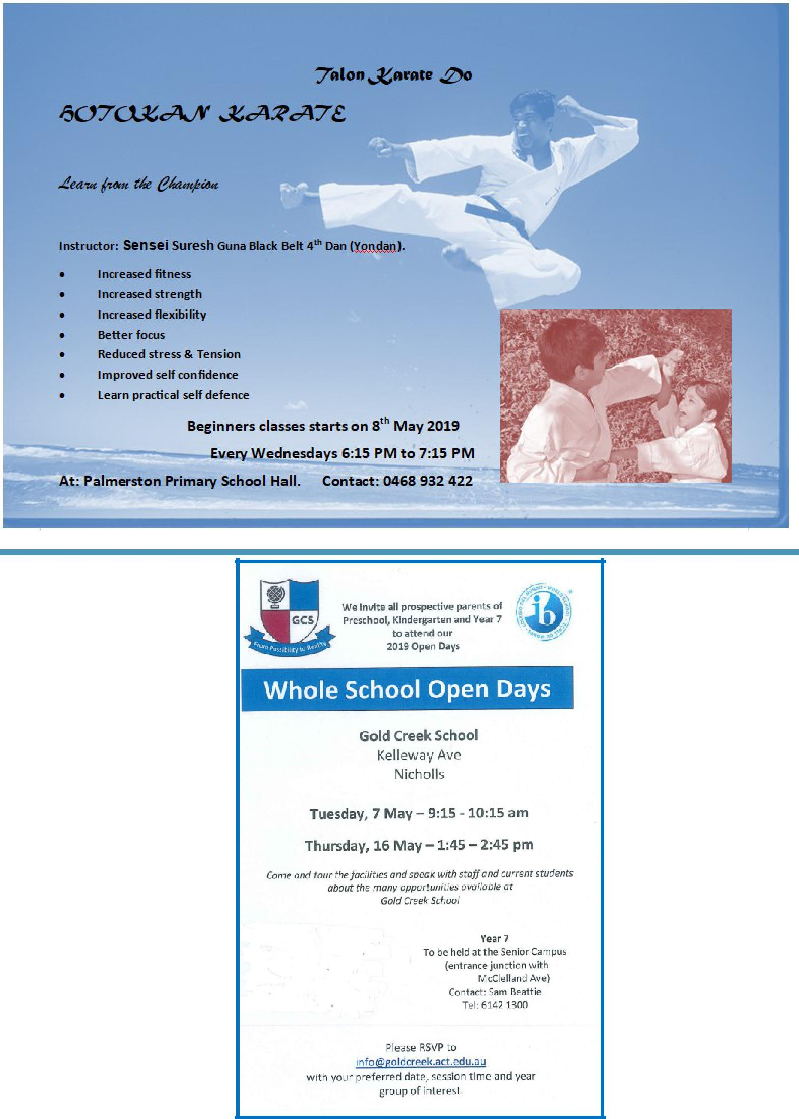

COMMUNITY NEWS

Together, we learn from each other

Palmerston Post

ParentLink

ParentLink provides parenting education to the community, from birth to teenage years. It is available for parents, carers, kin, teachers, and the broader community, providing information and links to local resources and services.

The ParentLink website provides links to all ParentLink guides including a variety of topics - Start-ing School, More than Reading and Writing, Optimism and Cyber Safety.

The ParentLink suite of resources includes guides specifically for Aboriginal and Torres Strait Islander families, and access to resources for diverse cultural groups.

ParentLink guides are available to view and order via the website at, https:// www.parentlink.act.gov.au/
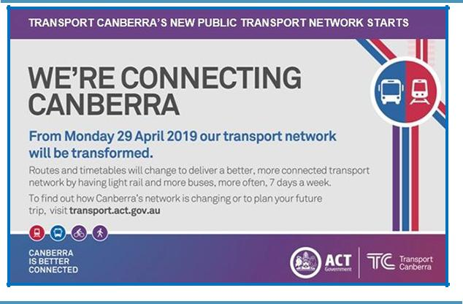

PARKING AROUND SCHOOLS

As we drive and park our cars around schools we all need to ensure the safety of school students is our priority. Parking ille-gally and unsafely across pedestrian crossings, corners and verges puts children at risk. We all need to help keep our chil-dren safe. Here is a short video demonstration: https:// youtu.be/AslMVXpA9Zc
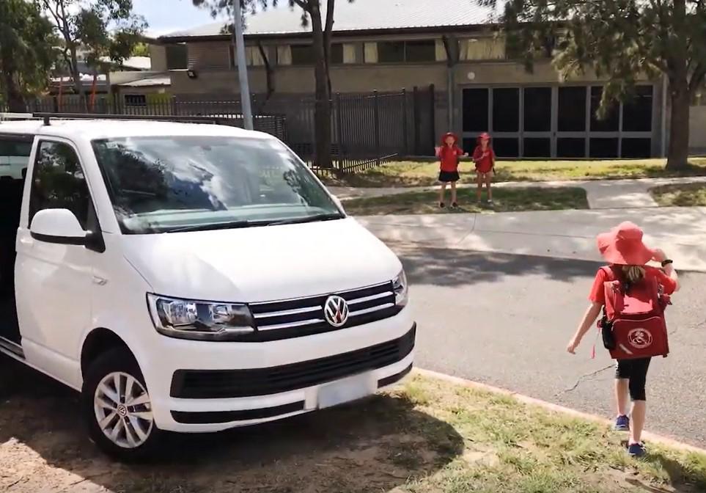
Access Canberra inspectors will be patrolling our school zones to help us ensure drivers do the right thing.

Together, we learn from each other

