Palmerston Post
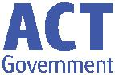

9 May 2019

Week 2, Term 2

Board Chair: Lisa Fior Board Members: Parent Reps: Adam Davidson and Kate Baron

Teacher Reps: Jessica Lago and Maxine Green

P&C President: Lisa Fior

Principal: Kate Smith Deputy Principals: Haeley Simms (A/g) & Kylie Moller (A/g)

Executive Teachers: Matt Gowen, Felicity McNeice, Catherine Griffin (A/g)

ASSEMBLY:

10 May Mother’s Day Concert

17 May Senior - 3JL & 3FB

DATES TO REMEMBER:

10 May P/S (end) Nutrition

Magician

10 May P/S (end) Mother’s

Day “Stay and Play”

10 May Mother’s Day Stall

14-17 May Naplan

17 May National Walk Safely

to School Day

21-24 May Naplan

22 May Simultaneous

Storytime

24 May Yr3/4 & IEC Theatre

Excursion

NOTES:

- Mother’s Day

- Yr3/4 & IEC theatre excursion

P&C BOARD NEWS P&C: 13 May 2019

All P&C activities, meeting agendas and minutes are available from the school website at – Parent Corner

School Board: TBA

PRINCIPALS’ MESSAGE

Hi everyone,

What an incredibly busy and wonderful start to the term we have had! Thank you to those of you who have met and chatted with me after school. I enjoy learning about you and your children, as

building connections is a very important component of my role.

I have spent a significant amount of time in classrooms in the past nine days. I am impressed by the learning environments and engaged students working busily no matter the task at hand. I am a keen photographer and you will notice the daily posts to the school Facebook page. Please, if you haven’t been on there for a while, hop on and see some of the learning and experiences through my eyes. Share comments and let’s build a vibrant page

for our school together.

Across my short time here already, I sense a very connected community, with a lot of pride from the way Mr Phil keeps the grounds through to the comments provided to me from parents and all that fits in between. We certainly have a school to be proud

of.

Speaking of being proud, I have spent time with four Yr 5/6 classes today, who went with me on a journey to talk about PRIDE and PBL and the role they play as some of the senior students in our school. It was really lovely to spend a little time with them and start to learn their stories. Some students were happy to share with me that we had connections with mutual friends, and I stated what a small world we live in. I was delighted with Safina’s response, “Yes Mrs Smith… small world, big things”. I think that

says it all.

Being impressed has been a theme this past fortnight – listening to teachers discuss the reporting process they find themselves in the middle of, listening to the executive team discuss the learning goals of the school, meeting with and listening to our School Board Chair, Lisa. Another highlight was meeting Blake Moon, from Yr 4, and being presented with a hard copy of his book – My Deltoran Journey. Blake has been working with Mrs Jeffs, and liaising with author Emily Rodda and Marc McBride – Illustrator. Magical moment of learning captured forever in the publication of his

book! Congratulations Blake.

Together, we learn from each other

Palmerston Post
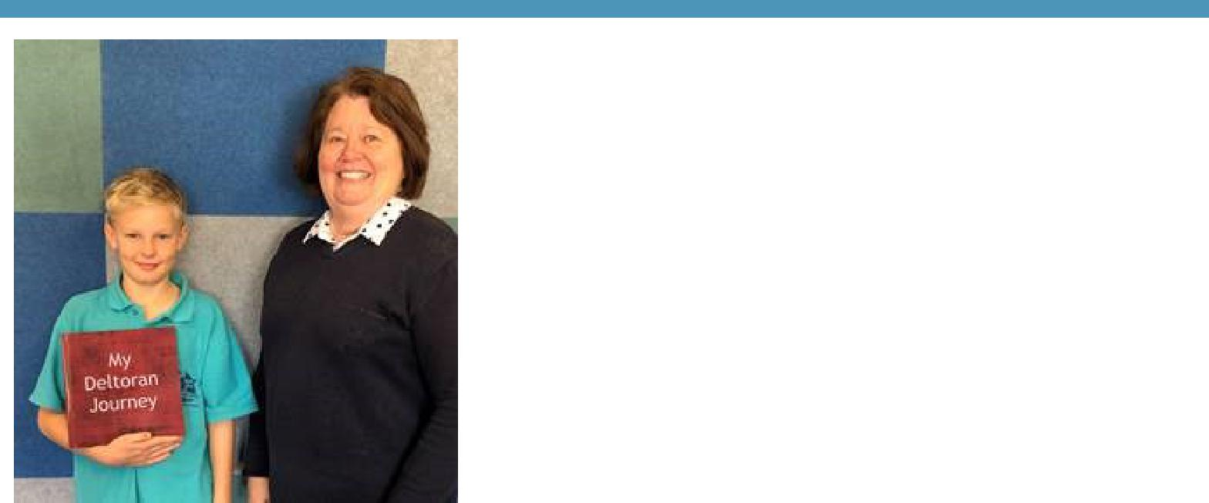

To all our mothers, grandmothers, carers and significant people in our community, I wish you a joyful Mother’s day, a time to cherish the moments with your family, and a time for you to close your eyes, smile and remember what a special person you are. I look forward to meeting many of you tomorrow morning.

Kate Smith

Positive Behaviours for Learning (PBL)
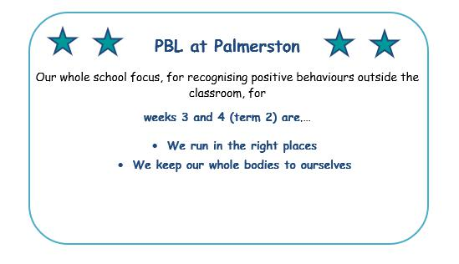

Together, we learn from each other

Palmerston Post

Positive Behaviours for Learning (PBL)

This year at Palmerston we are entering our second year of PBL. PBL is an evidence based whole school approach to student well-being and behaviour. It supports the school to create a positive learning environment to promote student learning and well-being.

Last year we completed our expectations and behaviour matrix. We then implemented this for the outside of the classroom. The three PBL expectations at Palmerston are: We are safe, respectful and learners.

The students were very excited at the beginning of last term when we introduced Palmy, our PBL mascot. Also at the start of last term, each class focused on the three expectations and created a display, a poster or even a video. They were fantastic. We have included some photos to show you. Unfortunately, we can’t include the videos but they were exceptional, particularly 5/6KB who made a rap of the values!

This term we are continuing on our PBL journey. We will be introducing tokens in the playground for students who are showing our PBL expectations. These are then added up and a reward is given to the house with the most points. Last term the lucky winner was Snowy who won ice blocks. We will also be placing signs around the school to make PBL more visible. Look out for them! Please ask your child about PBL. The PBL team are always happy for any parent feedback or comments. Once we have completed the outside component of PBL we will be moving to inside of the classroom. We will keep you up to date with our progress.

The PBL team
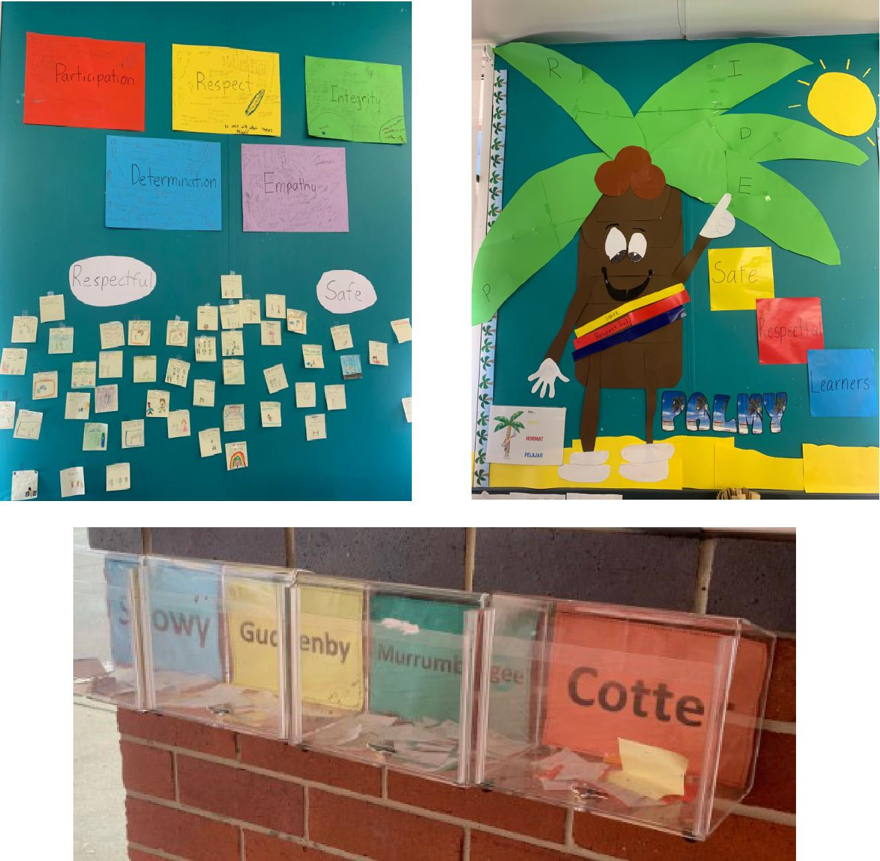

Together, we learn from each other

Palmerston Post

PBL NEWS
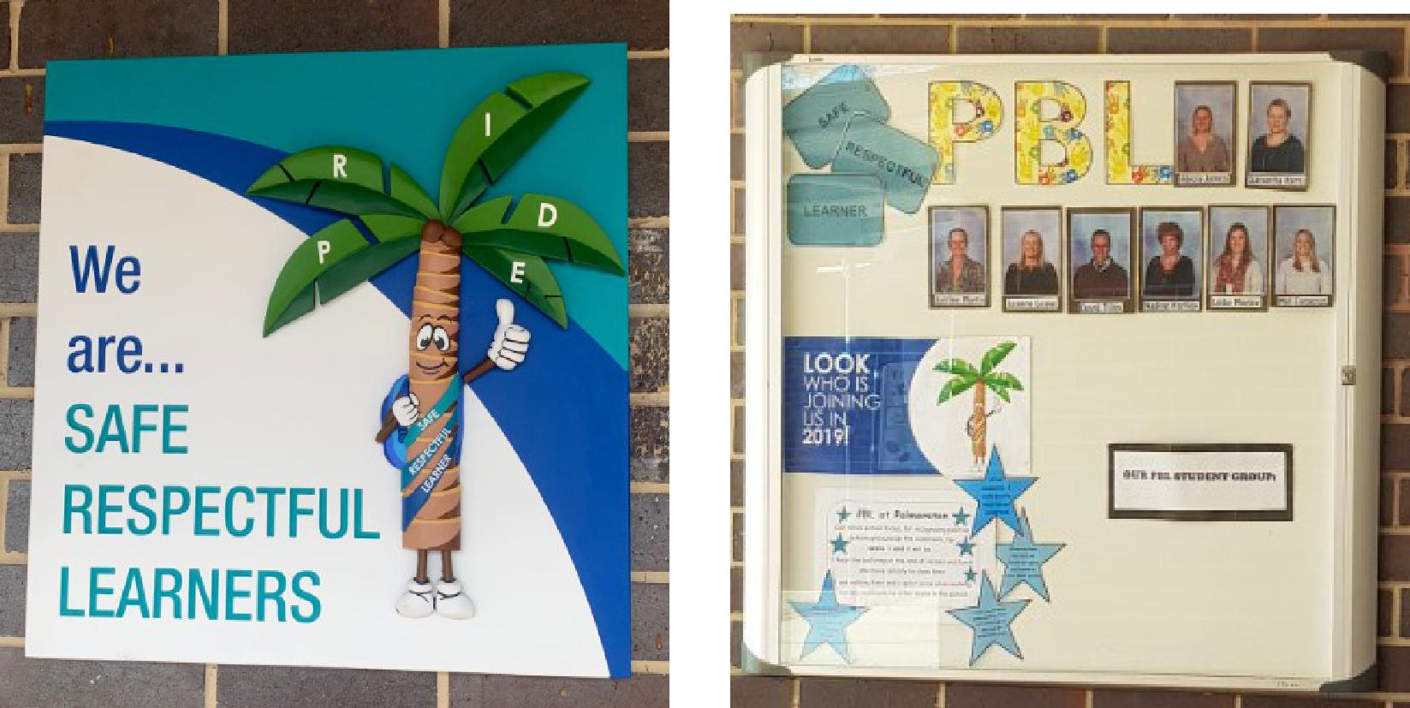
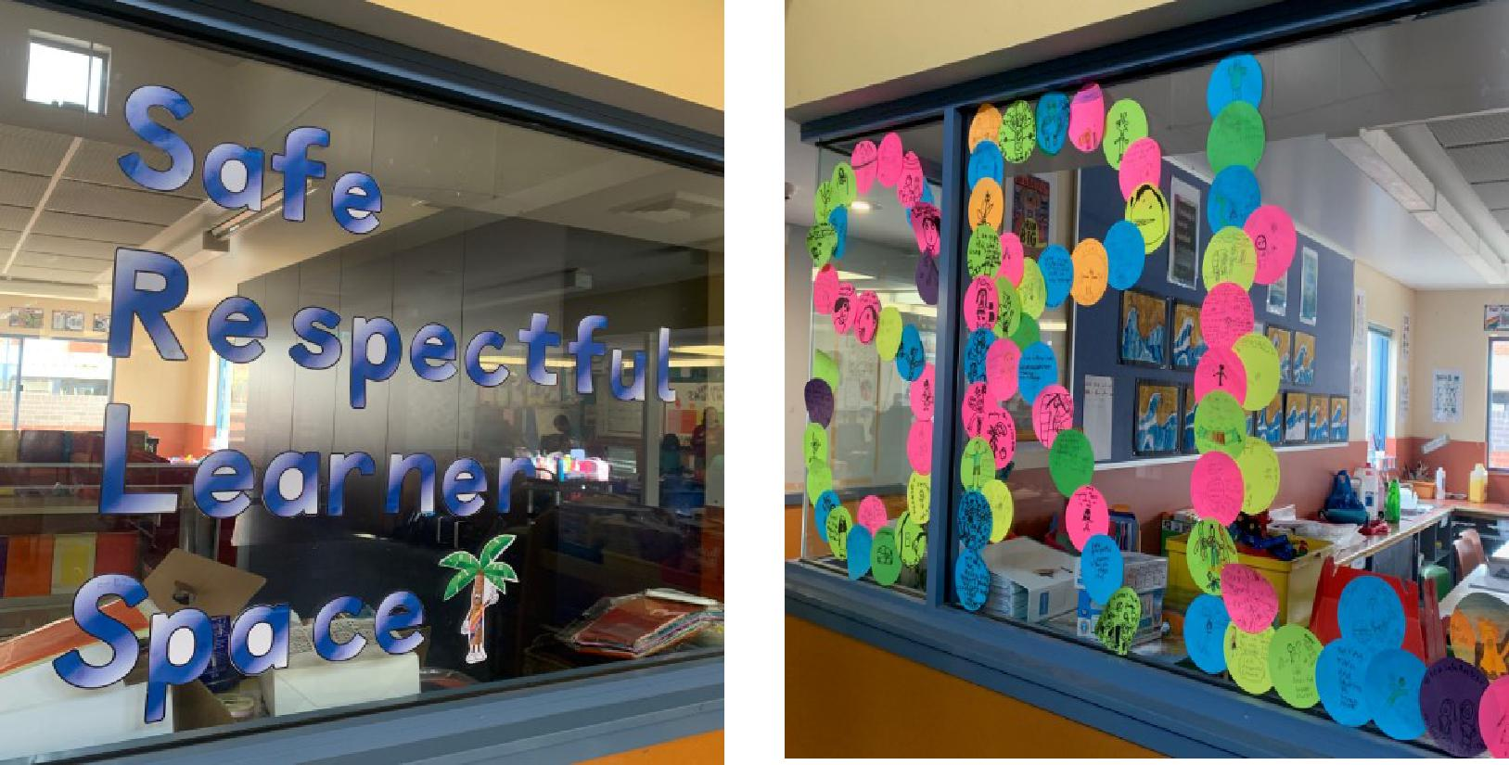

Together, we learn from each other

Palmerston Post

PBL NEWS
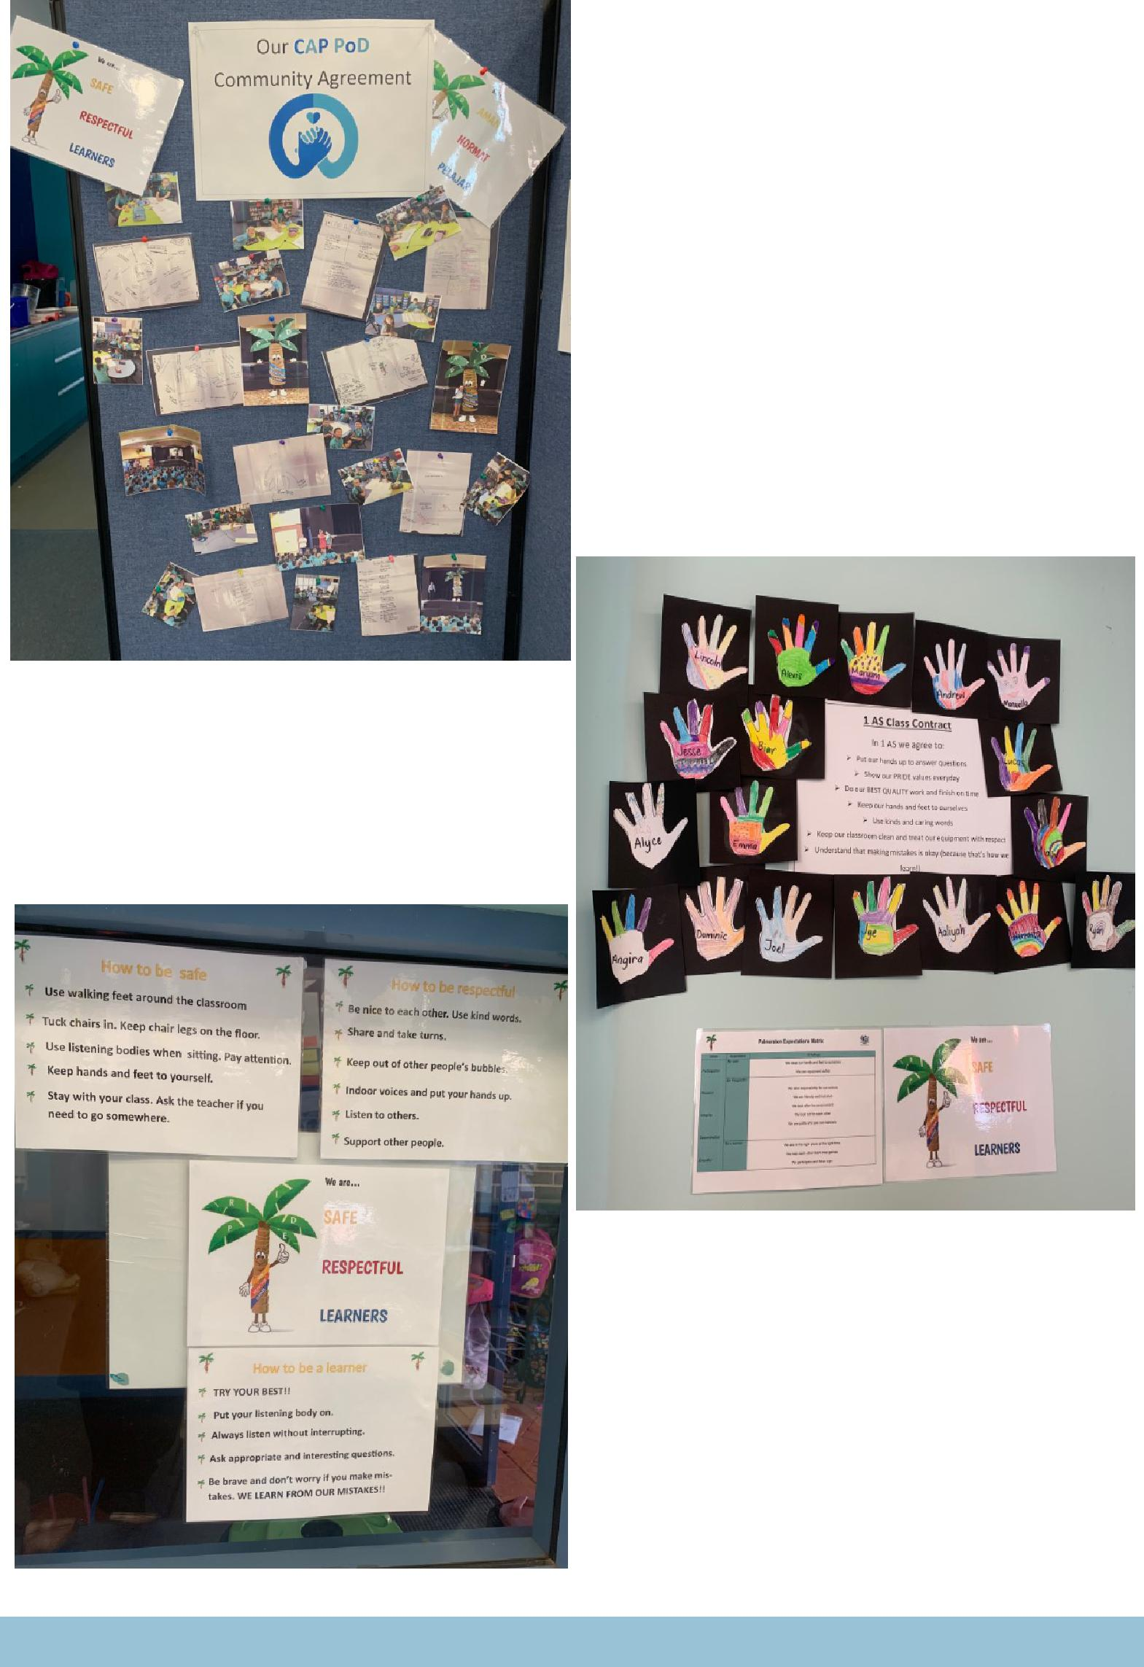

Together, we learn from each other

Palmerston Post

ENVIRONMENTAL SCIENCE

Classes that cooked with Mrs Campbell made silverbeet and feta triangles.

The silverbeet and garlic were grown in the garden and the eggs were from the chickens. The children found the triangles delicious! The recipe is included for you to try at home. Mrs Campbell
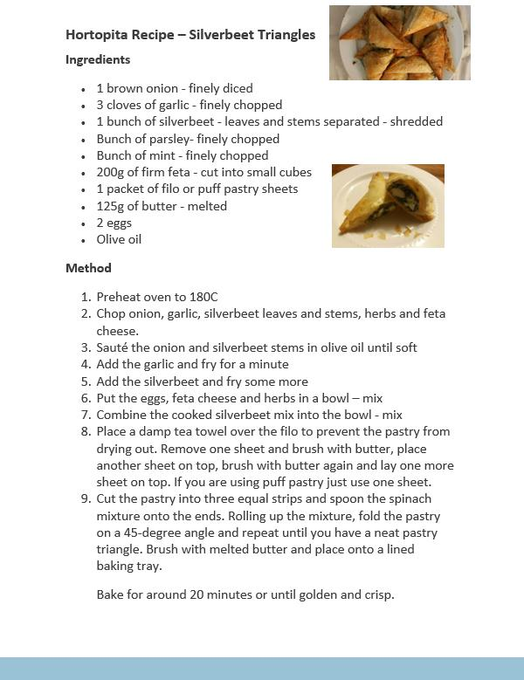

Together, we learn from each other

Palmerston Post

UPCOMING EVENTS

Preschool (end) - Nutrition Magician

Date: Friday 10 May 2019

Location: Library

Mother’s Day Concert

Date: Friday 10 May 2019

Location: PDPS, hall

Simultaneous Story Day

Date: Wednesday 22 May 2019

Location: PDPS

P&C NEWS
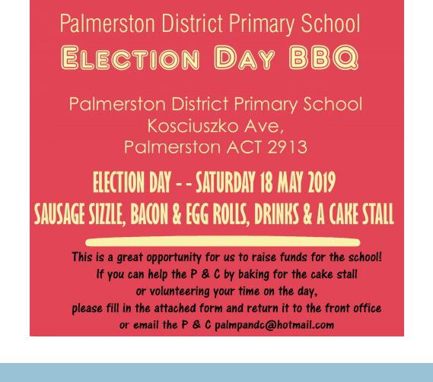

Together, we learn from each other

Palmerston Post

P&C NEWS
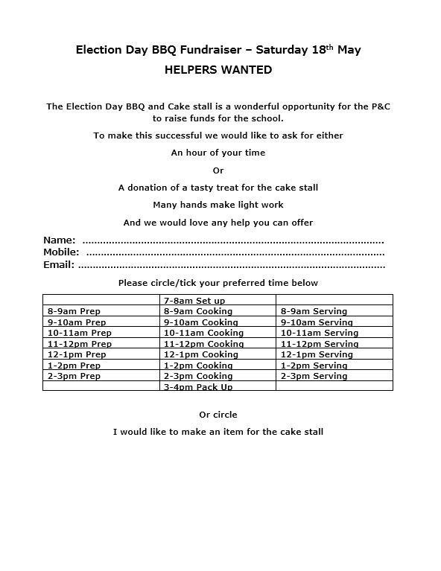

Together, we learn from each other

Palmerston Post

HIRERS NEWS
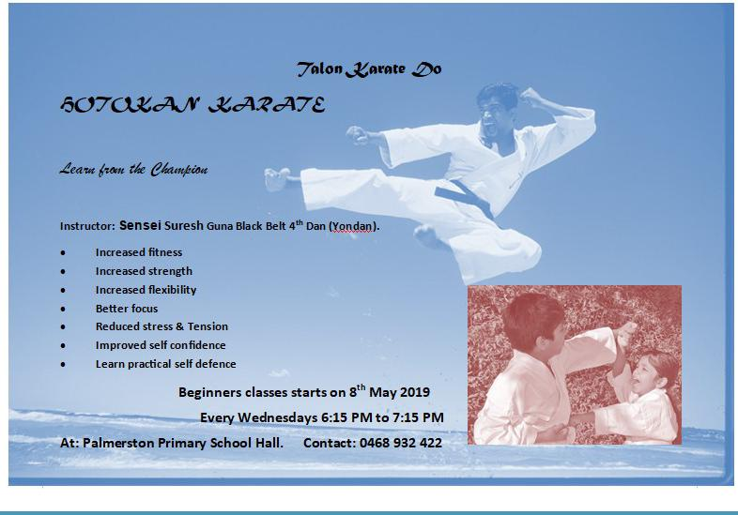

Together, we learn from each other

Palmerston Post

ParentLink

ParentLink provides parenting education to the community, from birth to teenage years. It is available for parents, carers, kin, teachers, and the broader community, providing information and links to local resources and services.

The ParentLink website provides links to all ParentLink guides including a variety of topics - Start-ing School, More than Reading and Writing, Optimism and Cyber Safety.

The ParentLink suite of resources includes guides specifically for Aboriginal and Torres Strait Islander families, and access to resources for diverse cultural groups.

ParentLink guides are available to view and order via the website at, https:// www.parentlink.act.gov.au/
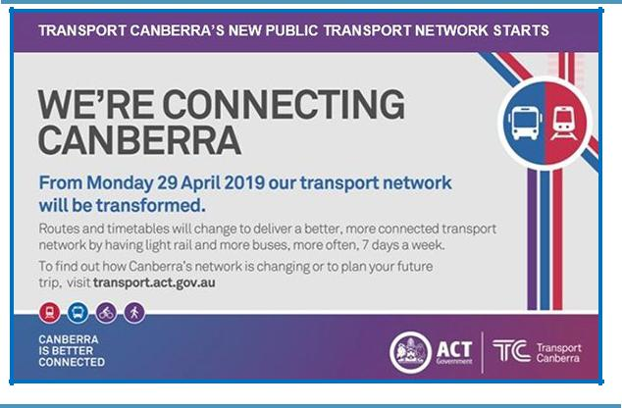

PARKING AROUND SCHOOLS

As we drive and park our cars around schools we all need to ensure the safety of school students is our priority. Parking ille-gally and unsafely across pedestrian crossings, corners and verges puts children at risk. We all need to help keep our chil-dren safe. Here is a short video demonstration: https:// youtu.be/AslMVXpA9Zc
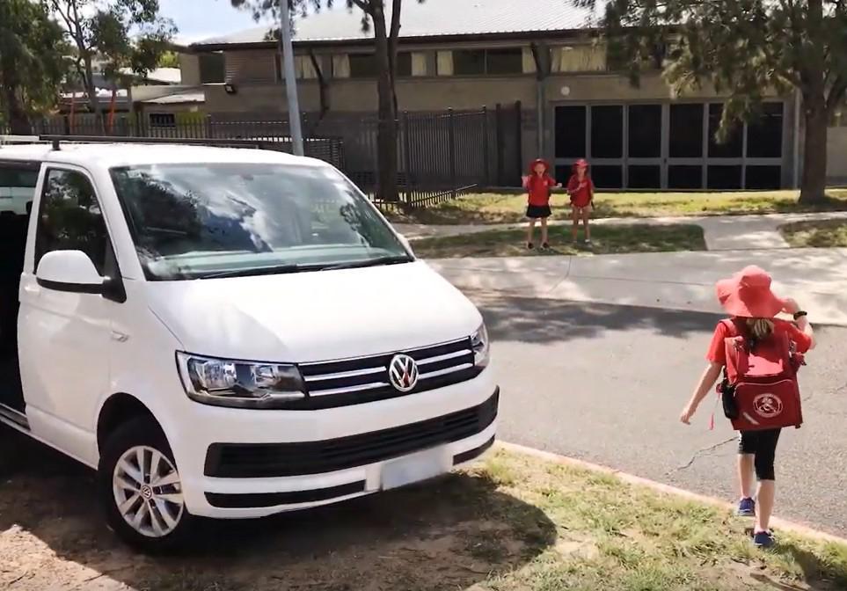
Access Canberra inspectors will be patrolling our school zones to help us ensure drivers do the right thing.

Together, we learn from each other

