Palmerston District Primary School acknowledges

the Ngunnawal People,

the traditional owners and custodians of this land.

Palmerston Post

PRINCIPALS MESSAGE

Community means everything in a school. Recently we have been witness to beautiful support from families during Book Week celebrations. Costumes recognising and celebrating favourite characters from books were seen on our pre-schoolers right through to Yr 6, it was also heartening to see our staff get in the spirit too and arrive to school with a very different look. Thank you for giving your child this experience and enjoying a week of focus on books and the meaning and relevance they have in our lives.

Every year, all schools undertake the School Satisfaction Survey. I am thrilled to announce that , at the moment, we have around 310 surveys completed, this is an incredible effort Palmerston community! This data is vitally important for us to use alongside students Yr 4-6, and all staff survey data to inform areas for improvement and attention as well as celebration. Thank you for taking the time to do this. The survey is open until Monday 2 September so there is still time to complete it if you have not done so already.

Thank you the our community for recently supporting Georgia Ritchie in her quest to raise money to kick cancer to the curb and Lifeline. Georgia was incredibly brave and shaved her long locks off to meet a goal. She surpassed her goal and we are very proud of her efforts – thank you to those of you who supported her.

Community connections are very important, they can add great strength and rigour to the learning programs we undertake each and every day. We have a community member, Mrs Carolyn Waters, a previous teacher of Palmerston DPS when the school opened, join us soon to be our pianist for our new Performance Choir, which is starting on Friday Sept 6 for students in Yr 2-6 in the Hall. Carolyn is an accomplished musician, and was indeed part of the small team who wrote the original Palmerston Primary School Song, we welcome her with open arms. If you have a particular skill you would like to share with us, please email me, I’d love to know how we can utilise the talents and skills we have in our community.

We are wondering if there are any future community connections we can harness to bring volunteers in during lunch time to teach a very eager group of students how to play chess. If you know of anyone who might be interested please let Kristina Collins know at Kristina.collins@ed.act.edu.au. A comment suggested by a parent on our Facebook community was to approach a nearby retirement village, which we will do, but also let us know of any contacts you may have.

Earlier this week, you would have received an email outlining the safety issues in the carpark, please work with us to improve the current conditions we are experiencing, whereby there are some unsafe driving behaviours occurring. This is a problem we face and need community support to change it. Entry into the carpark via Kosisuszko Ave, at the preschool end, must all turn right and follow the loop around, no stopping in the Kiss and Drop Off area, and slow driving are three ways that will vastly improve the crowded situation at the two hot times of the day, around 8.45am and 3pm. We are awaiting final timing for the commencement of the new carpark, hopefully during the upcoming school holidays. Thank you for your help.

For all our fathers, grandfathers and significant males in the lives of our students and staff, I wish you all a wonderful Father’s Day on Sunday, I hope you get to do what enriches your souls and make fun memories with your families. My dear 84 year old Dad, lives in Walcha, northern NSW and I know it is a special day to have a long chat on the phone as I remember the significant part he has played in my life.

Until next time, stay curious,

Kate

Smith

DATES TO REMEMBER

Please see page 15

Principal:

Kate Smith

Deputy Principals:

Marijana Pasalic Helen Cox

Executive Teachers:

Felicity McNiece Kylie Moller Haeley Simms Kristina Collins

Business Manager:

Sonya Campbell

Office Manager:

Kirsty Brown

Board Chair:

Lisa Fior

P & C President:

Lisa Fior

DEPUTY PRINCIPAL MESSAGE

Student Testing for 2019

As our School Procedures: Gifted and Talented Students state, at Palmerston District Primary School we wish to meet the needs of all learners including exceptional learners at both ends of the learning spectrum.

Students are people – not data. Our goal is to use data to enhance our understanding of stu-dents as individuals in order to inform instruction, increase student engagement and have a continuous positive impact on school culture. We want to base identification on students’ educational needs – not on program quotas, numbers or slots.

To that end, we are in the process of developing early and continuous procedures to evalu-ate our identification process. At the same time, we are developing a data plan that consid-ers multiple criteria, promotes inclusiveness and acknowledges cultural differences; it has a focus on the use of data to guide decision making about pedagogy, curriculum and school planning for improvement.
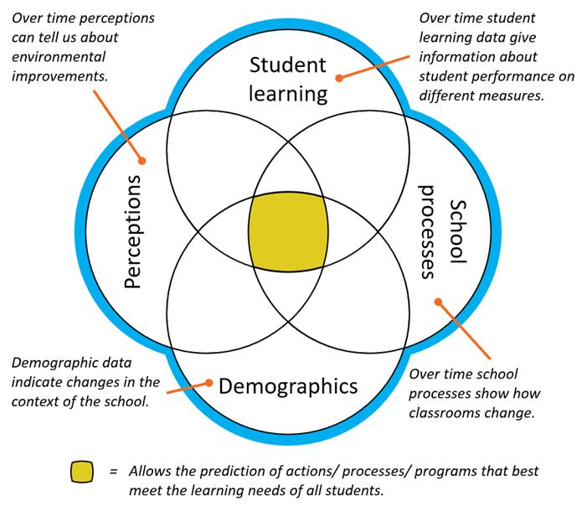

Bernhardt, V, 2004, Data analysis for continuous school improvement. Eye on Education: New York

Consequently, we will use this semester to undertake school-wide collection, analysis and use of existing student data; and we will undertake some testing of students who have not already undertaken testing at our school in 2018 and 2019. Testing will consist of group mental ability testing; and testing in English, Mathematics and Science, at appropriate age levels.

I am also the nominated Gifted and Talented Liaison Officer (GaTLO) for our school. If you have any queries,

please do not hesitate to contact the front office to make an appointment to meet with me.

Helen Cox

DEPUTY PRINCIPAL: Achievement and Potential

DEPUTY PRINCIPAL MESSAGE

Last week I met a friend for coffee at a local café and I was telling her all about our wonderful school, the friendly parents, the amazing students and wonderful staff. However, I also admitted to her that I had faced some challenges during the last five weeks. Things like remembering the names of staff and students and being away from my little fur-baby for the day. She asked me, “So when you are challenged, how do you respond? What do you do to cope?” I thought about it and said, “I don’t know. I guess I have a lot of resilience and stamina.” Driving home I thought about how resilient I am in the everyday challenges of life, and what skills and strategies I have used to cope with change. These included being aware of situations and acknowledging that I was a little overwhelmed, giving myself some slack and remembering that all good things take time, reaching out to people to talk about how I was feeling and taking care of myself by eating well and taking time out to walk my little furry friend.

I then thought about how we teach resilience and stamina to our students so that they may successfully bounce back from their own challenges, big and small. What skills do our children need to be resilient? How can we build stamina in them to keep going, even when the going gets tough? Nurturing stamina, perseverance and resilience in our little people is an acquired skill, and one that involves building brain muscles to help them cope with learning, friendships and everyday troubles. This takes time. We constantly teach our students about having a growth mindset and using the word “yet” in our everyday thinking. We teach them to say things like, “I haven’t learned that reading strategy yet, but I’ll get there!” We also teach them to identify good, and not so great emotions, and how to work through these. This takes time too.

Our school promotes a risk-taking environment, one where it is ok to fail. We all make mistakes and that’s ok. Our school encourages students to talk about things that went well. Students learn to name, reflect upon and remember emotions they experience as they succeed in learning and in play. They are also encouraged to explore the negative and how to maybe do things differently next time to experience success. Our school focuses on the positive, and a sense of hope for the future. Every day we ask our students to identify simple actions to help them reach their goals. This can include discussing statements that are helpful to navigate tricky social situations, complex learning environments, or even getting through the morning routine.

We all have strategies that we use to help us regain control and stay calm if life gets tricky. Lately I have walked through PODS and laid down with students doing a mindfulness meditation after lunch, listened to student/teacher conferences to help restore peace after conflict and admired displays that are focused on skills we need to be safe, respectful learners. Our school is a great school! Our staff have developed trust with students and the relationships that have been established are truly wonderful. Their interactions with students are purposeful and positive. I see it every day. In fact, it was only yesterday I looked out of my office window at about 3.00pm and smiled a big smile as I watched a staff member lead a small group of students to the bus that was waiting to drive them home. She kept turning around as they were walking, chatting to the little people following her so beautifully in the straightest line I had ever seen. They were all laughing - genuine, deep down in the belly laughs. She took time to say goodbye to each child and they all gave her an enthusiastic hi-5 as they jumped on board! She waved and walked away smiling! What a great way to end the day!

Marijana Pasalic

2019 School Satisfaction Survey

Over the next two weeks parents, students (in years 4-6) and teachers are being asked to participate in the 2019 School Satisfaction Survey. A letter and email have been sent home to families this week.

Although the survey is voluntary, we hope you will want to participate. It won’t take much of your time and will help us improve our school for your child and future students. A letter or email about the parent and carer survey have been sent out this week. The key ACT results from the 2018 School Satisfaction Surveys have been published on the Education Directorate website (www.education.act.gov.au) and a summary of our school results is provided in our 2018 School Board Report.

By doing this survey you will help us improve our school for your child and future students. The survey results will also be used in public interest

research projects and longitudinal studies aimed at improving the quality of services in the ACT. No personal information will be provided to any school or college. The survey will take about 5 to 10 minutes to complete and will be open until 2 September 2019.

The survey can be found here: https://acteducation.au1.qualtrics.com/jfe/form/ SV_6LosQ3xQfheARzn

Chess Tutors Needed

Chess is hugely popular at lunchtime in the Library but we really could use some help to learn to play properly. Do you know someone who might have time once or twice a week at lunchtime to teach small groups to play chess? We’d love to hear from you!

Kristina Collins, Librarian Kristina.collins@ed.act.edu.au

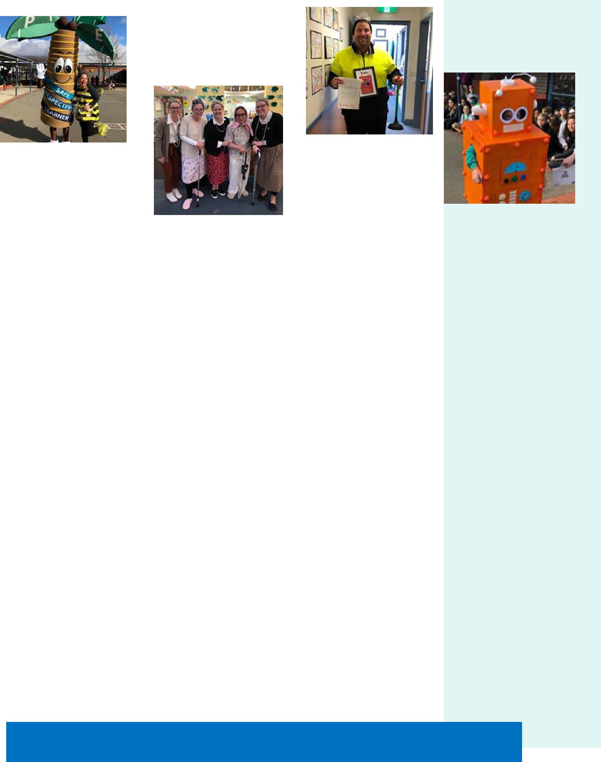

LIBRARY NEWS

Book Week

What a fantastic week last week with Book Week! Students across the school made a fantastic effort dressing up and showcasing their favourite books. How great to also see the teachers in their teams dressing up and joining in the fun.

Books for Bilingual Families

This semester in the Library we will be working on developing our collection to provide some parent resources and make more accessible our range of bilingual texts. Reading to your child in their first language will support maintenance and development of their first language literacy which is so important. We’d like to make these resources easier for students and their parents to access and borrow.

Parent Resources

We’d also like to develop our range of materials useful for parents. Suggestions so far include books on Autism, Protective Behaviours and managing challenging behaviours. If there are specific topics you’d like us to stock please let us know. These books are all in a particular section of the Library – please call in and ask us to show you where or email us with your suggestions: Kristna.collins@ed.act.edu.au

Together WeTogether We Learn From Each Other ₅

All P&C activities, meeting agendas and minutes are available from the school website at – Parent Corner

P & C/BOARD NEWS

The P&C are fundraising with the Entertainment book. The Entertainment™ Book is a local restaurant and activity guide which provides hundreds of up to 50% off and 2-for-1 offers from the finest restaurants, cafes, attractions, activities, retailers and hotel accommodation. The Membership entitles buy-ers to exclusive offers that are virtually restriction-free, and is valid through to 1 June 2020!

The Entertainment™ Digital Membership (app) puts all of the value of the Entertainment ™ Book into the customer's smartphone. With 'near me' technology and the ability to show and save using a phone, this is perfect for the person on-the-go, with no card or voucher to present.

You can purchase a book through the front office or download the app via this link

https://www.entertainmentbook.com.au/orderbooks/2487s6

6

Palmerston District Primary
School Science Fair

September 18-20
2019

SCIENCE IS FUN!

Ask a Question…
What do you wonder about?

The Science Fair is an annual event for Palmerston District Primary students. The idea is for students to have a fun and safe experience conducting a science experiment or researching the answer to a Science question at home. Then showcase their results at the Science Fair Wednesday 18 September - Friday 20 September in the school library.

This year display boards will be a $2 payment for all students who want to participate in the Science Fair. Money will be place in the money spinner as students collect their Science boards next week Tuesday 20 August, Wednesday 21 August and Thursday 22 August afternoons between 3:00 – 3:15pm from the library.

On Friday 20 September students and their families are invited to come and see the projects as part of the learning journey. But you can come anytime between Wednesday 18 September - Friday 20 September.

People’s Choice Award for junior (K-2), middle (3-4) and senior (5-6) students.

Looking forward to seeing lots of entries this year.

Karon Campbell
karon.campbell@ed.act.edu.au

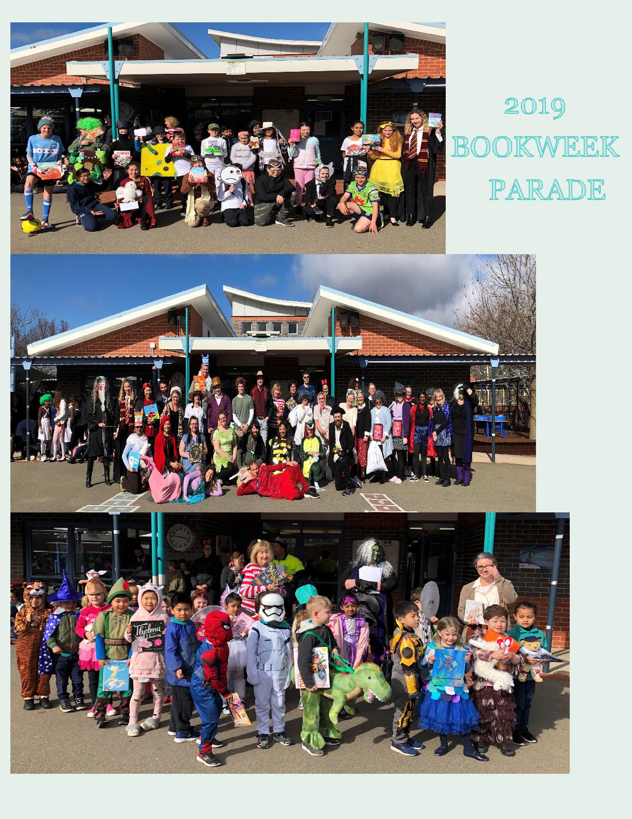

CLASSROOM CONNECTIONS
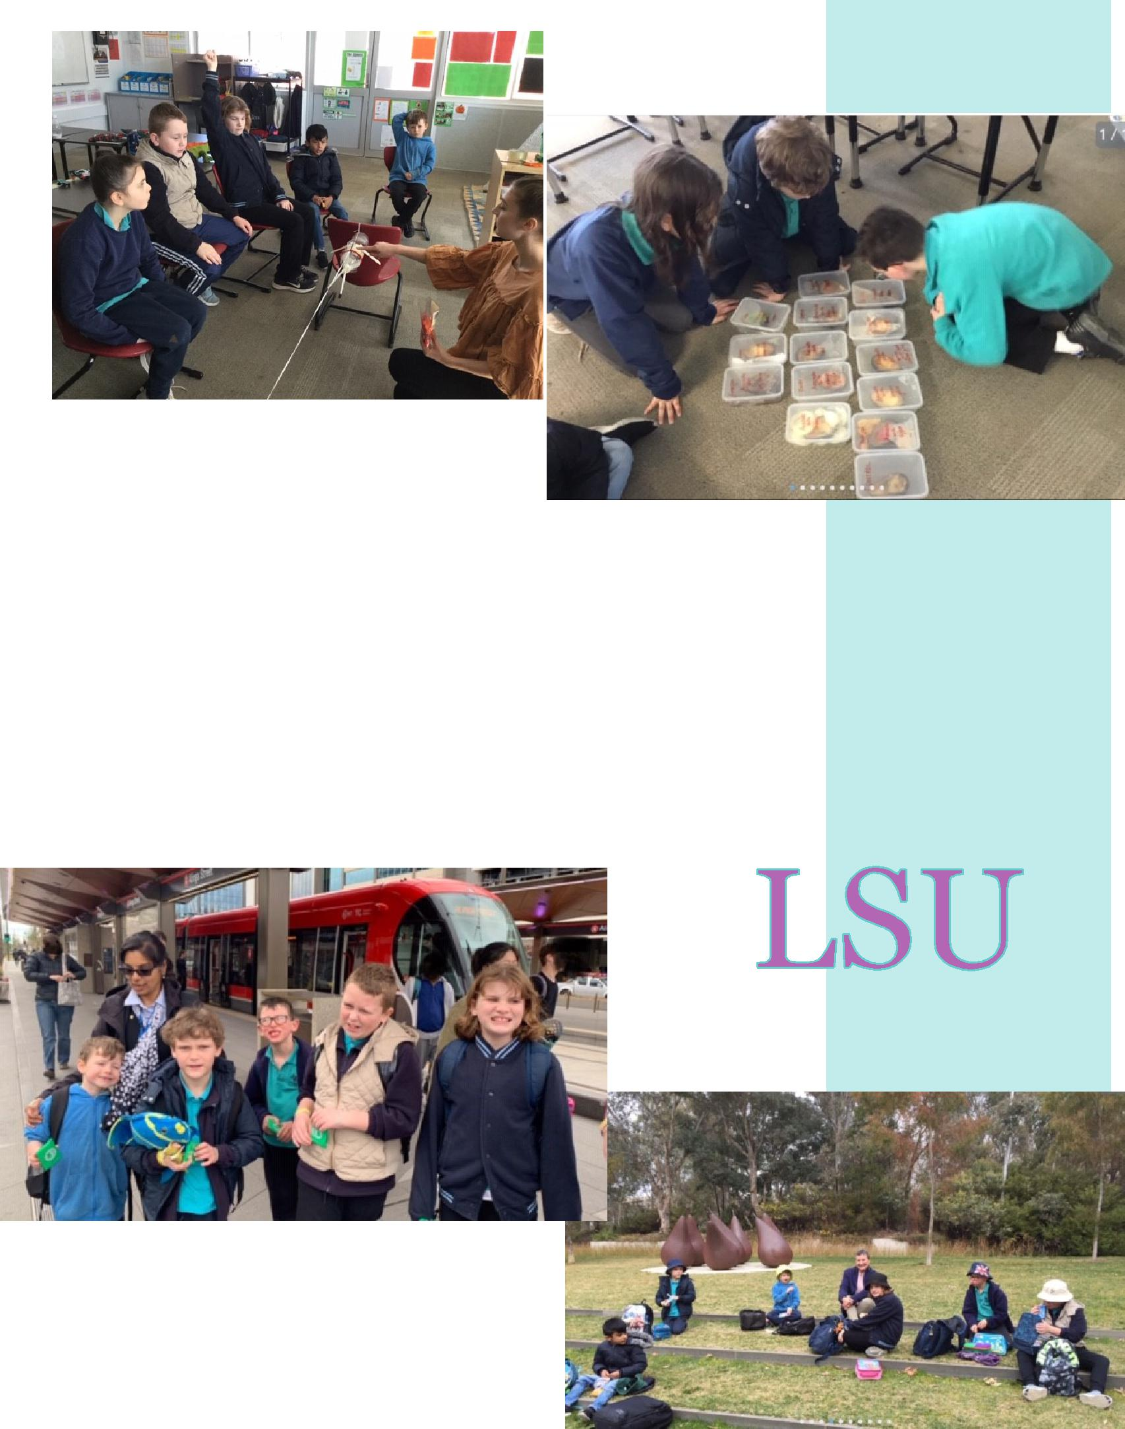

In the last few weeks we have been programming robots with Mr Witte during our technology session. We also worked with Ms Minnican the student teacher in our class to problem solve the manner in which we could engineer our rocket to get to the moon. Our scientific inquiry into the best methods of preserving cut avocados is progressing well. We also had a wonderful community access trip to the National Gallery to view Indigenous art styles. Our community artist Annie met us there and we had our lunch with her near some wonderful sculptures and water features. We are developing life skills as we access public transport and pay for items at the shops.

PALMERSTON PRIDE

Congratulations to the following students who received a PRIDE Award at assembly.

PARTICIPATION – becoming involved, “having a go” and cooperating

with others
Rufus— 3FS | Thomas— 3FS | Georgia—3/4DJ
Amaan—5/6KB | Amarlie—5/6CW | Valentina—5/6KB
William— 4RE | Ella— 4VS | Antoinette— 2DK

RESPECT – having respect for self, others and their property

Ela—Rose—3FS
Mima— 3AP

Olivia— 3AJ
Zohair—5/6CW

Amina— 3AP Annabella— 4VS

Natalie 5/6JM

INTEGRITY – being honest, fair, responsible and loyal

Mollie — 3/4DJ Charlotte—5/6KB Toby—5/6KB

Mason 5/6JM

DETERMINATION - being persistent and resilient

Hadi—IEC | Daisy—IEC | Maggie—3FS
Paul— 3/4DJ | Kimia— 3AJ | Isabela—5/6CW
Sebastian—5/6KB | Logan— 4RE | Sam—5/6JM
Georgia—5/6KB

EMPATHY - understanding and supporting others regardless of our differences

Ava -4VS Kobe—5/6KB

11

Well done Georgia!

$4026 Raised to kick cancer to the curb

and Lifeline.

Thank you to everyone who supported

this amazing achievement!
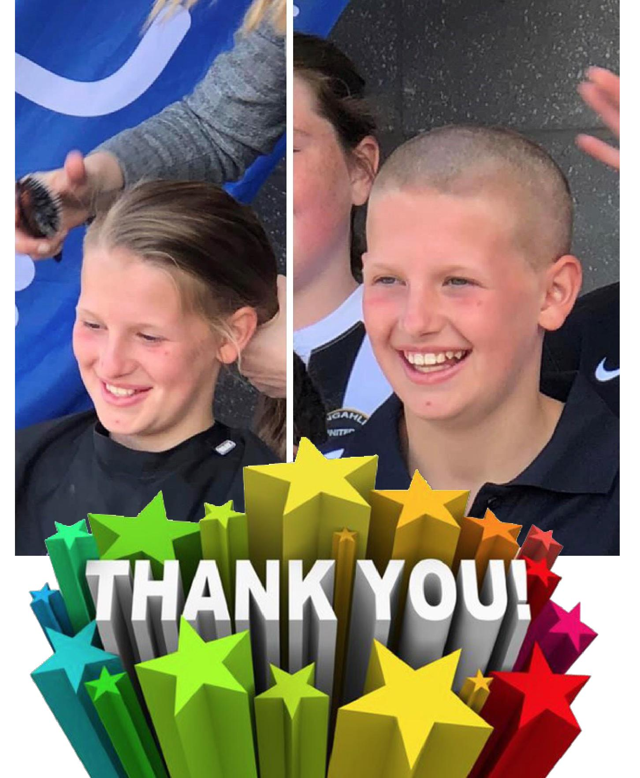

Car Park Safety Tips

TIPS FOR PARENTS:

- Drive very slowly through the car park (max 10km/h) and be alert for children at all times

- Never park in the pick-up and set down zone, it defeats the purpose of the area as a quick drop-off/collection point

- Children should always depart and enter the vehicle directly onto the footpath, not the road

- Children should have their bags and other items readily available so they can quickly depart/enter the car

- Minimise the days you drive your children by encouraging them to walk or ride

- If you need to drive, utilise partway drop off or collection points around the school to reduce congestion in the school carpark and pick-up and set down zone

BE PATIENT AND COURTEOUS WHEN DRIVING NEAR THE SCHOOL.

TIPS FOR STUDENTS:

- Have your personal belongings like your school bag ready, so you can quickly enter or leave the car

- Always depart and enter the car onto the footpath, not the road

- Wait in a safe location back from the kerb until you are collected

- Keep your seat belt on until the vehicle has stopped and you are ready to exit the car
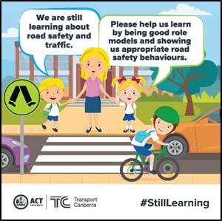

DEFENCE NEWS

Postings

Postings – Are you posting this year or early next year? I would love to know where you are heading for 2019/2020 so I can support your child, if your family are moving into another locality or school. You can contact me via email kristy.retzlaff@ed.act.edu.au or 6142 1440

Thank you, Kristy Retzlaff, Defence School Mentor

Defence Community Organisation –

Events

An ADF Family Event: Father’s Day at the Forge Sunday 1st September 2019 10:00am – 3:00pm

Cuppacumbalong Homestead, Tharwa Valley Forge 21 Naas Road, Tharwa, ACT 2620

Register: https://www.eventbrite.com.au/e/an-adf-families-event-fathers-day-at-the-forge-canberra-tickets-68567399939

www.dco.gov.au

Further information can also be found at the DCO Facebook Page.

NOTE: This event is only for Australian Defence Force members and their families.

ADF members and families in the ACT and surrounds, join us for a fun -filled Father’s Day at Cuppacumbalong Homestead. This event has activities on offer for the whole family to enjoy! Tharwa Valley Forge will be conducting woodwork, metalwork and leatherwork activities for all ages. Representatives from soccer, AFL and Little Athletics will be on -site to run activities for the kids. Scouts, and Parks and Wildlife will host a range of activities and walks to the old Homestead Cemetery. The Royal Military College PEP band will provide light entertainment. Bring along a picnic basket with your favourite picnic food and a blanket and relax in the beautiful Cuppacumbalong Homestead Gardens. We will supplement your picnic lunch by providing wood-fired pizza and a pig on a spit. A coffee van will be on -site for you to purchase tea and coffee. When registering, ensure your email address is accurate as you will receive a booking confirmation and further information via email. You will be asked to show your ticket so please bring either a printout or electronic copy and Defence Identification.

Things to note:
All attendees need to register including children
Children must be under parental supervision for all activities being conducted
Long sleeves, pants and enclosed footwear are required for woodwork, metalwork and
leatherwork activities ₁₄ Sports footwear and comfortable clothing to be worn for sports, Scouts and Parks and Wildlife related activities

This venue is wheelchair accessible. Tea and coffee may be purchased at the coffee van on -site

An ADF Family Event: Teen SMART (Ages 11-14), Canberra
Date: Thursday 3rd Oct and Friday 4th October
Time: 12:00pm to 2:30pm, both days.

Where: Defence Community Organisation, Thesiger Crt, Deakin, ACT 2600

Register: https://www.eventbrite.com.au/e/an-adf-families-event-teensmart-11-14-years-canberra-tickets -69252360675

Description:
NOTE: This event is only for Australian Defence Force members and their families.

This school holidays, teens of ADF members aged between 11 and 14 are invited to participate in a two-day ‘TeenSMART’ mini-workshop designed to provide teens with skills to manage life within a military family. The workshop will focus on positive self-image, maintaining a peer support network, parental absence, self-care and goalsetting. Come along and share ideas, experiences and pizza! When registering, ensure your email address is accurate as you will receive a booking confirmation and further information via email.
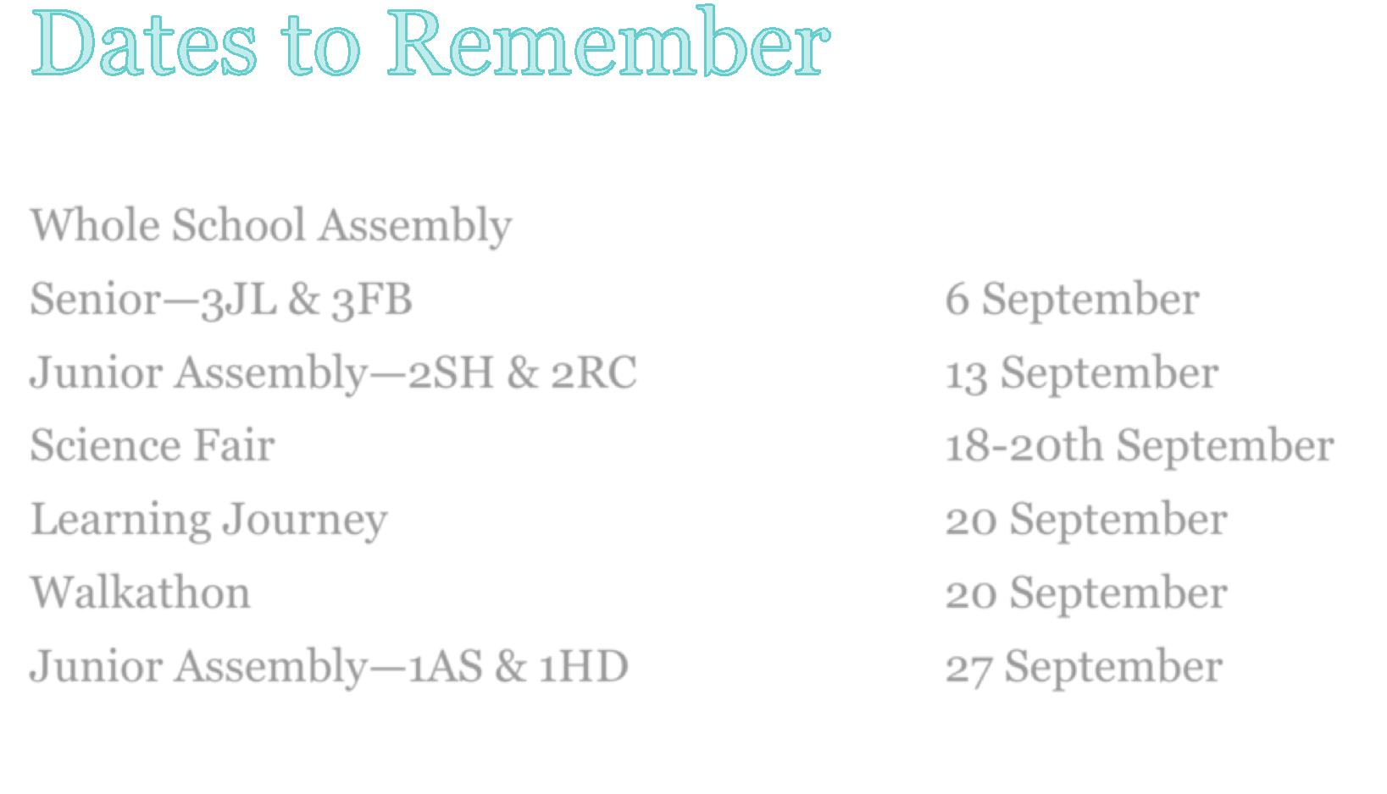

Whole School Assembly

Senior—3JL & 3FB

6 September

Junior Assembly—2SH & 2RC

13 September

Science Fair

18-20th September

Learning Journey

20 September

Walkathon

20 September

Junior Assembly—1AS & 1HD

27 September

COMMUNITY CONNECTIONS

Together WeTogether We Learn From Each Other

